

Workplace Active Travel Infrastructure Grant
Frequently Asked Questions
What does this fund cover?
The grant is a capital fund that can be used to purchase and install infrastructure to support walking, wheeling, and cycling to your workplace.
Eligible facilities include:
- Cycle shelter – open to suit staff and visitors
- Secure cycle shelter – available only to staff
- Cycle repair stand and pump
- Improved staff changing facilities
- Improved and storage / drying facilities for outdoor clothing
- Showers
- Dr bike sessions
- Repairs or improvements to existing infrastructure
- Installation of previously bought infrastructure
- Pool bikes & pool bike storage for workplace
This is a non-exhaustive list. Most commonly, the fund is used to improve cycle parking. If you are not sure if your project idea fits, please get in touch.

What is not covered by the fund?
The fund is a capital fund. This means it is suited for infrastructure projects that support walking, wheeling, and cycling for commuting and business journeys. It does not cover non-infrastructure initiatives, walking challenges, or active travel breakfasts. Dr Bike sessions can be included due to the maintenance aspect of this work fitting with capital funding.
We will not fund projects that do not contribute to increasing rates of walking, wheeling, cycling, or sustainable travel.
We will not fund projects at private residences.

What are the benefits of this funding opportunity?
Providing better facilities for walking, wheeling, and cycling helps create a healthier and more sustainable workplace. It can improve staff well-being, reduce demand for car parking, and support corporate sustainability goals.

Who can apply?
Eligibility depends on both your location and organisation type:
- Where are you based?
Your site must be in the Hitrans region. HITRANS is the statutory regional transport partnership covering the local authority areas of Eilean Siar (Western Isles), Orkney Islands Council, Highland, Moray, and most of Argyll and Bute. (*Helensburgh and Lomond is covered by Strathclyde Partnership for Transport (SPT): https://www.spt.co.uk)
Check your location on our HITRANS map.

- What types of organisations are eligible?
For this grant, we fund:
- businesses,
- charities,
- not-for-profit organisations
- public sector bodies
Providing you are seeking improvements to support increasing walking, wheeling or cycling at a workplace site or sites based in the HITRANS region. Applications can come from specific workplaces or departments within an organisation.
Private residences are not eligible.
Each project must have a designated lead contact with the necessary permissions and capacity to manage the project.

What is the timeline?
We follow a structured grant process:
GRANT PROCESS MILESTONE | DATE
Grant applications open | 21st April 2025
Grant information webinar | 30th April 2025
Grant applications close | 21st June 2025
Grant application initial review and scoring | w/c 30th June 2025
Notification of application acceptance / rejection | 7th July 2025
Final date for invoice submission | 2nd March 2026
Final date for evaluation report submission | 3rd April 2026

Once your project is approved, you will manage the delivery. Some projects may be completed as quickly as two months with minimal input from you. Other projects could take longer due to equipment delivery / construction lead times, contractor availability, and site preparation. We recommend that you plan your project into your existing work and start the work early, and communicate with others at your site.

Are there examples of past projects?
Yes, here are examples of successfully completed projects:
- Example 1: A secure cycle shelter
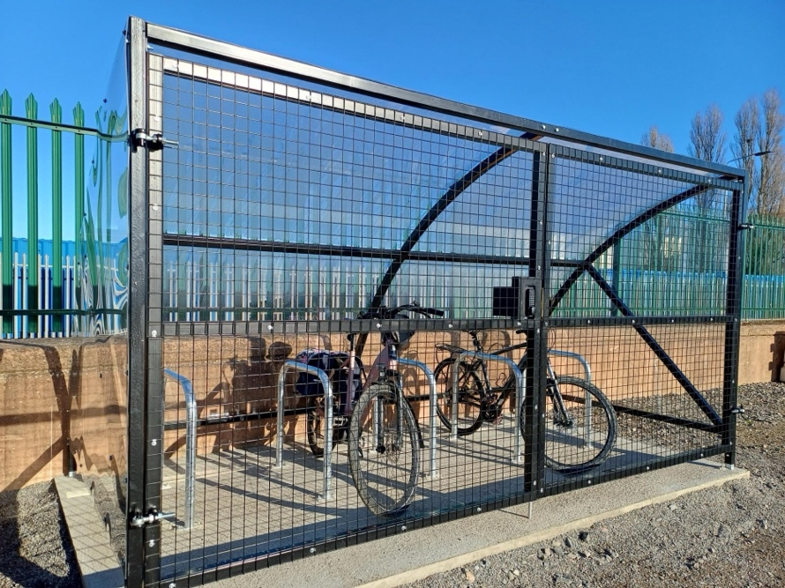
- Example 2: A secure on-street cycle pod


What should I do before applying?
- Read the guidance for the workplace active travel grant fund as well as this FAQ document.
- Research the best infrastructure solutions for your workplace, taking into account staff needs – e.g is the primary concern shelter or security or both for cycle parking. You may need to assess your site, measure up space(s) available there, and investigate commercially available options to suit.
- Obtain necessary permissions, especially if you are in leased premises. Some cycle parking projects involve sacrificing one car parking space as a cost effective solution.
- Review procurement guidance from Cycling Scotland https://cycling.scot/media/cujlurmw/2023-03-guidance-for-cycle-storage-and-parking-8-page.pdf
This will help you with tips on types of cycle parking solution to suit your needs, and considerations to make in assessing your site, and other factors such as access, lighting etc.
- Gather key details for your application, including location, estimated demand, costs, and expected impact.
- Obtain quotes for equipment and installation to ensure accurate project costs.
- You can ask for feedback on a draft of your application prior to submission.

Can I apply for multiple improvements?
Yes, you can apply for several improvements if they align with your staff’s needs. Ensure you provide fully costed details for all elements and can outline the anticipated impact in improving opportunities for walking, wheeling and cycling for staff. If you have priority items, highlight them in your application. Partial funding may be awarded, based on available funds.

Can I apply for multiple sites?
Yes, multiple sites can be included in one application, but you must provide separate cost breakdowns for each site. As with single-site applications, funding decisions will consider impact, and regional budget distribution.

Can I apply for infrastructure that multiple organisations will use?
Yes, if your organisation or business shares a premises or has access to a shared space with others, you can make arrangements for staff from all organisations or businesses to use the infrastructure. We need a lead contact for application, who will oversee the delivery of the project. When you give details of the impacts of your improvements in application be sure to include information about staff numbers from all organisations and businesses who would benefit.

Is there a maximum grant amount?
There is no set upper limit. Our grant funding comes from Transport Scotland so we will evaluate projects on both their impact on active travel uptake and their value for money.

Do I need match funding?
We offer 100% project funding. Match funding is not required, but if additional funding is available, we are open to co-funding initiatives.

Do I need planning permission for installing a cycle shelter?
In most cases, you won’t need planning permission to install a cycle shelter or other similar infrastructure. However, there are a few important things to check first:
- If your building is in a conservation area, you cannot place the cycle shelter in the front area of the building.
- You must not obstruct visibility for drivers entering or leaving your site – for example, don’t place a structure where it could block sightlines to a road or footpath.
- If you plan to install infrastructure on a public road or pavement, there are strict size limits (max: 1.5m high, 2.5m deep, and 5m long), and you must get permission from your local authority as the roads authority.
If you're unsure whether planning permission is needed for your site, we recommend speaking to your local planning or roads authority early on in your planning process.

When will I know if I have been successful?
Applicants will be notified by 7th July 2025. If additional details are required, we will contact you before scoring applications.

When must the project be completed?
Projects must be completed within the 2025/26 financial year. We encourage early project initiation to allow time for unexpected delays. Invoices must be submitted by 2nd March 2026, and evaluation reports by 3rd April 2026.

Do you recommend specific suppliers or contractors?
You are free to choose your suppliers and contractors. We advise checking lead times for delivery and installation. Cycling Scotland provides a list of suggested suppliers in their Cycling Infrastructure Guidance.

Are there grant conditions?
Yes. Successful applicants must sign a grant agreement. Funds are reimbursed to your organisation upon submission of an invoice. An evaluation report is required by 3rd April 2026.

How do I evaluate the impact of my project?
We will provide evaluation guidance, this may include staff surveys, usage monitoring, case study stories or feedback collection.

What support is available during the application process?
- Read through the full grant guidance.
- If you have additional questions, contact us for tailored advice.
- We offer feedback on draft applications before the deadline—reach out if you'd like a review.

