Sound of Barra Ferry Service:
Socio-Economic Case for Timetable Enhancements

Final Report

to







by



January 2023
CONTENTS

Executive Summary i

1 Introduction 1

2 Socio-Economic Profiles 3

3 Ferry Timetables 13

4 Ferry Traffic Analysis 17

5 Options for Timetable Enhancements 36

6 Traffic Forecasts 37

7 The Case for Timetable Enhancements 43

8 Conclusions 54

EXECUTIVE SUMMARY

Introduction

The objective of the research was to produce an assessment of the socio-economic impacts of timetable enhancements on the Sound of Barra ferry service.

The research included:

- Review of a previous study of Outer Hebrides ferry services.
- Desk-based research into the economic and population of Barra and Uist, and for data ferry carryings and bookings.
- Consultations with representatives of a range of organisations.
- Surveys of households, businesses and other organisations.

Socio-Economic Profiles

Barra and Uist each have small economies and small populations. The challenges facing the two islands are evident in both being HIE-designated Fragile Areas and their facing a relatively high cost of living.

Tourism is important to both islands’ economies. In addition, Barra has significant levels of employment in the public sector employment and food processing. In Uist the Qinetiq range is a major employer in Uist, along with fishing and aquaculture.

Wage levels in many sectors in Barra and Uist are likely to be lower than the Outer Hebrides average which in turn is below the Scottish average.

The population of Barra is stable. It is relatively old although with a relatively high proportion of those aged 0-15 years. The population of Uist has been in decline. It is relatively old and aging at a faster rate than in the Highlands and Islands and Scotland.

Ferry Timetables

The Sound of Barra service has a crossing time of 40 minutes.

The summer timetable has five return sailings per day, across a period of around 12 hours. Monday-Saturday first sailings are ex Barra 0700 and ex Eriskay 0810, last sailings are ex Barra 1730 and ex Eriskay 1830.

The gap between departures varies between 1¾ hours and around 4½ hours. There is a significant gap between the third and fourth sailings of the day-of around 3½ hours ex Eriskay and 4½ hours ex Barra.

The winter Monday-Saturday timetable is very similar to that in the summer. However, only two sailings operate on winter Sundays, with more than eight hours between them.

Throughout the year there are very few well timed connections with other Uist-based ferry services.

In Uist the ferry terminal at Eriskay is 33 miles from Balivanich-the main settlement on the island. It is also 59 miles from Berneray which is the terminal for the Sound of Harris ferry service. Between the two terminals there is an estimated drive time of between 1¼ and 1¾ hours, depending on familiarity with the road.

Ferry Traffic Analysis

In 2019 (pre-pandemic) the ferry service carried around 64,000 passengers, 25,000 cars, 2,000 Commercial Vehicles (Covid) and 100 coaches. CV numbers have declined to below 800 since 2019 and appear unlikely to recover to their former levels.

Passenger and car traffic is very seasonal. More than 75% of carryings are during the summer timetable, with a concentration between May and August.

Carryings in the summer are spread quite unevenly across individual sailings and, to an extent, the days of the week. These imbalances result in capacity constraints-particularly for the most popular sailings.

Residents’ use the service for a variety of trips, including health and visiting friends or relatives. Business travel is a significant part of non-visitor demand.

Most households and businesses book a vehicle space on the ferry in advance. However, they book quite near the day of travel-i.e. no more than two weeks in advance. Visitors tend to book much further ahead although some look to book quite late or only after they have arrived in the Outer Hebrides.

If a desired sailing is fully booked more than half of residents and businesses either have to travel on another day or do not travel at all.

Most sailings in the midsummer months that become fully booked for the first time do so in the final two weeks before the sailing. However, some become fully booked considerably earlier than this.

Desk-based analysis of estimated vehicle capacity utilisation shows very few sailings at 100% or more utilisation or 90%+utilisation. These are much fewer than would be expected given the number of sailings recorded as becoming fully booked and users’ views of the limited available capacity on the service-especially in June, July and August.

Survey respondents’ views on the main effects of inadequate capacity include inability to travel at short notice (including for essential trips such as health appointments) or at optimum times.

Around two thirds of household survey respondents consider the current sailing timings to be less, or no more, than adequate. Users see the main effects of this including too much or too little time available at their destination and an inability to connect with other Outer Hebrides ferry and air services.

Options for Timetable Enhancements

Option A: Increase the number of sailings within the current operating day

The number of return sailings could be increased from five to six within the current operating day-that is, between 0700 and 1910. This would remove the current gap in the sailing day between the third and fourth sailings.

Option B: Provide an additional return sailing before the current start time of 0700

As well as allowing travel within the Outer Hebrides, the aim would be for these sailings to connect with mainland ferry sailings.

Option C: Provide one or two later return sailings after the current end time of 1910

As well as allowing travel within the Outer Hebrides the aim would be for these later sailings to connect with mainland sailings.

Traffic Forecasts

There is a considerable degree of estimation in the traffic forecasts. That reflects, in particular, the mismatch between the desk-based capacity utilisation analysis and our primary research with users and the bookings data.

The forecasts are for cars and their accompanying passengers. They include both resident and visitor traffic. CVs and coaches have not been included because they can be expected to have much lower levels of frustrated demand than car traffic.

Across a full year it is estimated that the annual uplift in traffic (i.e. generated traffic) based on 2019 levels could be:

- Option A: Passengers 7%, Cars 8%.
- Option B: Passengers 2%, Cars 3%.
- Option C: Passengers 3%, Cars 4%.

In addition, some existing trips would now move to more suitable travel times.

These forecasts imply a large total increase in carryings if all three options were introduced.

Around half the generated traffic would occur in June, July and August, one third during the rest of the summer timetable, and one sixth in the winter timetable.

The Case for Timetable Enhancements

The strategic case for the enhancements is based around:

- Ferry service provision supporting the Outer Hebrides as a single entity in administrative, public services, economic and social terms.
- The distances and quality of roads between its main settlements.
- The need to raise productivity.
- Relatively high cost of living.
- Meeting household, business and visitor travel needs-sufficient capacity, greater day trip opportunities, ability to travel at short notice, and access to mainland and inter-island transport services.
- Increased ferry capacity, frequency and better timings making the Outer Hebrides a more attractive location.

Each option has been assessed through a mix of qualitative and quantitative measures, recognising that not all impacts can be quantified in monetary terms. The quantitative measures relate to tourism impacts, business productivity, and cost savings to businesses and households.

TABLE E.1: QUANTIFIED IMPACTS OF THE THREE OPTIONS (£000)
Option | Output | GVA | Household Benefit
A | 397 | 182 | 0
B | 62 | 51 | 32
C | 85 | 90 | 62
Total | 544 | 323 | 94

Across the three options the quantifiable impacts total around £540,000 of output, £320,000 of GVA and £90,000 of household benefit (i.e. cost savings). Option A accounts for most of the impacts.

We reiterate that these results reflect only the impacts that can be quantified. They do not include other important benefits-e.g. increased sales by non-tourism businesses.

1 INTRODUCTION

1.1 OBJECTIVE OF THE RESEARCH

This is the final report of an assessment of the socio-economic case for timetable enhancements on the Sound of Barra ferry service. The research was undertaken on behalf of HITRANS, Comhairle nan Eilean Siar (CnES) and Highlands and Islands Enterprise (HIE) between August 2021 and April 2022.

The overall objective of the research was to produce an assessment of the socio-economic impacts of timetable enhancements. There was no requirement to assess the effects of possible enhancements in terms of any:

- Additional ferry operating costs.
- Operational issues arising.

Rather, CalMac will provide this information to Transport Scotland when the timetable proposals come to be assessed.

Another, separate report has been produced for the Sound of Harris ferry service.

1.2 RESEARCH METHODS

1.2.1 Review of Previous Study

Use was made of some of the data and analysis contained in the report Outer Hebrides STAG Appraisal which was completed in 2019.

1.2.2 Consultations

Some 15 initial consultations were undertaken either by video call or phone. These covered:

- CnES elected members.
- Community representatives.
- Staff from CnES and HIE.
- CalMac staff.
- Outer Hebrides Tourism.
- Loganair.

Six further consultations were undertaken. These were with four sports/recreational groups (identified by CnES), NHS Western Isles and Western Isles Fisherman’s Association.

They produced general views and information on the use and performance of the ferry service, and in some cases the impacts of the current timetable on specific organisations or groups of people. As well as providing inputs to the socio-economic cases, the findings informed the design of the household and business surveys.

1.2.3 Desk-Based Research

This comprised, first, a socio-economic profile of the communities (i.e. Barra/Vatersay and Uist) on the two sides of the route. This complemented the information and views from the previous reports and the consultations for this study, as well as setting the findings in context.

Second, analysis of existing demand based on ferry carryings and bookings data. That included detailed information supplied by CalMac.

1.2.4 Surveys of Households and Businesses and Organisations

The online surveys were promoted by each of the three clients and took place during February and March 2022. The numbers returned were:

- Households: 75.
- Businesses: 14. These were supplemented by telephone calls with other local businesses to generate additional information. Overall, this gave a good representation of the business base that is reliant on the ferry service.

Our use of the household survey findings was informed by the results of surveys of Sound of Barra users undertaken as part of the Outer Hebrides STAG Appraisal in 2018:

- On board surveys of visitors and residents: 84 responses.
- Online survey of local households: 41.

1.2.5 Traffic Forecasts

The desk-based analysis and primary research were used as the basis for producing traffic forecasts for a number of options for timetable enhancements.

1.2.6 Impact Assessment

The preceding work was then used to assess the impacts of the timetable enhancement options including some quantified assessment where relevant/possible.

1.3 STRUCTURE OF THE REPORT

Chapter 2 Provides a socio-economic profile of the Barra and Uist communities.
Chapter 3 Presents and analyses the ferry timetables.
Chapter 4 Analyses the traffic on the route.
Chapter 5 Describes the timetable enhancement options that were considered.
Chapter 6 Contains our traffic forecasts.
Chapter 7 Sets out the case for timetable enhancements.
Chapter 8 Provides conclusions.

2 SOCIO-ECONOMIC PROFILES
Summary

Barra

- A small economy, with a relatively high level of part-time employment.
- Recent economic growth led by fisheries and tourism.
- There has been tourism investment but there may be emerging capacity issues-e.g. visitor accommodation.
- All parts of Barra are HIE-designated Fragile Areas, and there is a concentration of employment in a small number of industries.
- Wage levels in many sectors in Barra are likely to be lower than the Outer Hebrides average-which, in turn, is more than 10% below the Scottish average. That is in a context of a relatively high cost of living.
- Small (c1,300) but stable population.
- Relatively old population-although it also has a relatively high proportion of those aged 0-15 years.

Uist

- Relatively high levels of employment are supported by tourism and the Qinetiq range.
- Specialisations include tourism, fishing and aquaculture, and scientific research and development.
- The economy is constrained by an inability to fill some vacant posts and lack of capacity on the mainland ferry services.
- Wages in full time jobs in many sectors of the economy are likely to be more than 10% below the Scottish average, and likely to be lower than the Outer Hebrides average. That is in a context of a relatively high cost of living.
- All parts of Uist are in HIE-designated Fragile Areas. Uist has also been designated as one of the Convention of the Highlands and Islands’s priority “repopulation zones”.
- Small population-less than 5,000 people. It is estimated to have fallen by around 5% between 2011 and 2019.
- A relatively old population-and one that is aging at a faster rate than in the Highlands and Islands and Scotland.

These profiles are based on av

a

2.1 INTRODUCTION

These profiles are based on available statistics, supplemented by views and information provided by consultees.

The data used very largely relate to 2019. That is, the last full year before the onset of the Covid pandemic. It is intended to highlight some of the main underlying strengths and challenges facing Barra (including Vatersay) and Uist. These will continue to be relevant going forward. For example, the role of key economic sectors, and challenges in sustaining a balanced population age structure.

The statistics shown here should be viewed in this light. Their use is not intended to imply that activity will, in the future, simply revert to the levels seen before 2020.

2.2 BARRA

2.2.1 Employment

In 2019 there was a total of 450 employee jobs in Barra and Vatersay (hereafter shortened to “Barra”). This figure does not include the self-employed, and covers only businesses which are registered for VAT and/or PAYE or with Companies House. The data are based on a sample of businesses and are also rounded to maintain confidentiality for individual businesses. Information on self-employment is shown at 2.2.2.

The share of jobs in Barra which is part time (50%) is much higher than that in the Highlands and Islands (40%). Part time employment is even more prevalent than in Scotland (where the figure is 34%).

Table 2.1 shows the structure of employment in Barra in 2019 and compares this to the Highlands and Islands.

TABLE 2.1: BARRA EMPLOYMENT STRUCTURE: 2019
 | Share of Total Employment
Industry | Barra | Highlands and Islands
Agriculture, forestry and fishing/aquaculture | 5% | 5%
Mining and quarrying | 0% | 0%
Manufacturing | 10% | 7%
Electricity, gas, steam and air conditioning supply | 0% | 1%
Water supply, sewerage, waste management and remediation activities | 0% | 1%
Construction | 5% | 7%
Wholesale and retail trade; repair of motor vehicles and motor cycles | 5% | 13%
Transport and storage | 10% | 5%
Accommodation and food service activities | 26% | 12%
Information and communication | 0% | 2%
Financial and insurance activities | 0% | 1%
Real estate activities | 0% | 1%
Professional, scientific and technical activities | 2% | 5%
Administrative and support service activities | 2% | 4%
Public administration and defence; compulsory social security | 2% | 6%
Education | 12% | 8%
Human health and social work activities | 19% | 17%
Arts, entertainment and recreation | 0% | 3%
Other service activities | 2% | 1%
TOTAL | 100% | 100%

Barra’s largest employment levels were in:

- Accommodation and food service activities: 26% of total employment.
- Human health and social work activities: 19%.
- Education: 12%.
- Manufacturing: 10%.
- Transport and storage: 10%.

The data indicate the relative importance of tourism. The Outer Hebrides Visitor Survey 2017 showed a total of c219,000 visitors to the Outer Hebrides.

The employment data also highlight the importance of some types of public sector employment, food processing (notably Barratlantic) and employment at Barra airport.

Education, and Human health and social work activities, are particularly important sources of full-time jobs.

The three largest sources of employment (Accommodation and food service activities, Human health and social work activities, and Education) collectively account for more than half (57%) of all jobs. That is a high degree of dependence on a small number of industries. It is much more so than in the Highlands and Islands where the corresponding figure is considerably lower (42%).

The figures shaded in yellow highlight industries with a share of total employment at least two percentage points greater than in the Highlands and Islands. For example, Manufacturing accounts for 10% of employment in Barra compared to 7% in the Highlands and Islands.

The data show that each of the five Barra industries with the highest employment levels are over-represented compared to the Highlands and Islands economy.

In contrast, a number of industries (shaded in blue) are underrepresented in Barra. They include Wholesale and retail trade, etc., in particular, plus others such as Public administration and defence; compulsory social security; and Professional, scientific and technical activities.

Consultees reported that:

- Barra’s economy is seen as stronger than that of Uist.
- The economy is seen as growing through increased fisheries and tourism activity, plus a strong third sector. However, there remains a degree of reliance on public sector jobs.
- Staff recruitment can be challenging for some businesses.

Tourism numbers have continued to increase-notably through more camper vans-with the season now stretching to March-October. There has been investment in visitor accommodation and facilties, including pop up catering businesses. The proposed new distillery will also increase visitor numbers and could in time form part of distillery trail including ones in both Uist and Harris.

However, consultees also reported that there could increasingly be capacity issues for visitor accommodation and pressure on other infrastructure-e.g. roads.

2.2.2 Self-Employment

The 2011 Census showed that 18% of those working were self-employed rather than employees.
These individuals were most likely to be working in one of the following:

- Accommodation and food service activities.
- Agriculture, energy and water.
- Construction.

This reinforces the importance of tourism to Barra’s economy. It also highlights that agriculture and construction are more significant than the employment figures at Table 2.1 suggest.

2.2.3 Wage Levels

Data on wages are only available at the Outer Hebrides level. In 2019, the average (median) gross wage for a full time job was £26,772. That is over £3,000 (11%) less than the figure for Scotland (£30,000).

We expect that, overall, wage levels in Barra’s economy will be lower than the Outer Hebrides average. This reflects the:

- Significant employment in some industries which are lower paying-notably Accommodation and food service activities.
- Relatively high proportion of jobs that are part-time.

This in a context where a minimum acceptable standard of living in the Outer Hebrides requires between 20% and 42% more household spending than in urban parts of the UK.

2.2.4 Fragility

All parts of Barra are classified by HIE as Fragile Areas. These are generally characterised by declining population, under-representation of young people within the population, lack of economic opportunities, below average income levels, problems with transport and other issues reflecting their geographical location.

2.2.5 Economy: Summary

- Barra has a relatively high level of part-time employment.
- There is a concentration of employment in a small number of industries-notably Accommodation and food services.
- Specialisations include tourism, some types of public sector employment, and food processing.
- Wage levels in many sectors in Barra are likely to be lower than the Outer Hebrides average-which, in turn, is more than 10% below the Scottish average. That is in a context of a relatively high cost of living.
- All parts of Barra are HIE-designated Fragile Areas.

2.2.6 Population Levels

The estimated 2019 population in Barra was 1,281.
Figure 2.1 describes its age structure, comparing this to the Highlands and Islands and Scotland.

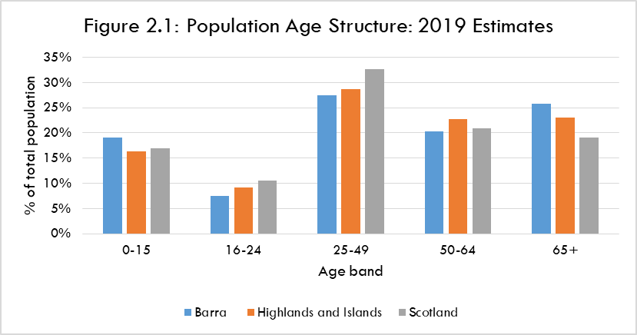

A distinctive feature is Barra’s higher proportion of those aged up to 15 years than in either the Highlands and Islands or Scotland. However, it has a lower proportion in each of the age bands between 16 and 64 years. That includes the 25-49 age band which is mostly likely to contain people in work and who are also raising families.

Further, Barra has a higher proportion (26%) of those aged 65 years+ than in the Highlands and Islands (23%) and Scotland (19%).

2.2.7 Estimated Population Change 2011 to 2019

The estimated 2019 population is virtually unchanged from 2011 when the estimated figure was 1,280. That is in contrast to population growth in both the Highlands and Islands (0.4%) and Scotland (3.0%) over that period.

Figure 2.2 describes how the age profile of Barra’s population changed in that time.

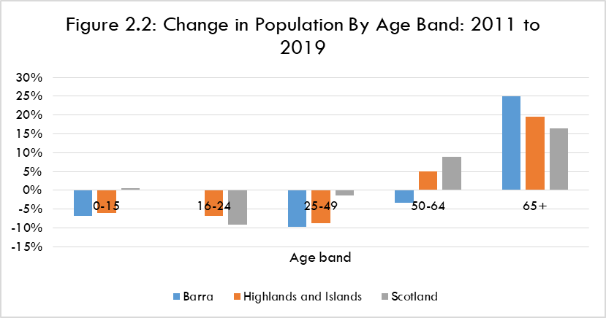

Barra has seen a decline in the numbers aged 0-15, 25-49 and 50-64. In contrast, there was a large increase (25%) in those aged 65 years or more. Thus, while Barra’s population level was unchanged, it has a more elderly profile.

Some of these trends are also evident in the Highlands and Islands and Scotland. However, there are also differences. On a positive note Barra’s number of 16-24 years olds was unchanged. That is in contrast to decreases in both the Highlands and Islands and Scotland.

Less positive are the relatively large falls in the number of 0-15 year olds and the important 25-49 age group.

While all three geographies have seen a significant increase in the number of people of 65 years or above, the largest percentage rise was in Barra.

2.2.8 Population: Summary

Barra has a small population-around 1,300 people. It is estimated to have been unchanged between 2011 and 2019, in contrast to growth at the regional and national levels.

It has a relatively aged population-although it also has a relatively high proportion of those aged 0-15 years. That reflects a decline in most age groups under 65 years between 2011 and 2019.

2.3 UIST

Here “Uist” refers to all of the islands between and including Berneray and Eriskay.

2.3.1 Employment

In 2019 there was a total of 1,875 jobs in Uist. This figure does not include the self-employed, and covers only businesses which are registered for VAT and/or PAYE or with Companies House. The data are based on a sample of businesses and are also rounded to maintain confidentiality for individual businesses. Information on self-employment is shown at 2.3.2.

The share of jobs in Uist which are part time (38%) is slightly lower than that for the Highlands and Islands (40%) but somewhat higher than in Scotland (34%).

Table 2.2, over, describes the structure of employment in Uist in 2019 and provides a comparison with the Highlands and Islands.

The industries in Uist with the largest employment levels were:

  - Accommodation and food service activities: 17%.
  - Human health and social work activities: 15%.
  - Education: 11%.
  - Wholesale and retail trade; repair of motor vehicles and motor cycles: 10%.

TABLE 2.2: UIST EMPLOYMENT STRUCTURE: 2019
 | Share of Total Employment
Industry | Uist | Highlands and Islands
Agriculture, forestry and fishing/aquaculture | 8% | 5%
Mining and quarrying | 0% | 0%
Manufacturing | 2% | 7%
Electricity, gas, steam and air conditioning supply | 1% | 1%
Water supply, sewerage, waste management and remediation activities | 1% | 1%
Construction | 7% | 7%
Wholesale and retail trade; repair of motor vehicles and motor cycles | 10% | 13%
Transport and storage | 5% | 5%
Accommodation and food service activities | 17% | 12%
Information and communication | 1% | 2%
Financial and insurance activities | 1% | 1%
Real estate activities | 2% | 1%
Professional, scientific and technical activities | 7% | 5%
Administrative and support service activities | 1% | 4%
Public administration and defence; compulsory social security | 4% | 6%
Education | 11% | 8%
Human health and social work activities | 15% | 17%
Arts, entertainment and recreation | 6% | 3%
Other service activities | 1% | 1%
TOTAL | 100% | 100%

This points to the relative importance of tourism. It will be boosted by the two proposed new whisky distilleries and the expansion of Ceolas-a centre for Gaelic culture, heritage and arts. In addition there are plans for the upgrade of existing and new visitor centres in Lewis, Harris and North Uist, a number of which will form a complementary visitor trail.

The three largest sources of employment (Accommodation and food service activities, Human health and social work activities, and Education) collectively account for 43% of all jobs. That is very similar to the Highlands and Islands where the corresponding figure for the three highest sources of employment is 42%.

Sub-sectors that are significant employers in Uist are:

- Fishing and aquaculture.
- Scientific research and development-related to the Qinetiq range.
- Libraries, archives, museums and other cultural activities.

The data in the Table shaded in yellow highlight industries with a share of total employment at least two percentage points greater than the corresponding share of Highlands and Islands employment. For example, Agriculture, forestry and fishing/aquaculture accounts for 8% of employment in Uist compared to 5% in the Highlands and Islands.

The other over-represented sectors are Accommodation and food service activities, Education, Arts, entertainment and recreation, and Professional, scientific and technical activities. The latter reflects the presence of Qinetiq at the range in Benbecula.

In contrast, a number of industries (shaded in blue) are underrepresented in Uist: Manufacturing in particular, as well as administrative related posts (in both the public and private sectors).

Consultees reported that:

  - Qinetiq is a major local employer which pays relatively high wages. This means that the local economy is quite dependent on it.
  - The creation of a spaceport in North Uist would be significant for the local economy.
  - There are employment opportunities in Uist. However, these can be in hard to fill sectors such as hospitality and care, or are hard to recruit to because of a lack of housing for incoming workers.
  - Tourism infrastructure is generally average/poor including roads and outdoor activities.
  - The economy is constrained by insufficient capacity on mainland ferry services affecting the movement of businesses’ staff and goods.

2.3.2 Self-Employment

The 2011 Census shows that 16% of those working were self-employed rather than employees. These individuals were most likely to be working in one of the following:

- Agriculture, energy and water.
- Construction.
- Wholesale and retail trade; repair of motor vehicles and motorcycles.

Thus, these industries will be more significant than the employment figures at Table 2.2 suggest.

2.3.3 Wage Levels

Data on wages are only available at the Outer Hebrides level. In 2019, the average (median) gross wage for a full time job was £26,772. That is over £3,000 (11%) less than the figure for Scotland (£30,000). Given its employment structure it is expected that wages in Uist will be lower than the Outer Hebrides average.

This in a context where a minimum acceptable standard of living in the Outer Hebrides requires between 20% and 42% more household spending than in urban parts of the UK.

2.3.4 Fragility

All parts of Uist are classified by HIE as Fragile Areas. These are generally characterised by declining population, under-representation of young people within the population, lack of economic opportunities, below average income levels, problems with transport and other issues reflecting their geographical location.

Uist has also been designated as one of the Convention of the Highlands and Islands’s priority “repopulation zones”.

2.3.5 Economy: Summary

- Three industries are responsible for over 40% of total employment in Uist.
- Distinctive features include the relatively high levels of employment supported by tourism and the Qinetiq range.
- Specialisations include tourism, fishing and aquaculture, and scientific research and development.
- Wages in full time jobs in many sectors of the economy are likely to be more than 10% below the Scottish average, and likely to be lower than the Outer Hebrides average. That is in a context of a relatively high cost of living.
- All parts of Uist are in HIE-designated Fragile Areas.

2.3.6 Population Levels

The estimated 2019 population in Uist was 4,630. Figure 2.3 describes its age structure.

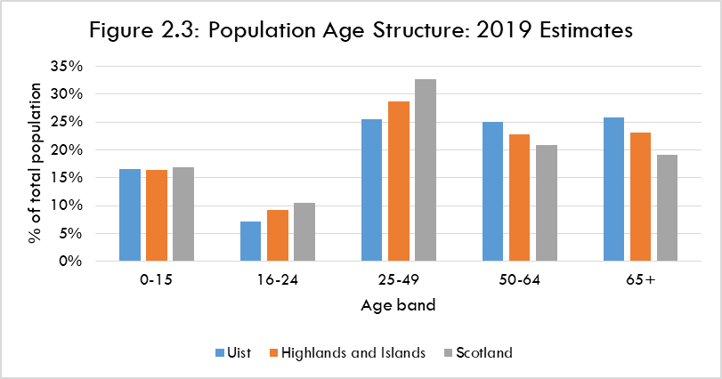

Uist’s population is older than that of the Highlands and Islands and Scotland. In particular it has lower proportions of those aged 16-24 and aged 25-49.

The latter is mostly likely to contain people in work and who are also raising families. Uist has 26% of its population in that age range, clearly lower than both the Highlands and Islands (29%) and Scotland (33%).

In contrast Uist has the highest proportions in the two oldest age bands. More than half of its population is aged 50 years or above, compared to 40% for Scotland.

2.3.7 Estimated Population Change 2011 to 2019

Figure 2.4, over, describes how the age profile of Uist’s population changed in that time.

It is estimated that between 2011 and 2019 Uist’s population fell from 4,862 to 4,630 people. That is a decrease of approaching 5%. That is in contrast to growth in both the Highlands and Islands (0.4%) and Scotland (3.0%) over that period.
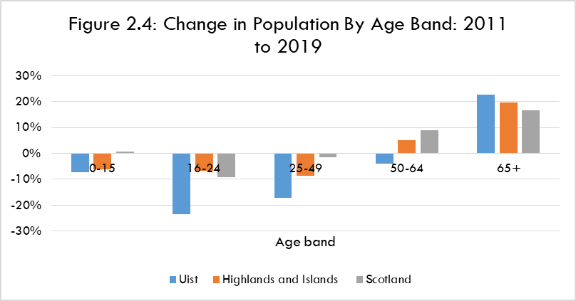

Uist has seen a decline in the numbers in each of the age bands up to 64 years. This generally mirrors the trend in the Highlands and Islands and Scotland. However, the extent of decline in Uist is much more marked. For example, a fall of 24% in the number of 16-24 year olds and of 17% in the 25-49 age band.

In contrast Uist had a large increase (23%) in those aged 65 years or more. That is above the level of increase at both the regional and national level.

2.3.8 Population: Summary

Uist has a small population-less than 5,000 people. It is estimated to have fallen by around 5% between 2011 and 2019, in contrast to growth at the regional and national levels.

Uist also has a relatively old population-and one that is aging at a faster rate than in the Highlands and Islands and Scotland. That includes an estimated large fall in the number of those aged between 16 and 49 years since 2011.
3 FERRY TIMETABLES
Summary

- The summer timetable has five return sailings per day, across a period of around 12 hours.
- The crossing time is 40 minutes.
- Monday-Saturday first sailings are ex Barra 0700 and ex Eriskay 0810, last sailings are ex Barra 1730 and ex Eriskay 1830.
- The gap (“headway”) between departures varies between 1¾ hours and around 4½ hours.
- There is a significant gap between the third and fourth sailings of the day-of around 3½ hours ex Eriskay and 4½ hours ex Barra.
- There are either no, or no well timed, connections with other Uist based ferry services apart from afternoon arrivals at Lochmaddy on three days of the week.
- The winter Monday-Saturday timetable is very similar to that in the summer. However, only two sailings operate on winter Sundays, with more than eight hours between the sailings.
- There are either no, or no well timed, connections with other Uist based ferry services in the winter apart from with afternoon arrivals at Lochmaddy on two days of the week.

3.1 SUMMER 2021

The summer timetable, shown overleaf, operated from March 26 to 17 October 2021.
The crossing time is 40 minutes.

Five return sailings per day operate. The first sailing of the day is from Barra and the last from Eriskay. On Sunday four return sailings are timetabled, with the other (first return sailing of the day) operating on a request only basis.

The sailing day is around 12 hours (between the first departure from Barra and the arrival of the last sailing there). Monday to Saturday the first and last sailings are:

- Ex Barra: 0700 and 1730.
- Ex Eriskay: 0810 and 1830.

There are three morning sailings from Barra and two from Eriskay. The gap (“headway”) between departures varies as follows:

- Ex Barra: from 1 hour and 45 minutes to 4 hours and 35 minutes.
- Ex Eriskay: from 1 hour and 55 minutes to 3 hours and 35 minutes.

This reflects a significant gap between the third and fourth sailings of the day. That is:

- Ex Barra: between 1110 and 1545.
- Ex Eriskay: between 1300 and 1635.

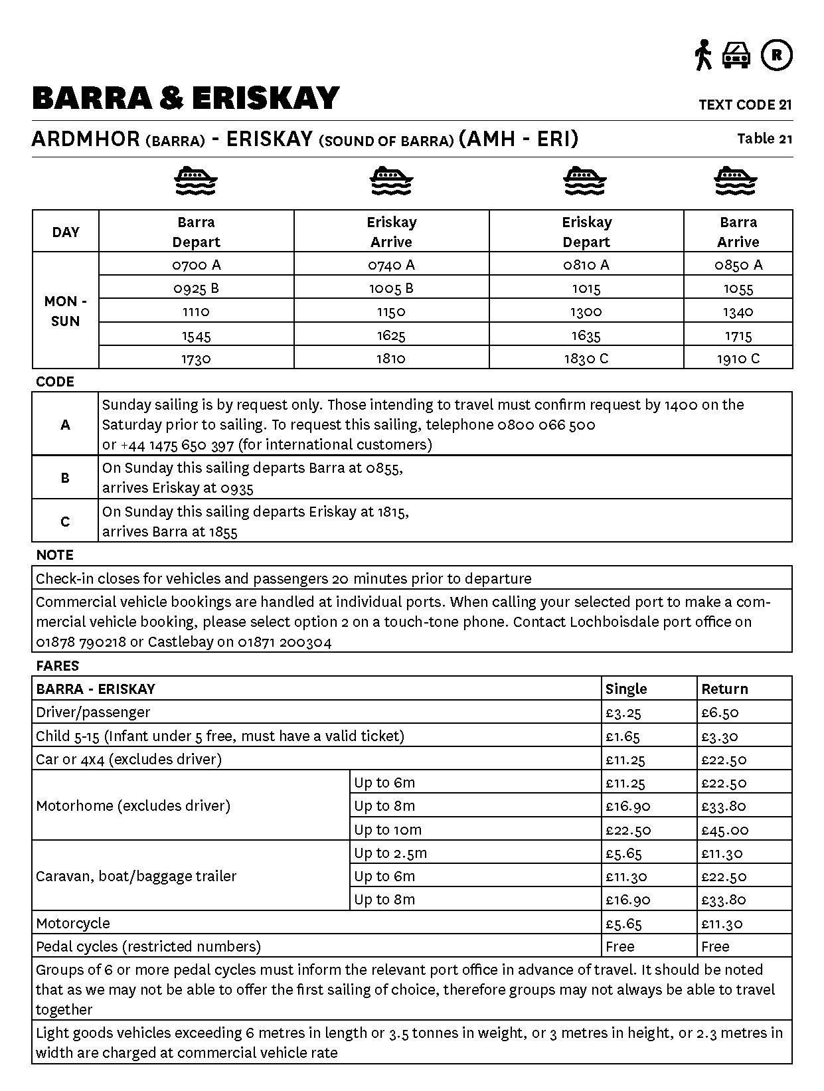
In Uist the terminal at Eriskay is 33 miles from Balivanich. It is also 59 miles from Berneray which is the terminal for the Sound of Harris ferry service. That has an estimated drive time of between 1¼ and 1¾ hours depending on familiarity with the road.

The service timings do not offer connections between Barra and Mallaig-Lochboisdale sailings or ones between Uist and direct Castlebay-Oban sailings.

Nor do they connect with the Sound of Harris sailings without, generally, involving quite long waits. That is in a context of a 56 mile road journey between Stornoway and Leverburgh and the 59 mile journey between Eriskay and Leverburgh.

However, there are well timed connections between the afternoon arrival of the ferry at Lochmaddy and the last sailing of the day from Eriskay on Tuesday, Thursday and Saturday.

It should be noted that in the summer 2022 timetable the fares for motorhomes up to 8m and up to 10m have increased quite significantly. That is from £33.80 to £58.00 (return) for up to 8m in length and from £45.00 to £69.60 for those up to 10m.

3.2 WINTER 2021-22

The timetable which operated between around mid-October 2021 and late March 2022 is shown below.
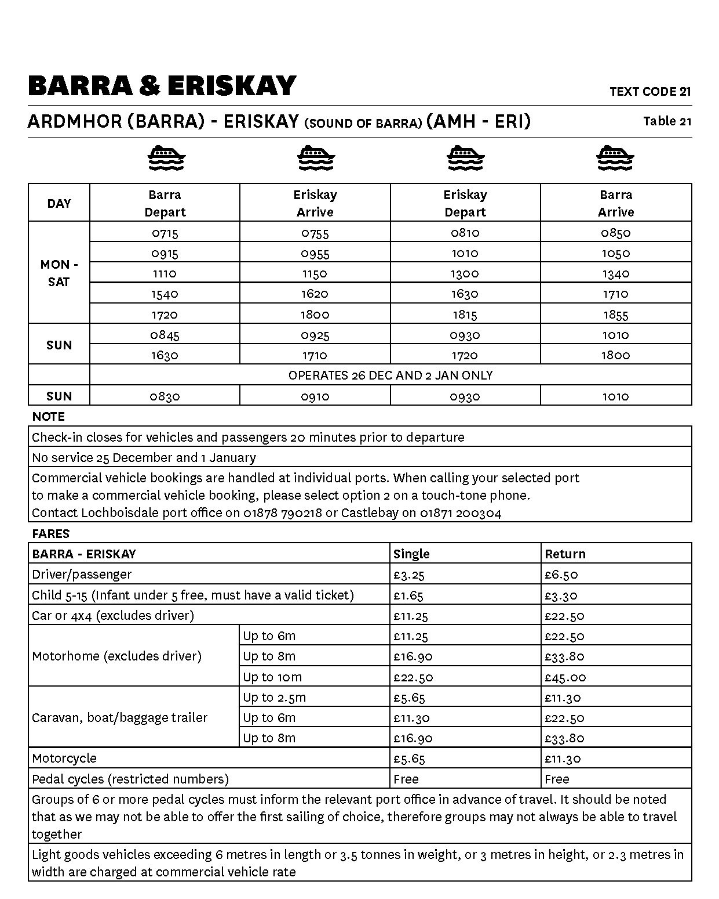
Monday to Saturday the timetable is very similar to that in the summer. There are five return sailings per day across a sailing day of 11 hours and 40 minutes. The first and last departures are at very similar times to those in the summer.

However, the winter Sunday timetable is much less frequent than in the summer. Only two rather than five sailings operate, across a sailing day of nine hours and 15 minutes.

There is a lengthy gap between the two sailings. Those arriving in Barra in the morning have over 6 hours before the return sailing back to Eriskay; and those arriving in Eriskay have almost 8 hours before the return sailing to Barra.

As in the summer the service timings do not offer connections between Barra and Mallaig-Lochboisdale sailings or ones between Uist and Castlebay-Oban sailings. Nor did they connect with the Sound of Harris sailings without involving quite long waits.

However, there were well timed connections between the afternoon arrival of the ferry at Lochmaddy and the last sailing of the day from Eriskay on Tuesday and Saturday.

4 FERRY TRAFFIC ANALYSIS

Summary

- In 2019 the ferry service carried around 64,000 passengers, 25,000 cars, 2,000 CVs and 100 coaches.
- Between 2017 and 2019 passenger carryings grew by 6% and cars by 10%.
- CV numbers have declined to below 800 since 2019 and appear unlikely to recover to their former levels.
- Passenger and car traffic is very seasonal. More than 75% of carryings are during the summer timetable, with a concentration between May and August.
- Summer carryings on sailings from Barra are higher than on sailings from Uist. This appears to reflect visitors arriving at Barra and then using the service to travel onwards to other islands in the Outer Hebrides.
- Carryings in the summer are spread quite unevenly across individual sailings and, to an extent, the days of the week.
- These various imbalances in carryings result in capacity constraints-particularly for the most popular sailings.
- Residents’ use the service for a variety of trip types, including health and visiting friends or relatives.
- Businesses’ travel is a significant part of non-visitor demand.
- The service is used to connect with other Outer Hebrides ferry and air services-although in many cases connections are not well timed.
- Most households and businesses book a vehicle space on the ferry in advance. However, they book quite near the day of travel-i.e. no more than two weeks in advance. Visitors tend to book much further ahead although some look to book quite late or only after they have arrived in the Outer Hebrides.
- If a desired sailing is fully booked more than half of residents and businesses either have to travel on another day or do not travel at all.
- Most sailings in the midsummer months that become fully booked for the first time do so in the final two weeks before the sailing. However, some become fully booked considerably earlier than this.
- Analysis of estimated vehicle capacity utilisation shows very few sailings at 100% or more utilisation (3% of all sailings) or 90%+utilisation (6%). These are much fewer than would be expected given 1) the number of sailings recorded as becoming fully booked 2) resident, business and consultee views of available capacity on the service-especially in June, July and August when capacity is viewed as very inadequate.
- Survey respondents’ views on the main reasons for/effects of inadequate capacity include: increased tourist traffic, sailings fully booked well in advance, space taken up by motorhomes, inability to travel at short notice (including for essential trips such as health appointments) or at optimum times.
- Around two thirds of household respondents consider the current sailing timings to be less, or no more, than adequate. Main reasons for/effects of this among households and businesses include: inability to connect with other Outer Hebrides ferry and air services, gap between the third and fourth sailings of the day, operating day is too short, too much or too little time available at their destination.
4.1 INTRODUCTION

This Chapter uses a range of sources to analyse traffic on the Sound of Barra ferry service. For carryings, we have used data for 2019. That was the last full year before the Covid pandemic which resulted in markedly lower carryings and a different balance between local residents and visitor traffic.

4.2 ANNUAL CARRYINGS

Table 4.1 shows annual carryings (single movements) between 2017 and 2021.

TABLE 4.1: ANNUAL CARRYINGS 2017-2021
Year | Passengers | Cars | Coaches | Commercial Vehicles
2017 | 59,887 | 22,975 | 148 | 1,908
2018 | 61,076 | 23,888 | 163 | 1,986
2019 | 63,676 | 25,321 | 116 | 2,057
2020 | 25,178 | 13,288 | 4 | 910
2021 | 49,247 | 21,381 | 72 | 766

In the last full year (2019) before the Covid pandemic the route saw around 64,000 passengers and over 25,000 cars. In addition there were around 2,000 Commercial Vehicles (CVs). Coach carryings were very slight-around 100 movements.

Traffic levels had grown between 2017 and 2019:

- Passengers: +6%.
- Cars: +10%.
- CVs: +8%.

In contrast, coach numbers fell between the two years.

Between 2017 and 2019 the highest absolute levels of passenger and car growth were mostly outside the peak summer months-i.e. in May, July and April.

In 2019, the average length of CV on the route was 7.9m. That is markedly less than the average length across all CalMac routes (11.9 m) in that year.

During the pandemic the carryings fell dramatically. However, they rebounded strongly from June 2021 onwards. In August and September of that year both passenger and car numbers were above those seen in the corresponding months of 2019. That may reflect an increase in the UK resident staycation market during 2021.

However, CV numbers have remained significantly below those in 2019. From our consultations the reasons for this appear to be:

- Some cargoes now being shipped direct to the mainland from Uist and Barra which had previously travelled via the Sound of Barra in addition to the mainland sailing.
- Some ongoing economic effects from the Covid pandemic.
- Some freight is now being moved in 6 metre vans (which are classified as cars on the ferry) instead of in CVs.

4.3 MONTHLY CARRYINGS

Figure 4.1 shows significant peaking of passenger traffic in the summer months of 2019.

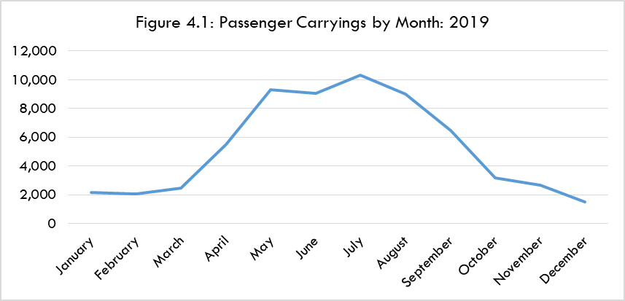

The numbers range from under 2,000 in December to over 10,000 in July. The main four summer months (May-August) accounted for around 60% of annual carryings.

Passenger demand is heavily concentrated in the main summer months.

Figure 4.2 also shows significant peaking of car traffic in the main summer months, albeit to a lesser extent than for passengers.

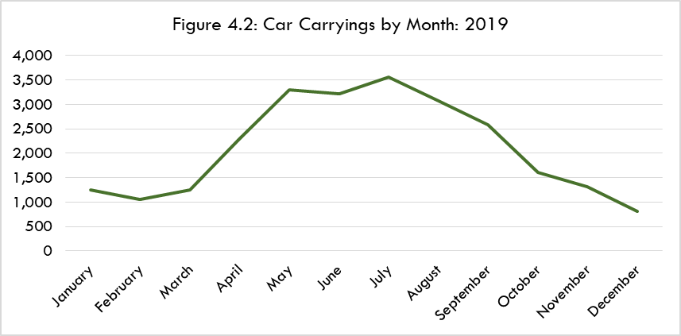

Car numbers ranged from less than 1,000 in December to more than 3,500 in July. The main four summer months (May-August) accounted for more than half (52%) of annual carryings.

Car demand is quite heavily concentrated in the main summer months.

Figure 4.3 shows that CV traffic has a seasonal pattern that is different than passengers and cars.

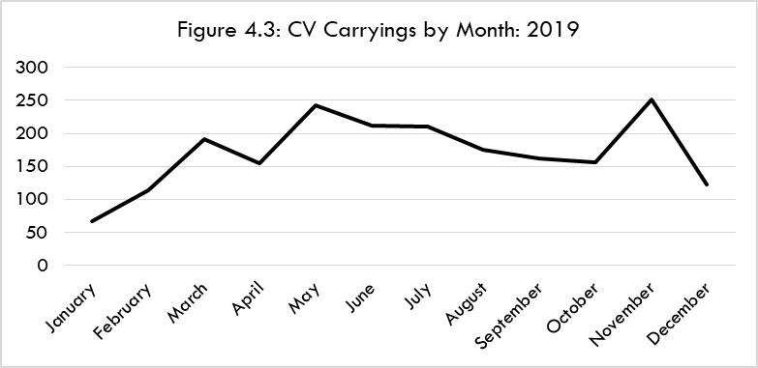

The numbers ranged between 66 in January and c250 in November. Otherwise, the highest volumes were in May, June and July coinciding with the peak periods for passengers and cars.

In 2019 the vast majority of coaches (102 out of 116) used the service between May and September. None were carried in January, February, November or December.

4.4 TRAFFIC PROFILE

4.4.1 Carryings By Season, Day and Sailing

Table 4.2 shows that carryings during the summer timetable account for a large majority of annual traffic.

TABLE 4.2: TRAFFIC VOLUMES BY SEASON: 2019
Timetable | Passengers | Cars | Coaches | Commercial Vehicles
Summer | 52,077 | 19,170 | 110 | 1,232
Winter | 11,599 | 6,151 | 6 | 825
Total | 63,676 | 25,321 | 116 | 2,057

This includes more than 80% of annual passengers and over 75% of annual cars, along with almost all coaches. The summer accounts for the vast majority of passenger, car and coach traffic.

There is also an imbalance of passenger and car traffic by leg during the summer timetable, as shown at Table 4.3.

TABLE 4.3: PASSENGER AND CAR TRAFFIC BY SAILING LEG: SUMMER TIMETABLE
2019
Sailing Leg | Passengers | Cars
Ardmhor to Eriskay | 29,045 | 10,558
Eriskay to Ardmhor | 23,032 | 8,612

Around 6,000 more passengers and around 2,000 more cars travel on the Ardmhor to Eriskay leg than on the leg between Eriskay and Ardmhor.

This appears to be because more visitors arrive in the Outer Hebrides at Barra then use the Sound of Barra ferry to travel onwards to other parts of the islands than arrive elsewhere in the Outer Hebrides and ultimately leave on the ferry from Castlebay.

Table 4.4 shows summer passenger and car carryings by day of the week. The sailings with the highest volumes are highlighted in orange.

TABLE 4.4: PASSENGER AND CAR TRAFFIC BY DAY OF THE WEEK: SUMMER
TIMETABLE 2019
 | Passengers |  | Cars
 | Ex Ardmhor | Ex Eriskay | Ex Ardmhor | Ex Eriskay
Monday | 3,908 | 2,844 | 1,500 | 1,060
Tuesday | 4,672 | 3,419 | 1,786 | 1,348
Wednesday | 4,545 | 3,729 | 1,639 | 1,406
Thursday | 4,484 | 3,954 | 1,713 | 1,589
Friday | 3,722 | 3,299 | 1,454 | 1,368
Saturday | 4,313 | 3,696 | 1,355 | 1,078
Sunday | 3,401 | 2,091 | 1,111 | 763
Total | 29,045 | 23,032 | 10,558 | 8,612

Tuesday, Wednesday and Thursday are the busiest days-in both directions of travel. Sunday has the lowest carryings. This is in contrast to the peaking of demand at/around weekends on the Outer Hebrides mainland services. Around half the weekly carryings are on three weekdays.

Tuesday, Wednesday and Thursday are also the busiest days during the winter timetable.

Table 4.5 shows carryings by timetabled sailing in summer 2019. Again, the sailings with the highest volumes are highlighted in orange.

TABLE 4.5: CARRYINGS BY SAILING: SUMMER TIMETABLE 2019
Ex Ardmhor |  |  |  |  | Ex Eriskay
Sailing | Passengers | Cars | Coaches | CVs | Sailing | Passengers | Cars | Coaches | CVs
07:00 | 2,313 | 1,186 | 0 | 115 | 08:10 | 3,313 | 1,382 | 1 | 202
08:55/  09:25 | 5,927 | 2,303 | 3 | 126 | 10:15 | 7,087 | 2,142 | 43 | 93
11:10 | 7,252 | 2,565 | 3 | 122 | 13:00 | 4,911 | 2,021 | 1 | 182
15:45 | 7,955 | 2,628 | 24 | 170 | 16:35 | 5,396 | 2,107 | 12 | 85
17:30 | 5,457 | 1,821 | 20 | 81 | 18:15/  18:30 | 2,090 | 874 | 1 | 29

It shows considerable differences in the volumes per sailing. Ex Ardmhor the busiest sailings for passengers and cars were the third (1110) and fourth (1545) of the day. The 1545 sailing was also the busiest for coaches and CVs.

Ex Eriskay the busiest sailings for passengers, cars and coaches were the second (1015) and fourth of the day (1635). In contrast, most CVs moved on the first (0810) and third (1300) sailings of the day.

Demand is concentrated on certain sailings while other some others are relatively quiet (e.g. last sailing of the day from Eriskay).

Table 4.6 provides the same analysis for Monday-Saturday sailings during the winter timetable. Again, the sailings with the highest volumes are highlighted in orange.

TABLE 4.6: MONDAY TO SATURDAY CARRYINGS BY SAILING: WINTER TIMETABLE
2019
Ex Ardmhor |  |  |  |  | Ex Eriskay
Sailing | Passengers | Cars | Coaches | CVs | Sailing | Passengers | Cars | Coaches | CVs
07:15 | 708 | 454 | 0 | 55 | 08:10 | 1,379 | 662 | 0 | 152
09:15 | 1,506 | 755 | 1 | 79 | 10:10 | 913 | 537 | 2 | 76
11:10 | 1,115 | 602 | 0 | 96 | 13:00 | 1,360 | 736 | 0 | 107
15:40 | 1,526 | 768 | 2 | 125 | 16:30 | 1,334 | 744 | 0 | 53
17:20 | 830 | 395 | 1 | 47 | 18:15 | 399 | 232 | 0 | 14

Ex Ardmhor the busiest sailings are generally the second (0915) and the fourth (1540). Ex Eriskay the busiest sailings are spread between the first (0810), third (1300) and fourth (1630).

4.4.2 User Profile

Trip Purpose

The household survey showed, in order of number of responses, the most frequently mentioned trip purposes as:

- Visiting friends or relatives (VFR).
- Health appointment.
- Holiday.
- Leisure or entertainment.
- Shopping.
- Business travel.

The most common (i.e. most frequent) trip purposes were:

- VFR.
- Health appointment.
- Business travel.

This was also the case in the Outer Hebrides STAG Appraisal surveys.

A number of consultees referred to family links between South Uist and Barra which generate VFR trips on the ferry service.

The vast majority (95%) of the household survey respondents normally accompany a vehicle on the ferry.

Data provided by CalMac for 2019 bookings showed that, within the Outer Hebrides, most were made from the Stornoway postcode area (44%). This figure may reflect public sector travel bookings made by organisations’ Stornoway HQs. It may also reflect Lewis-based travellers wanting to guarantee a space on the Sound of Barra service given the road distance and time involved in travelling to and from the ferry terminal in Eriskay.

A further 28% were from the Barra postcode area. The remainder were:

- Benbecula: 9%.
- South Uist: 8%.
- Lewis outside Stornoway: 7%.
- North Uist: 3%.
- Harris/Scalpay: 1%.

In 2019 NHS patient travel on the service was around 1,200 single passenger trips and around 900 single car trips (including escorts whose travel costs are met by NHS). That will include trips for appointments in either Balivanich or Stornoway-some of which can be at quite short notice. Some consultees see NHS patients as the main source of demand for travel from Barra to Stornoway.

Sports trips are made by both children and adults. They include a wide range of activities such as football, athletics and badminton, as well as horse riding.

Shopping trips made via the ferry service were seen as largely by Barra residents rather than people who live in Uist.

In the business survey the most commonly mentioned uses were Customers use it to visit our premises and own staff business travel.

CnES staff and elected members are significant users of the ferry service, with a number of the Comhairle’s services in Barra delivered from Uist. In 2019, around 1,100 single trips were made-the vast majority accompanying a car.

Our consultations identified a wide range of business usage including movement of goods. These include:

- Movement of fish/shellfish.
- Manufacturers of food products-e.g. bakery.
- Contractors-e.g. in construction and related trades, including those undertaking work for the Comhairle.
- Waste moved on the Comhairle’s own vehicles. Around 300 such single trips were made in 2019.
- Emergency services.
- Couriers.
- Gas supplies.
- Vets.
- Movement of animals to Barra abattoir.

Many residents and businesses value the ability to make day trips and trips at short notice on the ferry service.

Connecting Trips

Some of the trips on the service connect with other transport services in the Outer Hebrides. In particular, the Sound of Harris and the Lochmaddy–Uig ferry services, the latter being used by Barra residents to travel to/from Inverness.

There is also more occasional use of Mallaig-Lochboisdale sailings by Barra residents, plus some use of the flights from Benbecula including those to Stornoway. In turn, some Uist residents cross the Sound of Barra to use Barra-Glasgow flights (which can be cheaper than flights from Benbecula) and the ferry service to Oban.

Some connecting trips can be planned well in advance but others have to be made at short notice if weather or vessel breakdown means people look to travel to the mainland on one of the other island’s ferry services. For example, Uist residents or businesses using Castlebay-Oban if one or both of their mainland ferry services is not operating.

Trip Frequency

In the household survey, most of the sample use the Sound of Barra service less than weekly. Together, around 75% use it either 1 to 3 times a month or at least four times a year. Some 12% use it once a week or more. That is a more frequent level of use that was found in the Outer Hebrides STAG Appraisal surveys.

From the business survey, use is mostly either 2-4 days per week or 1 to 3 times per month. A number of businesses do not use the service themselves but still benefit from it. For example, visitor accommodation providers whose guests use the ferry service.

Estimated Breakdown of User Types

The following are best estimates from data analysis, the online surveys and our consultations.

Across the whole year:

- 49% of car traffic is visitors and 51% Outer Hebrides residents.
- 62% of car-accompanying passengers are visitors, 38% are Outer Hebrides residents.

This reflects our estimates of car occupancy as around:

- Visitors: 2.6 people per car.
- Outer Hebrides residents: 1.6 people per car.

The latter figure for residents appears to reflect the significant business element of residents’ use of the Sound of Barra service. Business trips could account for around 40% of all residents’ trips on the service.

Finally, we estimate that 25% of visitor trips on the service are one way, with the remaining visitor trips being a return trip (very largely on the same day).

4.5 VEHICLE BOOKINGS

4.5.1 Primary Research Findings

Making A Booking

The vast majority (88%) of household respondents always make a booking to use the service in June, July and August. In April, May, September and October over two thirds (69%) always book while a further quarter (24%) do so for most trips. There is a high level of booking rather than turn up and go.

The extent of booking is lower among businesses. Around two thirds always make a booking in June, July and August, while less than half (43%) do so in April, May, September and October.

How Far In Advance Bookings Are Made

Most households book at relatively short notice-i.e. up to two weeks in advance, around:

- 60% in June, July and August-including 26% less than one week before.
- 80% in April, May, September and October-including 47% less than one week before.

However, this is less short notice than was found in the Outer Hebrides STAG Appraisal household survey.

The responses from businesses were very similar to those of the households.

In contrast, visitors generally book much further ahead than residents as the dates of their trip are known well in advance. The 2017 Outer Hebrides Visitor Survey found that 60% of leisure visitors planning the trip three months or more in advance.

Availability of Vehicle Spaces on Desired Sailings

Households were asked how often they are able to get a vehicle space on the sailings they want to use. More than half (58%) stated Less than half the time, with most of the remainder (35%) stating Most of the time. Some 5% said Always, with the rest (c1%) stating Never. Again, the results were similar for businesses.

Households were then asked what usually happens if the Sound of Barra sailing they want to use is fully booked. The responses were as follows:

  - I travel to the ferry terminal to try and catch the sailing I want to use in case a space is actually available: 24%.
  - I travel on the same day but at a different time: 20%.
  - I travel on another day: 24%.
  - I don't make the trip at all: 31%.

If a desired sailing is fully booked more than half either have to travel on another day or do not travel at all.

Again, the distribution of responses from businesses was very similar to that of the households.

4.5.2 CalMac Booking Data

CalMac provided an analysis of booking data for 2019. These identified the number of days in advance when a sailing was first shown as being fully booked for vehicles. (Thereafter the sailing may have had space available again due to cancellations-and even after that have become fully booked again at a later date).

Table 4.7 shows the number of sailings that were fully booked at some stage.

TABLE 4.7: SAILINGS THAT WERE FULLY BOOKED AT SOME POINT: 2019
Month | Number of Sailings | Share of Total Monthly Sailings
January | 7 | 3%
February | 7 | 3%
March | 17 | 6%
April | 53 | 18%
May | 161 | 52%
June | 122 | 42%
July | 118 | 37%
August | 71 | 23%
September | 53 | 18%
October | 44 | 15%
November | 33 | 12%
December | 34 | 13%
Full Year | 720 | 21%

The highest number of sailings fully booked at some point were in May, June and July. They account for the more than half of these sailings across the year. More than half (52%) of the total sailings in May became fully booked at some point. The share of sailings in each of June and July was broadly around 40%.

The numbers of fully booked sailings in October, November and December reflect the deployment of the MV Loch Bhrusda on the route in those months. It is a smaller vessel than the route’s main one (MV Loch Alainn).

Table 4.8, over, shows the build-up of sailings becoming fully booked for the first time in the months of May-July 2019. In each month:

- A very small number (less than seven) sailings became fully booked for the first time more than 100 days in advance of the day of sailing.
- No more than 12 sailings became fully booked for the first time around seven weeks before the day of sailing.
- No more than 19 sailings became fully booked for the first time by around four weeks in advance.
- Around 80% of the sailings that became fully booked for the first time did so in the final two weeks before the day of sailing-and mostly within the final seven days.

TABLE 4.8: BUILD-UP OF FULLY BOOKED FOR THE FIRST TIME SAILINGS
May |  | June |  | July
Number of Days Before  Sailing | Number of Sailings Becoming Fully Booked for the First Time (Cumulative) | Number of Days Before Sailing | Number of Sailings Becoming Fully Booked for the First Time (Cumulative) | Number of Days Before Sailing | Number of Sailings Becoming Fully Booked for the First Time (Cumulative)
170 | 1 | 189 | 1 | 156 | 1
156 | 2 | 149 | 2 | 140 | 2
154 | 3 | 138 | 3 | 139 | 3
140 | 4 | 117 | 4 | 126 | 4
117 | 5 | 80 | 5 | 53 | 5
108 | 6 | 75 | 6 | 51 | 6
81 | 7 | 55 | 7 | 49 | 7
79 | 8 | 50 | 8 | 43 | 8
63 | 9 | 42 | 9 | 42 | 9
62 | 10 | 33 | 10 | 34 | 10
58 | 11 | 28 | 11 | 31 | 11
56 | 12 | 26 | 12 | 29 | 12
47 | 13 | 25 | 13 | 23 | 13
38 | 14 | 24 | 14 | 20 | 14
34 | 16 | 22 | 15 | 19 | 15
32 | 18 | 21 | 17 | 18 | 16
29 | 19 | 19 | 18 | 17 | 18
24 | 20 | 15 | 21 | 16 | 20
23 | 22 | 14 | 25 | 14 | 22
21 | 24 | 13 | 27 | 12 | 23
17 | 25 | 12 | 30 | 11 | 25
15 | 26 | 11 | 32 | 9 | 26
14 | 28 | 9 | 33 | 8 | 30
13 | 29 | 8 | 37 | 5 | 35
12 | 32 | 7 | 40 | 4 | 43
11 | 34 | 6 | 47 | 3 | 53
9 | 37 | 5 | 51 | 2 | 75
8 | 45 | 4 | 54 | 1 | 103
7 | 52 | 3 | 72 | 0 | 118
6 | 57 | 2 | 91
5 | 70 | 1 | 114
4 | 80 | 0 | 122
3 | 102
2 | 116
1 | 147
0 | 161

Visitors are not seen as likely to travel to the terminal on the chance of a space becoming available on what is a fully booked sailing. The point was made that local residents and businesses may need to travel at short notice while visitors can book well in advance because their holiday dates are set.
4.6 VEHICLE CAPACITY: UTILISATION AND AVAILABILITY

4.6.1 Approach

The main vessel used on the service is the MV Loch Alainn. CalMac advised that this ship has a car (Passenger Car Unit) capacity of 24. The relief/overhaul vessel is the MV Loch Bhrusda which, CalMac advised, has a car (Passenger Car Unit) capacity of 16.

CalMac provided information that allowed the conversion of the meterages of the CVs and coaches carried to Passenger Car Unit (PCU) equivalents. These were added to the number of cars carried to give a total PCU equivalent figure for carryings on each sailing. That figure was then divided by the vessel’s PCU capacity to produce a % deckspace utilisation figure as a measure of how full each sailing was. The greater the number of full or nearly full sailings then the greater the apparent capacity pressures on the route.

We recognise that CV numbers have declined significantly since 2019 when they accounted for between 20% and 30% of total PCUs carried. This will have eased capacity pressures to an extent. However, the effect of this will be reduced because the average length of the remaining CVs on the route in 2021 was higher than the average in 2019 (10.5m compared to 7.9m).

4.6.2 Factors That Can Cause Actual Capacity Utilisation To Be Understated

The estimates of PCU equivalents are simply that. They do not take into account factors than can lead to an underestimation of actual capacity utilisation.

1

The 2019 numbers for “cars” include larger vehicles such as motorhomes, trailers and caravans. These will be longer than the average car. These may also be wider-e.g. some motorhomes-and straddle lanes on the deck thus reducing available capacity. The mix of types of vehicles classed as “cars” will vary from sailing to sailing. This will result in an understatement of capacity utilisation to the extent that motorhomes, etc. are being carried.

2

The conversion of CVs to a PCU equivalent cannot fully take into account the greater width of some of these vehicles, again understating the actual vessel lane metres being taken up.

3

The growth in the average size of cars over the years may mean that actual car capacity of the vessels is less than when they first came into service.

These factors were recognised in the Outer Hebrides STAG Appraisal. It stated that “from an analytical perspective, the utilisation analysis presented in this report and the Route Profiles systematically underestimate capacity utilisation on the Outer Hebrides fleet and thus it simply has to be borne in mind when interpreting the material presented”.
This should be borne in mind in the interpreting the following analysis.

4.6.3 Capacity Utilisation Analysis

In 2019 3,196 sailings were operated on the route. Table 4.9 provides an analysis of deckspace capacity utilisation.

TABLE 4.9: CAPACITY UTILISATION ESTIMATES: 2019
Sailings Shown As 100% or More Utilisation
 | Split By Vessel |  | Split By Season
Number/  (% of all sailings) | Loch Alainn | Loch Bhrusda* | Summer Timetable | Winter Timetable | Most Common Months | Most Common Days | Ex Ardmhor Sailings | Most Common Sailings Ex Ardmhor | Most Common Sailings Ex Eriskay
99  (3%) | 75% | 25% | 67% | 33% | Oct, Aug  Jun | Tue, Thu  Wed | 63% | 1545, 1540 | 0810, 1300  1015
Sailings Shown As 90% or More Utilisation
207  (6%) | 75% | 25% | 70% | 30% | Aug, Jun  Jul | Tue, Thu  Wed | 55% | 1545, 1110 | 0810,1300
Sailings Shown As 80% or More Utilisation
394 (12%) | 79% | 21% | 74% | 26% | Aug, July, May | Wed, Thu, Tue | 59% | 1545, 1110 | 0810, 1300
*Note: MV Loch Bhrusda was the sole vessel on the route for around nine weeks of 2019-in October, November and December

Given the uncertainties around precise measurement of utilisation, this has been presented using three different levels of utilisation (i.e. 100%+, 90%+ and 80%+). This recognises that on some sailings the vehicle deck could actually be full even if the calculated utilisation figure is less than 100%.

The analysis shows that:

- The number of (potentially) full sailings ranges between 99 and 394 according to the measure used.
- MV Loch Alainn was the vessel on around three quarters of the affected sailings.
- Most (between two thirds and three quarters) of the sailings are during the summer timetable.
- August, June and July are the months when most of the affected sailings occur.
- Most affected sailings are ex Ardmhor-though not to a great extent=and sailings in the middle of the week.
- The most commonly affected sailings are ex Ardmhor (1545, 1110) and ex Eriskay (0810, 1300).
- The number of sailings with 80% or more estimated deckspace utilisation is around half the number of sailings that were at some point fully booked.

4.6.4 Primary Research Findings: Households

Responses

Household respondents were asked to describe available vehicle capacity on the ferry service in June, July and August. The results are shown at Figure 4.4, over.

Most (two thirds) of respondents rated the capacity as either “1” (i.e. totally inadequate) or “2” (slightly better than totally inadequate). In total, 80% rated it either “1”, “2” or “3”. Only around 10% rated the capacity as “6” or above. Thus, the available capacity is generally viewed as very inadequate.
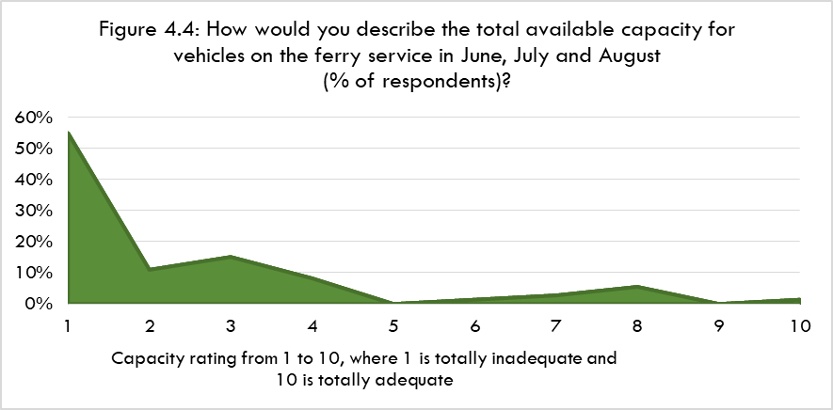
Figure 4.5 shows the responses regarding available vehicle capacity in April, May, September and October.

More than half (55%) of responses are between “1” and “5”, with more than one third between “1” and “3”.

Main Reasons Given For Ratings

Survey respondents’ main reasons given for the ratings for vehicle capacity are summarised below. They are accompanied by illustrative quotes from the survey responses.

- Pressure on capacity attributed to increased tourist traffic including a lengthening of the season

This is now stretching from the traditional holiday times to much of the year

Tourist travel and Hopscotch bookings make short notice ferry bookings more difficult

Locals are unable to get vehicle bookings on the ferry from May to early September due to the tourist traffic

- Sailings filling up quickly, booked up well in advance

Last two summers it has been a nightmare trying to get a booking weeks in advance

Demand is such that it is extremely difficult to get bookings

Tourists to the island have planned out their trips months in advance and are booking up the spaces.

- Camper vans/motorhomes taking up a large amount of deckspace

Due to tourist camper vans, travelling at short notice becomes impossible

Difficult to get a booking sometimes. Especially summer with campervans

- Inability to travel at short notice

My shift patterns change or I am needed to do extra hours and I cannot get booked on the ferry at the times or dates required. I have had to go the day before or had to stay longer than needed to, incurring extra accommodation costs and more time away from my family, croft and businesses

Often unable to book car so do not travel

If I have to travel at short notice, I am sometimes unable to travel as I haven’t booked.

Often I have to get lifts from people if I can’t book on, my work often means booking is last minute

If you have any last minute reason to travel (ill relative, medical appointments) or just want to go on the ferry for leisure reasons, there’s never any space on the ferry

- Attending health appointments

Health appointments can be at short notice and at a fixed time i.e. there is little flexibility to choosing alternative sailings
We as Islanders might get a hospital appointment a week before the appointment and you try book on the ferry and its fully booked for weeks

4.6.5 Primary Research Findings: Businesses

Responses

For the total available capacity for vehicles on the ferry service in June, July and August, more than 75% of businesses rated this either “1” or “2”. Most others rated it either “4” or “5”. Thus, the available capacity is generally viewed as very inadequate.

For April, May, September and October, most (54%) of the businesses rated capacity between “1” and “4”-that is, less than adequate.
Main Reasons Given For Ratings

The main reasons given for businesses’ ratings for vehicle capacity are summarised below. They are accompanied by illustrative quotes from the survey responses.

- Capacity issues due to high visitor demand

Can’t get bookings due to high number of tourists travelling

Due to the size and number of camper vans booked on in the summer months I find it increasingly difficult to book a vehicle slot

- Inability to travel at short notice

We're often required to be in Lewis at fairly short notice. Last summer we had to cancel one week’s work in Lewis because there was no capacity on the Sound of Barra ferry

Unable to book transport at short notice for vehicles carrying fish and shellfish

- Inability to travel at required/optimum times

The 1110 sailing always booked up leaving length of day too long

We can't visit sites and meet clients when we need to

- Ferries booked up well in advance

Guests can often neither move on from Barra or come to Barra as the ferry is often fully booked well ahead of the tourism season (Mid-April - end- September). We lose a substantial number of potential bookings from guests as they cannot get either ferry bookings

The potential for last minute room sales is irrelevant as ferries are full so customers cannot get to travel.

4.7 PRIMARY RESEARCH: VIEWS ON THE CURRENT TIMETABLE

4.7.1 Households

Ratings

Household survey respondents were asked to rate the arrival and departure times of sailings on the ferry service. The results are shown at Figure 4.6, over.

The numbers of respondents fell broadly evenly between ratings of:

- “1” “2” or “3”.
- “4” or “5”.
- “6” or above.

Thus, around two thirds of respondents consider the current timings to be less or no more than adequate.

Main Reasons Given For Ratings

- Timings do not allow connections with ferry services in other parts of the Outer Hebrides

Tie in the times to connect with the Castlebay to Oban ferry

Need a ferry to Eriskay after arrival of Oban ferry, likewise earlier ferry to allow Uist people to get the Oban ferry

Ferry timings do not integrate with the Lochmaddy ferry

- Length of time between the third and fourth sailings of the day

The gap in the middle of the day is really inconvenient

If you do not make the 1300 sailing back to Barra, you are then stuck there until 1635
I have sat many a time at Eriskay from 1pm until 1630 because I’ve just missed the ferry when I’ve come down from Berneray

- Operating day is too short

We rely on this service for the vets. We are left from 1830 to 0810 without any sailings

If I am doing a night shift I have to leave early to catch the ferry, also day shifts do not finish till 1915 so have to wait to next day to get ferry

Could do with much later final departure from Barra to facilitate day trips

This issue was also referred to by some consultees-in particular for business trips. The lack of later sailings is seen as leading to additional trips having to be made or an overnight stay to complete business the following day. However, high tourism demand in summer means that it is not always possible to get overnight accommodation in Barra. That means a further trip is required to complete all necessary business.

- Timings do not allow connections with Benbecula-Stornoway flights

Unable to get the Benbecula to Stornoway flight in the morning

A 6am start would get patients to connect with flights to Stornoway and not need overnight accommodation

A number of consultees argued for the times of the Sound of Barra ferry and Benbecula-Stornoway flights to allow connections to be made between the two services. This was seen as important for patients-some of whom are elderly-from Barra receiving treatment in Stornoway. In some cases this could reduce the number of nights away from home from two to one.

Other consultees also pointed to a lack of integration between the Sound of Barra and Sound of Harris timetables. This can affect, among others, business travellers and sports clubs leading to an extended time away-including overnight stays which incur accommodation costs.

- Dead time

Often you have to catch earlier ferries for medical appointments

Have had to spend more time than required in Uist as no early afternoon ferry

- Time can be tight to make desired sailing with risk that missing it will mean a long wait

Getting to and from medical appointments, especially when sailings are full, can be very tight

- Those who were positive about the current timetable

More than enough sailings and the timings are perfect

Generally very acceptable for my purposes

Importance of Retaining Existing Sailing Times

Household respondents were asked, if changes were made to the timetable, how important is it that the timings of the existing sailings are kept the same. Around one third considered this either very (13%) or quite (21%) important. However, higher numbers considered this either only slightly important (27%) or not at all important (31%).

The most commonly mentioned sailings to be retained were the:

  - First two (0700, 0925) sailings from Barra.
  - The last (1830) sailing from Eriskay.

These choices could, in part, reflect that more than half the household survey respondents were Barra residents.

4.7.2 Businesses

Ratings

Business survey respondents were asked to rate the arrival and departure times of the existing sailings. Around:

- 40% rated them either “4” or “5”.
- 30% rated them between “1” and “3”.
- 30% rated them “7” or above.

Main Reasons Given For Ratings

- Too much or too little time available at destination

If vet arrives for his visit the time between ferries is either too short or too long. As there is often only one vet on duty in Uist he cannot risk being away a full day in Barra for a two/ three hour visit.

Ideally I have to be on site for 8am so the early sailing from Barra doesn't arrive in time to reach sites in Benbecula, Grimsay or North Uist. If it left earlier I would use the ferry more often instead of staying over in Uist

Harris and Lochmaddy ferries do not always connect with Barra Ferry

- Gap in the sailing day

Long wait time between 1110 and 1545 departures

We need an extra return crossing in the middle of the day to provide extra capacity

The timetable doesn't work if we only have one site to visit. If we go over to Barra on the 1015 sailing we have to stay until 1545 so a whole day out of the office

Importance of Retaining Existing Sailing Times

Most (around two thirds) of the business respondents considered it not at all important that existing sailing times are retained. Almost all the others (c30%) thought this was quite important. Where specific sailings were mentioned these were spread across the timetable.

5 OPTIONS FOR TIMETABLE ENHANCEMENTS

5.1 INTRODUCTION

Three options have been assessed, having been agreed with the client group. They were tested in the online surveys of households and businesses. Two of the options (A and C) were identified in the Outer Hebrides STAG Appraisal.

Taken together the three options would provide an extended operating day. However, they had been assessed separately in this report. That is to allow assessment of the different impacts for each option. It also provided ease of understanding for survey respondents.

5.2 OPTIONS

5.2.1 Option A

Increase the number of sailings within the current operating day

On most days of the year the current timetable provides five return sailings between Barra and Eriskay Using the current vessel on the service, if extra crew were available then the number of return sailings could be increased from five to six during the operating day-that is, between 0700 and 1910. This would provide a 20% increase in capacity across the day and remove the current gap in the sailing day between the third and fourth sailings.

5.2.2 Option B

Provide an additional return sailing before the current start time of 0700

As well as allowing travel within the Outer Hebrides, the aim would be for these sailings to connect with mainland ferry sailings. For example, travellers from Uist accessing the Castlebay-Oban sailing or Barra residents using the first sailing from Lochmaddy on certain days. That would include when the mainland sailings from their own island are disrupted or withdrawn.

This would provide a 20% increase in capacity across the day. It would extend time ashore in both Barra and Uist by around two hours per day in both summer and winter.

5.2.3 Option C

Provide one or two later return sailings after the current end time of 1910

As well as allowing travel within the Outer Hebrides the aim would be for these later sailings to connect with mainland sailings. For example, on some days those arriving at Lochmaddy in the evening could travel on to Barra on the same day.

This option would provide either a 20% or 40% increase in capacity across the day compared to the current service. It would also extend time ashore in:

- Barra by either c2 hours (one extra sailing) or 3½ hours (two extra sailings).
- Uist by either 1 hour 40 minutes (one extra sailing) or 3 hours 20 minutes (two extra sailings).
6 TRAFFIC FORECASTS

Summary

- There is a considerable degree of estimation in the forecasts. That reflects, in particular, the mismatch between the desk-based capacity utilisation analysis and our primary research with users and the bookings data.
- Our approach has been to consider the available information in the round rather than mechanistically applying figures from various parts of the research.
- The forecasts are for cars and their accompanying passengers. They include both resident and visitor traffic. CVs and coaches have not been included because they can be expected to have much lower levels of frustrated demand than car traffic.
- Across a full year it is estimated that the annual uplift in traffic based on 2019 levels could be:
* Option A Passengers 7%, Cars 8%.
* Option B Passengers 2%, Cars 3%.
* Option C Passengers 3%, Cars 4%.
- Around half the generated traffic would occur in June, July and August, one third during the rest of the summer timetable, and one sixth in the winter timetable.
- The forecasts imply a large total increase in carryings if all three options were introduced. However, it could well be that this would not produce the full uplift in traffic shown. That is because each option has been assessed individually. Some people may undertake a new trip under Option A and under Option C when these are presented individually. Yet, they would only undertake one or the other of the trips if both options were introduced.

6.1 INTRODUCTION

This Chapter sets out our traffic forecasts. These are, first, for unconstrained demand on the basis that vessel capacity is unlimited. Second, for each of the three options considered in this study where a set number of additional sailings are provided by the vessels that currently serve the route.

There is a considerable degree of estimation in the forecasts. In particular, this is because as noted at Chapter 4 the capacity utilisation figures for the current service appear to understate the amount of frustrated demand. That is particularly so in light of the greater extent of capacity constraints implied by:

- Our primary research with households, businesses and consultees.
- To a lesser extent, the profile of bookings.

Put simply, the primary research and booking data point to greater capacity constraints than the utilisation figures suggest.

Therefore, we have adopted the approach used in our previous traffic forecasts for CalMac services. That is, the forecasts are based on estimation and professional judgement taking the evidence as a whole rather than attempting to mechanistically apply specific data from the capacity utilisation analysis, household surveys, etc.
6.2 EVIDENCE BASE

The key findings from the ferry traffic analysis at Chapter 4 were:

- Strong growth in passenger and car traffic between 2017 and 2019 (very largely in summer timetable), plus a rebound in later summer traffic in 2021 as pandemic restrictions eased.
- The reduction in CVs between 2019 and 2021 will, to some extent, have reduced capacity constraints. It is also expected that coaches will remain only a very small share of the vehicles using the service.
- Primary research with users suggests limited capacity in the summer months and notably in June, July and August.
- This particularly affects resident household and business travellers as they tend to book less far in advance than visitors. The primary research indicates having to travel at a different day than required or, in some cases, no trip being made at all due to the lack of capacity to meet demand.
- Overall there is an imbalance of demand between individual sailings, days of the week and months of the year-rather than demand being evenly spread.
- Vehicles classified as “cars” account for the vast majority of the vehicle deckspace that is occupied.
- It is estimated that business travel could account for around 40% of Outer Hebrides residents’ trips on the service.
- It is estimated that, across the year, the split of car traffic is broadly even between Outer Hebrides residents and visitors. However, the latter have a higher car occupancy level.

6.3 APPROACH

The figures shown are the increase in carryings from 2019 levels (i.e. generated traffic). They do not include any underlying traffic growth between 2019 and the year when an option would be introduced.

The forecasts are for changes in vehicles classified as cars in 2019 and their accompanying passengers.

This reflects, first, the expectation that very many coaches and most CVs will have booked relatively far in advance. Short notice CV trips may not be able to be made on the desired sailing due to it being fully booked. However, our experience is that they are then largely made at other times. Thus, capacity constraints do not result in a significant suppression of CV demand.

Second, the survey evidence indicates that foot passengers are a very small proportion of overall passenger carryings-and will generally not be affected by vehicle capacity constraints.

The forecasts assume that each of the three options’ new sailings operate all year round. They include car and passenger numbers in three time periods-i.e. June, July and August, rest of the summer timetable, winter timetable.

The split of generated traffic between visitors and resident car trips is estimated as 50:50 during the summer timetable, and 90:10 in favour of residents during the winter timetable. However, as noted at Chapter 4, visitor cars have a higher number of passengers than residents. In turn, residents’ cars making a non-business trip have a higher occupancy than those making business trips.

Our experience is that frustrated visitor demand tends to be less apparent than for residents. It is generally a significant part of the traffic increase when west coast ferry services’ frequency is increased.

That is despite visitors generally booking earlier than residents. However, as shown at Chapter 4, businesses provided evidence of frustrated visitor demand under the current timetable.

6.4 ESTIMATES OF UNCONSTRAINED DEMAND

Even with the additional sailings that would be provided under each option there would still be times when the increased capacity would not be able to meet all car demand. That is because demand would still, to an extent, be spread unevenly across individual sailings, days of the week and months of the year-while the capacity of the vessels on the route is fixed.

The following three Tables show our estimates of unconstrained demand under each of the three options. That is, on the basis that vessel capacity is unlimited. As explained at 6.3 the forecasts are for the number of vehicles classified as cars in 2019 and their accompanying passengers.

TABLE 6.1: OPTION A: ESTIMATED TOTAL UNCONSTRAINED DEMAND
 | Existing (2019) |  | Estimated Total Unconstrained Demand
Period | Pax | Cars | Pax* | Cars
Jun-Jul-Aug | 28,376 | 9,845 | 33,154 | 12,085
Rest of Summer | 23,701 | 9,325 | 25,789 | 10,305
Winter | 11,599 | 6,151 | 12,343 | 6,582
Annual | 63,676 | 25,321 | 71,285 | 28,972
*Compared to all current passengers-i.e. including those accompanying CVs and coaches, and foot passengers

TABLE 6.2: OPTION B: ESTIMATED TOTAL UNCONSTRAINED DEMAND
 | Existing (2019) |  | Estimated Total Unconstrained Demand
Period | Pax | Cars | Pax* | Cars
Jun-Jul-Aug | 28,376 | 9,845 | 34,587 | 12,757
Rest of Summer | 23,701 | 9,325 | 26,415 | 10,599
Winter | 11,599 | 6,151 | 12,566 | 6,711
Annual | 63,676 | 25,321 | 73,568 | 30,067
*Compared to all current passengers-i.e. including those accompanying CVs and coaches, and foot passengers

TABLE 6.3: OPTION C: ESTIMATED TOTAL UNCONSTRAINED DEMAND
 | Existing (2019) |  | Estimated Total Unconstrained Demand
Period | Pax | Cars | Pax* | Cars
Jun-Jul-Aug | 28,376 | 9,845 | 34,109 | 12,533
Rest of Summer | 23,701 | 9,325 | 26,206 | 10,501
Winter | 11,599 | 6,151 | 12,492 | 6,668
Annual | 63,676 | 25,321 | 72,807 | 29,702
*Compared to all current passengers-i.e. including those accompanying CVs and coaches, and foot passengers

The figures for Options B and C are higher than for Option A. That is because they are less able to satisfy currently unmet demand because they are at times of day that are less attractive to users than the additional sailing during the working day under Option A.

6.5 TRAFFIC FORECASTS: OPTION A

Option A would increase the number of return sailings within the operating day from five to six between 0700 and 1910. This would provide a 19% increase in daily deckspace capacity throughout the year. It would also reduce the headway between the third and fourth sailings to around two hours.

Around two thirds (68%) of household survey respondents-and half of businesses-stated that they would make more trips on the Sound of Barra ferry service under Option A.

This confirms the potential for generating additional trips. However, it is generally accepted that survey respondents tend to overestimate the number of new trips they will make as a result of an enhanced transport service.

Table 6.4 sets out the forecast of generated traffic for Option A.

TABLE 6.4: OPTION A: GENERATED TRAFFIC
 | Existing (2019) |  | Estimated Generated Traffic |  | Increase
Period | Pax | Cars | Pax | Cars | Pax* | Cars
Jun-Jul-Aug | 28,376 | 9,845 | 2,730 | 1,280 | 10% | 13%
Rest of Summer | 23,701 | 9,325 | 1,193 | 560 | 5% | 6%
Winter | 11,599 | 6,151 | 425 | 246 | 4% | 4%
Annual | 63,676 | 25,321 | 4,348 | 2,085 | 7% | 8%
*Compared to all current passengers-i.e. including those accompanying CVs and coaches, and foot passengers

The forecast uplift is an annual increase of 8% for cars and 7% for passengers. As would be expected most of this occurs in the three midsummer months when visitor numbers peak as do capacity constraints on the ferry service.
6.6 TRAFFIC FORECASTS: OPTION B

Option B would provide an additional return sailing before the current start time of 0700. As well as allowing travel within the Outer Hebrides the aim would be for these extra sailings to connect with mainland ferry sailings.

More than half (56%) of household survey respondents-and around half of businesses-stated that they would make more trips on the Sound of Barra ferry service under Option B.

Table 6.5 shows the forecast of generated traffic for Option B. The total increase in annual traffic is around 2-3%. It is spread more evenly across the year than in Option A.

TABLE 6.5: OPTION B: GENERATED TRAFFIC
 | Existing (2019) |  | Estimated Generated Traffic |  | Increase
Period | Pax | Cars | Pax | Cars | Pax* | Cars
Jun-Jul-Aug | 28,376 | 9,845 | 693 | 325 | 2% | 3%
Rest of Summer | 23,701 | 9,325 | 448 | 210 | 2% | 2%
Winter | 11,599 | 6,151 | 302 | 175 | 3% | 3%
Annual | 63,676 | 25,321 | 1,443 | 710 | 2% | 3%
*Compared to all current passengers-i.e. including those accompanying CVs and coaches, and foot passengers

6.7 TRAFFIC FORECASTS: OPTION C

Option C would provide one or two later return sailings after the current end time of 1910. The following forecast is based on two return sailings. As well as allowing travel within the Outer Hebrides the aim would be for these sailings to connect with mainland sailings.

Around two thirds of household survey respondents-and around half of businesses-stated that they would make more trips on the Sound of Barra ferry service under Option C.

Table 6.6 presents the forecast of generated traffic for Option C.

TABLE 6.6: OPTION C: GENERATED TRAFFIC
 | Existing (2019) |  | Estimated Generated Traffic |  | Increase
Period | Pax | Cars | Pax | Cars | Pax* | Cars
Jun-Jul-Aug | 28,376 | 9,845 | 853 | 400 | 3% | 4%
Rest of Summer | 23,701 | 9,325 | 693 | 325 | 3% | 3%
Winter | 11,599 | 6,151 | 518 | 300 | 4% | 5%
Annual | 63,676 | 25,321 | 2,065 | 1,025 | 3% | 4%
*Compared to all current passengers-i.e. including those accompanying CVs and coaches, and foot passengers

The increase across the year is around 3-4%.

6.8 ALL THREE OPTIONS: COMBINED ESTIMATES

Table 6.7 combines the estimates for the three options.

TABLE 6.7: ANNUAL TOTAL GENERATED TRAFFIC: OPTIONS COMBINED
 | Estimated Generated Traffic |  | Increase
Option | Pax | Cars | Pax* | Cars
A | 4,348 | 2,086 | 7% | 8%
B | 1,443 | 710 | 2% | 3%
C | 2,065 | 1,025 | 3% | 4%
Total | 7,856 | 3,821 | 12% | 15%
*Compared to all current passengers-i.e. including those accompanying CVs and coaches, and foot passengers

It shows that there could be an increase of 12% in passengers and 15% in cars if all three options were introduced. That is, if the number of sailings per day rose from five to nine (except on winter Sundays).

It could well be that introducing all three options would not produce the full uplift in traffic shown at Table 6.7. That is because each option has been assessed individually. Some people may undertake a new trip under Option A and under Option C when these are presented individually. Yet, they would only undertake one or the other of those trips if both options were introduced.

Broadly, around half the generated traffic would occur in June, July and August, one third during the rest of the summer timetable, and one sixth in the winter timetable.

The household survey asked if one or more of the timetable options was to be introduced, when the additional sailings should operate. Most respondents said either:

- All year round: 44%; or
- During the summer timetable: 41%.

The business survey showed a similar result.

7 THE CASE FOR TIMETABLE ENHANCEMENTS

Summary

- The strategic case for the enhancements is based around:
* ferry service provision supporting the Outer Hebrides as a single entity in administrative, public services, economic and social terms.
* the distances and quality of roads between its main settlements.
* the need to raise productivity among businesses, third sector organisations and the public sector.
* the relatively high cost of living.
* meeting household, business and visitor travel needs-sufficient capacity, greater day trip opportunities, ability to travel at short notice, and access to mainland and inter-island transport services.
* increased ferry capacity, frequency and better timings making the Outer Hebrides a more attractive location and supporting efforts towards a more balanced demographic.
- Each option has been assessed through a mix of qualitative and quantitative measures, recognising that not all impacts can be quantified in monetary terms.
- The quantitative measures relate to tourism impacts, business productivity, and cost savings to businesses and households.
- Across the three options as whole the annual impacts that are capable of being quantified are around £540,000 of output, £320,000 of GVA and £90,000 of household benefit (i.e. cost savings). Option A accounts for most of these impacts.

7.1 INTRODUCTION

This Chapter sets out the case for timetable enhancements on the Sound of Barra service. It comprises:

- The strategic case for the enhancements.
- An assessment of each of the three options-both qualitative, and quantified where possible. This draws on a range of information including the household and business surveys.
- A summary of the total quantified impacts for the three options.

7.2 STRATEGIC CASE

The Outer Hebrides is a series of islands separated by water-notably between Barra and Uist, and between Lewis/Harris and the Southern Isles. The Outer Hebrides is a single entity for:

- Key economic activities-notably the supply of goods and services from Stornoway to businesses and consumers in the rest of the islands, and from Uist to Barra.
- Public administration, with many organisations having staff distributed across the islands.
- Health services provided by NHS Western Isles. Barra residents travel for appointments in Uist and in Stornoway.
The Sound of Barra service is a barrier to the integration of the islands. That is because the ferry service adds time to the journey. That is both time spent on the crossing and because the ferry operates to a fixed timetable (unlike a tunnel or a causeway).

This is in a context of the road lengths between main settlements in Uist and Lewis/Harris, with journey times elongated due to the road quality.

The Outer Hebrides economy faces the challenge of low productivity, reflected in its relatively low wages. For some areas and businesses this is partly due to internal ferry services which add time to journeys (including gaps in the timetable during the operating day) and a lack sailings in the early morning and later evening. This can involve increased costs and time-e.g. having to make unwanted overnight stays. That is in a context of the relatively high cost of living in the Outer Hebrides.

At times the sailings have insufficient capacity to meet vehicle demand. This means that some trips are delayed, shortened or not made at all.

Ferry sailing times and capacity constraints also reduce the ability to make day trips. They also constrain short notice trips-e.g. business appointments, personal/family emergencies.

All these factors affect the various types of trips that are made using the Sound of Barra service. These include:

- For residents, health travel in particular, plus other trip types such as VFR and participating in inter-island sports competitions and other events.
- A significant amount of business travel by the public, private and third sectors.
- Tourism, an important and growing part of the economy.
- Accessing air and ferry services in other parts of the Outer Hebrides, including when one’s own island’s services are not available due to weather or withdrawal.

Increased ferry capacity, sailing frequency and better timings can support each of the above elements.

In so doing, this will make the islands a more attractive place to live, work, visit and invest. It will help attract/retain the key group of working age people, including those with families.

7.3 OPTION ASSESSMENT

7.3.1 Scope

Each option assessment includes a mix of qualitative and quantitative analysis. It should be recognised that only some impacts can be quantified. That is because of a lack of information or absence of values that can be used.

Accordingly, we have focussed on impacts that can be measured and which relate most closely to the intended outcomes of the options. Thus, the figures presented are partial ones. They do not encompass all the potential economic impacts of an option.

7.3.2 Quantitative Measures Used

The following impacts have been assessed at the level of the Outer Hebrides economy:

- Tourism-impacts of increased visitor numbers and activity-output and Gross Value Added (GVA).
- Conversion of business waiting time into productive time-output and GVA.
- Reduction in business overnight stay costs-GVA.
- Reduction in household overnight stay costs-financial value of reduction (“household benefit”).

7.4 APPROACH TO VALUATION OF IMPACTS

7.4.1 Tourism

The traffic forecasts produced estimates of generated visitor trips on the Sound of Barra service.

These were converted into absolute visitor numbers. That was by applying the estimated split of visitor trips on the service that are one way (25%) with the remaining visitor trips (75%) being a return trip (as noted at Chapter 4).

Based on our knowledge of the Outer Hebrides visitor market we estimated the amount of additional activity the generated visitor trips might produce. The factors used are set out at Table 7.1.

TABLE 7.1: TOURISM IMPACTS: ADDITIONALITY FACTORS FOR GENERATED TRIPS
Ferry Use Type/Additionality | Deadweight/  Displacement | An Additional Day Spent In the Outer Hebrides | Wholly Additional Trip to the Outer Hebrides
One Way | 20% | 30% | 50%
Day Return | 45% | 35% | 20%

It is assumed that 20% of those making through trips (one way) on the ferry do not spend any more time and money in the Outer Hebrides as a result of now being able to travel on the Sound of Barra service. For example, they may have spent a holiday in another area of the Outer Hebrides-e.g. Harris.

A further 30% of visitors stay an additional day in the Outer Hebrides as a result of now making a trip on the ferry service. Finally, the remainder (50%) would not have made a trip to the Outer Hebrides if they had not been able to use the Sound of Barra ferry service so their spend in the islands is wholly additional.

The same process was applied to visitors who would now make a day return trip on the Sound of Barra service.

Visitor expenditures were based on data from the 2017 Outer Hebrides Visitor Survey, expressed in 2022 prices. The expenditures per head are estimated as:

- An additional day spent in the Outer Hebrides: £57.
- Wholly additional trip to the Outer Hebrides: £349.

The visitor expenditure total was converted into output by, first, deducting VAT on the visitor spend. Output was then converted into GVA by applying the ratio between the two measures from the 2019 Annual Business Survey data for the Outer Hebrides.

Note that output and GVA are two different measures of economic activity. Therefore, they should not be added together.

Finally, indirect and induced impacts were included in both output and GVA. That was by applying multipliers based on our experience in undertaking tourism impact studies in the Outer Hebrides:

- Output: 1.24.
- GVA: 1.27.

7.4.2 Conversion of Business Waiting Time Into Productive Time and Increased Output

This applies to Option A only.

The inclusion of an additional sailing within the current operating day will reduce the waiting time between the third and fourth sailing by slightly over two hours. Some businesses are expected to switch to the earlier sailings so they can return to their business earlier; or, for example, make additional customer visits on their return leg.

The time has been valued at £15 per hour. That broadly reflects average wages in the Outer Hebrides and information provided by business consultees for our research.
Based on our consultations and the business survey we estimate that 75% of businesses who divert to the new sailings will use the time saved productively and thus increase their business output.

In addition to the impacts of diverted business trips we also included those of generated ones. As a proxy for the latter we took half of the value of a diverted trip (as per the “rule of half” in transport appraisal).

The total impact was calculated by, first, multiplying the total hours that are now productive by the £15 per hour wage rate. That was converted into output and GVA using 2019 Annual Business Survey data for the Outer Hebrides.

Some of this additional output is likely to be displaced from other Outer Hebrides businesses. Therefore, the impacts were reduced by 30%. That figure is based on a combination of:

- Business survey responses.
- Our own knowledge of the Outer Hebrides economy.
- The fact that some of the benefits will accrue to public sector organisations that do not have competitors in the islands.

Finally, indirect and induced impacts were included by applying the following multipliers:

- Output: 1.20.
- GVA: 1.33.

7.4.3 Reduction in Business Overnight Stay Costs

From our consultations the average cost for a business person to stay overnight in accommodation in the Southern Isles is estimated as £70 (net of VAT).

Earlier or later sailings than at present (part of Option B and of Option C) means this cost can be avoided. That is because business travellers would not need to travel the previous evening to begin work elsewhere at the required time, or to stay overnight away from home after finishing business. However, this could very likely apply only in one direction of a return trip and this is reflected in the calculation.

It is estimated that 75% of the business people would otherwise have had to pay for overnight accommodation to make the trip in the absence of the additional early (Option B) or later (Option C) sailings.

Again, in addition to the impacts of diverted business trips we also included those of generated ones. As a proxy for the value of the latter we took half of the value of a diverted trip-as per the “rule of half” in transport appraisal.

The avoidance of some overnight stays reduces a business’s “bottom line” operating cost which in turn increases its GVA. However, as it is a cost saving rather than an increase in output no multipliers are applied to the amount saved.

7.4.4 Reduction in Household Overnight Stay Costs

This calculation uses the same approach as for business overnight stay costs (as described at 7.4.3). As the trips are not business-related then the impact is simply treated as a saving to the household.

7.5 OPTION A: SUMMARY ASSESSMENT

7.5.1 Households

Strategic

  - Greater ability to undertake trips at short notice and day trips, including health appointments.
  - Improved opportunities for accessing air and ferry services in other parts of the Outer Hebrides.
  - Extra deckspace capacity to support VFR trips.

Main Expected Purposes of Generated Trips

VFR, Leisure/entertainment, Shopping, Business.

Identified Wider Benefits

- Ability to make better timed trips, including health appointments.
- Accessing ferry services in other parts of the Outer Hebrides.

Potential Negative Impacts

12% of household respondents referred to potential negative impacts:

- Increased financial cost to CalMac of operating additional sailings.
- Additional use of the vessel could make the service less resilient.
- Increased tourist traffic placing further strain on island infrastructure.

7.5.2 Business/Economy

Strategic

- Improved business productivity by reducing sailing headways.
- Support tourism growth and dispersal of activity.
- Increased capacity during the working day to meet vehicle demand.
- Allow more short notice business trips-including day trips.
- Improve opportunities for accessing air and ferry services in other parts of the Outer Hebrides-and thus provide better access to markets outside the islands.

Main Expected Purposes of Generated Trips

General business trips, sourcing supplies.

Business Impacts

The vast majority of businesses expect positive impacts.

More than half expect the changes in their business performance to be “significant”.

Main business effects expected to be:

- Improved access to/for customers.
- Increased staff productivity by removing dead time waiting for sailings.
- Increased collaboration with other Outer Hebrides businesses/organisations.

Impacts are expected to be mostly increased sales (reported by most businesses), but also reduced costs and increased employment.

7.5.3 Quantified Economic Impacts

Table 7.2 shows the economic impacts that have been quantified for Option A.

TABLE 7.2: OPTION A: QUANTIFIED IMPACTS (£000)
Impact | Output | GVA
Tourism from generated trips: One Way: 623, Day Trips: 935 | 204 | 90
Productive Time Leading To Increased Business Output: from 535 generated and 1,896 diverted trips | 193 | 92
Totals | 397 | 182

7.6 OPTION B: SUMMARY ASSESSMENT

7.6.1 Households

Strategic

- Facilitate more day trips, reducing unwanted overnight stays.
- Extending opportunities to use air and ferry services elsewhere in the Outer Hebrides.

Main Expected Purposes of Generated Trips

Leisure/entertainment, VFR, Shopping.

Identified Wider Benefits

- Better connectivity, travel flexibility and travel options.
- Better timed trips.
- Supporting business, VFR and health trips.

Suitability of Sailing Times

More than half of households said they would now be able to make trips at times that are more suitable than the present ones.

Use of Outer Hebrides-Mainland Ferry Services

Some 40% of households expect to make more ferry trips to/from the mainland under Option B.

Potential Negative Impacts

Some 25% of households foresee potential negative impacts from Option B. The main ones are:

- Could lead to a reduction in the number of sailings on the Castlebay-Oban service.
- An earlier start to the Sound of Barra timetable could lead to earlier last sailings of the day.
- Longer crew hours having to be worked.
- The financial cost to CalMac of providing additional sailings.

7.6.2 Business/Economy

Strategic

- Improved business productivity by reducing sailing headways.
- Offering some support for tourism growth and dispersal of activity.
- Facilitating business day trips, avoiding unwanted overnight stays.
- Extending opportunities to use air and ferry services elsewhere in the Outer Hebrides.
Main Expected Purposes of Generated Trips

General business trips, increase in providing services to customers.

Business Impacts

Around half of businesses stated that Option B would result in positive impacts for their business.

More than half expected the changes in their business performance to be either “significant” or “very significant”.

More than half said they would now be able to make trips at times that are more suitable than the present ones.

Around one fifth expect to make more ferry trips to/from the mainland under Option B.

The main business effects of Option B are expected to be:

  - Improved access to/for customers.
  - Increased productivity through staff not having to make unwanted overnight stays.
  - Increased staff productivity through removal/reduction in dead time waiting for the next sailing.

The main impacts on business performance were seen as, broadly equally, increased sales, reduced costs and increased employment.

Potential Negative Impacts

A small number of businesses referred to having to provide services to customers at very early hours of the day; and expected unwillingness of tourists to use very early sailings.

7.6.3 Quantified Impacts

Table 7.3 shows the economic impacts that have quantified for Option B.

TABLE 7.3: OPTION B: QUANTIFIED IMPACTS (£000)
Impact | Output | GVA | Household Benefit
Tourism from generated trips: One Way: 188, Day Trips: 282 | 62 | 27 | 0
Saving on overnight costs-business: generated trips: 127, diverted trips: 834 | 0 | 24 | 0
Saving on overnight costs-household: generated trips: 362, diverted trips: 1,406 | 0 | 0 | 32
Total | 62 | 51 | 32

7.7 OPTION C: SUMMARY ASSESSMENT

7.7.1 Households

Strategic

- Facilitating more day trips, reducing unwanted overnight stays.
- Extending opportunities to use air and ferry services elsewhere in the Outer Hebrides.

Main Expected Purposes of Generated Trips

Leisure/Entertainment, VFR and Shopping.

Identified Wider Benefits

- Better connectivity, travel flexibility and travel options.
- Better timed trips.
- Supporting VFR trips.
- Supporting health-related trips by Barra residents.

Suitability of Sailing Times

More than half of households said they would now be able to make trips at times that are more suitable than the present ones.

Use of Outer Hebrides-Mainland Ferry Services

Around 40% expect to make more ferry trips to/from the mainland under Option C.

Potential Negative Impacts

Around one in six respondents foresee potential negative impacts. These were mostly concerns that there would be a threat to/reduction in the number of sailings on the Lochboisdale and/or Castlebay services.

7.7.2 Business/Economy

Strategic

- Improving business productivity by reducing sailing headways.
- Offering some support for tourism growth and dispersal of activity.
- Facilitating business day trips, avoiding unwanted overnight stays.
- Extending opportunities to use air and ferry services elsewhere in the Outer Hebrides.

Main Expected Purposes of Generated Trips

General business, movement of goods.

Business Impacts

Around half of the businesses stated that Option C would result in positive impacts for their business.

Around half expected the changes in their business performance to be “significant”.

More than half said they would now be able to make trips at times that are more suitable than the present ones.

Around one fifth expect to make more ferry trips to/from the mainland under Option B.

The most commonly identified effects were:

  - Improved access to/for customers.
- Increased staff productivity through removal/reduction in dead time waiting for the next sailing.
- Increased productivity through staff not having to make unwanted overnight stays.

The main impacts on business performance were seen as, broadly equally, increased sales (reported by most businesses), reduced costs and increased employment.

Potential Negative Impacts

Around one in four businesses see potential negative impacts from the increase in the number of sailings. These related to:

- Concerns that the current timetable’s first sailings of the day would be discontinued.
- Managing their customers at the time of day when the sailings would operate.
- More sailings leading to more vessel breakdowns.

7.7.3 Quantified Impacts

Table 7.4 shows the economic impacts that have been quantified for Option C.

TABLE 7.4: OPTION C: QUANTIFIED IMPACTS (£000)
Impact | Output | GVA | Household Benefit
Tourism from generated trips: One Way: 259, Day Trips 389 | 85 | 46 | 0
Saving on overnight costs-business: generated trips 282: diverted trips: 1,525 | 0 | 44 | 0
Saving on overnight costs-household: generated trips 772: diverted trips: 2,710 | 0 | 0 | 62
Total | 85 | 90 | 62

7.8 QUANTIFIED IMPACTS: COMBINATION OF OPTIONS

Table 7.5 brings together the impacts that have been quantified for the three options.

TABLE 7.5: QUANTIFIED IMPACTS OF THE THREE OPTIONS (£000)
Option | Output | GVA | Household Benefit
A | 397 | 182 | 0
B | 62 | 51 | 32
C | 85 | 90 | 62
Total | 544 | 323 | 94

It shows a total of around £540,000 of output, £320,000 of GVA and £90,000 of household benefit (i.e. cost savings). Option A accounts for most of the impacts.

We reiterate that these results reflect only the impacts that can be quantified. They do not include other significant benefits-e.g. increased sales by non-tourism businesses.

8 CONCLUSIONS

The case for the timetable enhancements is evident in the traffic forecasts indicating potential for significant increase in demand for use of the Sound of Barra service. In addition, some existing trips could now be made at more suitable times, saving both time and costs for personal and business travel.

Second, the strategic case is strong. The options collectively address the main issues for improving the economy and quality of life for residents-including access to health appointments. That is by more fully meeting household, business and visitor travel needs. That would be though providing increased capacity, greater day trip opportunities, enhanced ability to travel at short notice, and improved access to mainland and inter-island transport services.

Third, we have quantified a range of impacts in monetary terms. The results reflect not only potential generated demand on the ferry. They also reflect the assumptions that underpin the calculations. For example, how far the generated visitor trips on the Sound of Barra service would lead to new spend in the Outer Hebrides rather than simply distributing existing expenditures more widely across the islands.

It is recognised that some of the business benefits of enhanced timetables cannot be quantified. In particular, the business survey and our consultations highlighted the significance of improved timetables in providing better access to customers (potentially leading to new sales); and also more opportunities to collaborate with other Outer Hebrides businesses-which would help to increase productivity.

An issue raised by consultees and in our surveys was greater integration of the timings of the two Sounds services. However, each route has its own dynamic requiring sailings at certain times. Co-ordinating timings between the two routes could have significant negative impacts on some existing trips made by households and businesses. However, in itself an increased number of sailings-including ones at new times of the day-will still offer greater opportunities for more efficient journeys between Barra and Lewis/Harris.

A Minimum Income Standard For Remote Rural Scotland: A Policy Update (Centre for Research in Social Policy, Loughborough University October 2016)

