Sound of Harris Ferry Service:
Socio-Economic Case for Timetable Enhancements

Final Report

to







by



January 2023
CONTENTS

Executive Summary i

1 Introduction 1

2 Socio-Economic Profiles 3

3 Ferry Timetables 17

4 Ferry Traffic Analysis 21

5 Options for Timetable Enhancements 42

6 Traffic Forecasts 44

7 The Case for Timetable Enhancements 48

8 Conclusions 56

EXECUTIVE SUMMARY

Introduction

The objective of the research was to produce an assessment of the socio-economic impacts of timetable enhancements on the Sound of Harris ferry service.

The research included:

- Review of a previous study of Outer Hebrides ferry services.
- Consultations with representatives of a range of organisations.
- Desk-based research into the economies and populations of Uist, Harris and Lewis, and data on ferry carryings and bookings.
- Surveys of households, businesses and other organisations.

Socio-Economic Profiles

Uist has a small economy. The Qinetiq range as well as tourism and fishing and aquaculture are major employers.

The population of Uist is small and has been in decline. It is relatively old and aging at a faster rate than in the Highlands and Islands and Scotland

Harris has a small economy and a limited employment base. Three industries are responsible for more than half of total employment. Tourism is a major employer, with other specialisations include Fishing and aquaculture and Manufacture of beverages.

Harris has a small population which has been in decline. It is relatively old and aging at a faster rate than the Highlands and Islands and Scotland.

Wage levels in many sectors in both Uist and Harris are likely to be lower than the Outer Hebrides average which in turn is below the Scottish average. That is in a context of a relatively high cost of living. The challenges facing the two islands are evident in both being HIE-designated Fragile Areas.

Lewis has a much larger economy and population than either Uist or Harris. Stornoway is a centre for services and goods for the rest of the islands.

There is a concentration of employment in a small number of industries-notably public sector and care. Specialisations include Manufacture of food products, parts of the construction sector and Manufacture of textiles. Tourism is a much smaller part of the economy than elsewhere in the Outer Hebrides.

Wage levels are likely to be higher than the Outer Hebrides average. However, that is in a context of a relatively high cost of living.

Lewis’s population accounts for more than 70% of the Outer Hebrides’ total. However, it has fallen in number in recent years. The population is relatively old and there has been a decline in most age groups.

Ferry Timetables

The crossing time on the Sound of Harris service is one hour.

The service is limited to the hours of daylight. This constrains the length of operating day-and particularly so in the winter.

The timetable is also restricted by the tides. On many days of the year there are potential alterations to sailing times due to tidal conditions.

For most of the summer timetable either four or five return sailings per day are provided, Monday-Saturday. A lower frequency (three per day) operates on Sundays.

Monday-Saturday first sailings are mostly ex Berneray 0700 and ex Leverburgh 0815, last sailings are ex Berneray 1720 and ex Leverburgh 1815. The gap between departures varies between 2½ hours and 5 hours.

The winter timetable has a lot fewer sailings and a very limited length of operation. Most of the time there are two return sailings per day, with the service starting at 0815 and ending at 1540.

In general, Sound of Harris sailings do not connect to those on the Sound of Barra without requiring quite long waits.

The terminal at Berneray is 33 miles from Balivanich which is the largest settlement in Uist. It is also 59 miles from the terminal for the Sound of Barra ferry service. That has an estimated drive time of between 1¼ and 1¾ hours depending on familiarity with the road. The terminal at Leverburgh (Harris) is a 56 miles drive from Stornoway.

Ferry Traffic Analysis

In 2019 (pre-pandemic) the ferry service carried around 76,000 passengers, 32,000 cars, 1,300 Commercial Vehicles (CVs) and 170 coaches.

In summer 2021 on the days when a fifth sailing operated these were well utilised by cars.

Passenger and car traffic is heavily concentrated in the main summer months. 85% of annual passengers and almost 80% of annual cars travel during the summer timetable.

Summer passenger and car carryings on sailings from Uist are higher than on the sailings from Harris. This appears to reflect visitors arriving in Barra and then using the service to travel onwards to other islands in the Outer Hebrides.

Passengers and cars are spread broadly evenly across most of the days of the week. However, demand is spread less evenly across the ex Berneray sailings than across those ex Leverburgh. Sailings with the highest number of CVs tend to be at times when car demand is lower.

Overall, there is a pattern of traffic imbalances which result in capacity constraints-particularly for the most popular sailings.

Residents use the service for a variety of trip types, including VFR and health appointments. Business travel is a significant part of non-visitor demand.

A high percentage of households and businesses always book a vehicle space on the ferry in advance-at all times of the year. Most households book at quite short notice-i.e. up to two weeks in advance. However, businesses book earlier than this-especially in the midsummer months. Visitors tend to book much further ahead although some look to book quite late.

If a desired sailing is fully booked more than half of residents and businesses either have to travel on another day or do not travel at all.

Estimated vehicle capacity utilisation shows very few sailings at 100% or more utilisation (1% of all sailings) or 90%+utilisation (5%). These are much fewer than would be expected given the number of sailings becoming fully booked in advance and users’ views of available capacity on the service. That is especially in June, July and August-when capacity is viewed as very inadequate.

Survey respondents’ views on the main effects of inadequate capacity include inability to travel at short notice or optimum times and some visitors being unable to get bookings.

Most households and more than half of businesses consider the current summer sailing times to be adequate or very adequate.

More than half of the households rate the winter sailing times as somewhat inadequate. More than half of businesses rate them as totally or very inadequate. Survey respondents’ views on the main effects of this include an inability to make a day trip.

Options for Timetable Enhancements

Option A: Increase the number of return sailings in the summer timetable

From the current four or five per day, Monday-Saturday, to up to eight sailings with longer hours of operation-within available daylight hours.

Option B: Increase the number of return sailings in the winter timetable

From the current 2 or 3 per day, Monday-Saturday, to four per day.

Traffic Forecasts

There is a considerable degree of estimation in the traffic forecasts. That reflects, in particular, the mismatch between the desk-based capacity utilisation analysis and our primary research with users and the bookings data.

The forecasts are for cars and their accompanying passengers. They include both resident and visitor traffic. CVs and coaches have not been included because they can be expected to have much lower levels of frustrated demand than car traffic.

Across a full year it is estimated that the annual uplift in traffic (i.e. generated traffic) based on 2019 levels could be:

- Option A Passengers 10%, Cars 11%.
- Option B Passengers 2%, Cars 2%.

In addition, some existing trips would now move to more suitable travel times.

The Case for Timetable Enhancements

The strategic case for the enhancements is based around:

- Ferry service provision supporting the Outer Hebrides as a single entity in administrative, public services, economic and social terms.
- The distances and quality of roads between its main settlements.
- The need to raise productivity.
- Relatively high cost of living.
- Meeting household, business and visitor travel needs-sufficient capacity, greater day trip opportunities, ability to travel at short notice, and access to mainland and inter-island transport services.
- Increased ferry capacity, frequency and better timings making the Outer Hebrides a more attractive location.

Each option has been assessed through a mix of qualitative and quantitative measures, recognising that not all impacts can be quantified in monetary terms. The quantitative measures relate to tourism impacts, business productivity, and cost savings to businesses and households.

TABLE E.1: QUANTIFIED IMPACTS OF THE TWO OPTIONS (£000)
Option | Output | GVA | Household Benefit
A | 541 | 256 | 33
B | 92 | 43 | 0
Total | 633 | 299 | 33

Across the two options the quantifiable impacts total around £630,000 of output, £300,000 of GVA and £30,000 of household benefit (i.e. cost savings). Option A accounts for the vast majority of the impacts.

We reiterate that these results reflect only the impacts that can be quantified. They do not include other important benefits-e.g. increased sales by non-tourism businesses.
1 INTRODUCTION

1.1 OBJECTIVE OF THE RESEARCH

This is the final report of an assessment of the socio-economic case for timetable enhancements on the Sound of Harris ferry service. The research was undertaken on behalf of HITRANS, Comhairle nan Eilean Siar (CnES) and Highlands and Islands Enterprise (HIE) between August 2021 and April 2022.

The overall objective of the research was to produce an assessment of the socio-economic impacts of timetable enhancements. There was no requirement to assess the effects of possible enhancements in terms of any:

- Additional ferry operating costs.
- Operational issues arising.

Rather, CalMac will provide this information to Transport Scotland when the timetable proposals come to be assessed.

This report is one of two. Another, separate report has been produced for the Sound of Barra ferry service.

1.2 RESEARCH METHODS

1.2.1 Review of Previous Study

Use was made of some of the data and analysis contained in the report Outer Hebrides STAG Appraisal which was completed in 2019.

1.2.2 Consultations

Some 15 initial consultations were undertaken either by video call or phone. These covered:

- CnES elected members.
- Community representatives.
- Staff from CnES and HIE.
- CalMac staff.
- Outer Hebrides Tourism.
- Loganair.

Six further consultations were undertaken with four sports/recreational groups identified by CnES; NHS Western Isles; and Western Isles Fisherman’s Association.

They produced general views and information on the use and performance of the ferry service, and in some cases the impacts of the current timetable on specific organisations or groups of people. As well as providing inputs to the socio-economic cases, the findings informed the design of the household and business surveys.

1.2.3 Desk-Based Research

This comprised, first, a socio-economic profile of the communities (i.e. Uist, Harris and Lewis) on the two sides of the route. This complemented the information and views from the previous reports and the consultations for this study, as well as setting the findings in context.

Second, analysis of existing demand based on ferry carryings data. That included detailed information supplied by CalMac.

1.2.4 Surveys of Households and Businesses and Organisations

The online surveys were promoted by each of the three clients and took place during February and March 2022. The completed numbers returned were:

- Households: 65.
- Businesses: 24. These were supplemented by calls with businesses to generate some additional information. Overall, this gave a good representation of the business base that is reliant on the ferry service.

Our use of the household survey findings was informed by the results of surveys of Sound of Harris users undertaken as part of the Outer Hebrides STAG Appraisal in 2018:

- On board surveys of visitors and residents: 264 responses.
- Online survey of local households: 82.

1.2.5 Traffic Forecasts

The desk-based analysis and primary research were used as the basis for producing traffic forecasts for a number of options for timetable enhancements.

1.2.6 Impact Assessment

The preceding work was then used to assess the impacts of the timetable enhancement options including some quantified assessment where relevant/possible.

1.3 STRUCTURE OF THE REPORT

Chapter 2 Provides a socio-economic profile of the two communities at each end of the route.
Chapter 3 Presents and analyses the ferry timetables
Chapter 4 Analyses the traffic on the route.
Chapter 5 Describes the timetable enhancements options that were considered.
Chapter 6 Contains our traffic forecasts.
Chapter 7 Sets out the case for timetable enhancements.
Chapter 8 Provides our conclusions.

2 SOCIO-ECONOMIC PROFILES

Summary

Uist

- Relatively high levels of employment in tourism and at the Qinetiq range.
- Specialisations include tourism, fishing and aquaculture, and scientific research and development.
- The economy is constrained by an inability to fill some vacant posts and lack of capacity on the mainland ferry services.
- Wages in full time jobs in many sectors are likely to be more than 10% below the Scottish average, and likely to be lower than the Outer Hebrides average. That is in a context of a relatively high cost of living.
- All parts of Uist are in HIE-designated Fragile Areas. Uist has also been designated as one of the Convention of the Highlands and Islands’s priority “repopulation zones.
- Small population-less than 5,000 people. It is estimated to have fallen by around 5% between 2011 and 2019.
- A relatively old population-and aging at a faster rate than in the Highlands and Islands and Scotland.

Harris

- Three industries are responsible for more than half of total employment.
- Tourism is a major employer.
- Specialisations include Accommodation, Fishing and aquaculture, Manufacture of beverages and Residential care activities.
- Wages in full time jobs in Harris appear to be more than 10% below the Scottish average, and are likely to be lower than the Outer Hebrides average. That is in a context of a relatively high cost of living.
- All parts of Harris are in HIE-designated Fragile Areas.
- Small population-less than 2,000 people. It is estimated to have fallen by over 3% between 2011 and 2019.
- A relatively old population that is aging at a faster rate than the Highlands and Islands and Scotland. The high number of second homes and a lack of affordable housing seen as a significant contributory factor to this.

Lewis

- Concentration of employment in a small number of industries-notably public sector and care.
- Specialisations include Manufacture of food products, parts of the construction sector and Manufacture of textiles. Tourism is a much smaller part of the economy than elsewhere in the Outer Hebrides.
- Stornoway is a centre for services and goods for the rest of the islands.
- Employment growth potential from Islands Deal projects and Stornoway deepwater port.
- Wage levels likely to be higher than the Outer Hebrides average. However, that is in a context of a relatively high cost of living.
- 40% of data zones in Lewis are in HIE-designated Fragile Areas.
- Population around 19,000, accounting for more than 70% of the Outer Hebrides’ total. Its numbers are estimated to have fallen by over 3% between 2011 and 2019.
- A relatively old population, with a decline in most age groups under 65 years old between 2011 and 2019.
2.1 INTRODUCTION

The profiles presented here is based on available statistics, supplemented by views and information provided by consultees.

The data used very largely relate to 2019. That is, the last full year before the onset of the Covid pandemic. It is intended to highlight some of the main underlying strengths and challenges facing Uist, Harris and Lewis. These will continue to be relevant going forward. For example, the role of key economic sectors and challenges in sustaining a balanced population age structure.

The statistics presented here should be viewed in this light. Their use is not intended to imply that activity will, in the future, simply revert to the levels seen before 2020.

2.2 UIST

Here “Uist” refers to all of the islands between and including Berneray and Eriskay.

2.2.1 Employment

In 2019 there was a total of 1,875 jobs in Uist. This figure does not include the self-employed, and covers only businesses which are registered for VAT and/or PAYE or with Companies House. The data are based on a sample of businesses and are also rounded to maintain confidentiality for individual businesses. Information on self-employment is shown at 2.2.2.

The share of jobs in Uist which are part time (38%) is slightly lower than that for the Highlands and Islands (40%) but somewhat higher than in Scotland (34%).

Table 2.1, over, describes the structure of employment in Uist in 2019 and provides a comparison with the Highlands and Islands.

The industries in Uist with the largest employment levels were:

  - Accommodation and food service activities: 17%.
  - Human health and social work activities: 15%.
  - Education: 11%.
  - Wholesale and retail trade; repair of motor vehicles and motor cycles: 10%.

This points to the relative importance of tourism. The Outer Hebrides Visitor Survey 2017 showed a total of c219,000 visitors to the Outer Hebrides.

Tourism will be boosted by the two proposed new whisky distilleries and the expansion of Ceolas-a centre for Gaelic culture, heritage and arts. In addition there are plans for the upgrade of existing and new visitor centres in Lewis, Harris and North Uist, a number of which will form a complementary visitor trail.

The three largest sources of employment (Accommodation and food service activities, Human health and social work activities, and Education) collectively account for 43% of all jobs. That is very similar to the Highlands and Islands where the corresponding figure for the three highest sources of employment is 42%.

TABLE 2.1: UIST EMPLOYMENT STRUCTURE: 2019
 | Share of Total Employment
Industry | Uist | Highlands and Islands
Agriculture, forestry and fishing/aquaculture | 8% | 5%
Mining and quarrying | 0% | 0%
Manufacturing | 2% | 7%
Electricity, gas, steam and air conditioning supply | 1% | 1%
Water supply, sewerage, waste management and remediation activities | 1% | 1%
Construction | 7% | 7%
Wholesale and retail trade; repair of motor vehicles and motor cycles | 10% | 13%
Transport and storage | 5% | 5%
Accommodation and food service activities | 17% | 12%
Information and communication | 1% | 2%
Financial and insurance activities | 1% | 1%
Real estate activities | 2% | 1%
Professional, scientific and technical activities | 7% | 5%
Administrative and support service activities | 1% | 4%
Public administration and defence; compulsory social security | 4% | 6%
Education | 11% | 8%
Human health and social work activities | 15% | 17%
Arts, entertainment and recreation | 6% | 3%
Other service activities | 1% | 1%
TOTAL | 100% | 100%

Sub-sectors that are significant employers in Uist are:

- Fishing and aquaculture.
- Scientific research and development-related to the Qinetiq range.
- Libraries, archives, museums and other cultural activities.

The data in the Table shaded in yellow highlight industries with a share of total employment at least two percentage points greater than the corresponding share of Highlands and Islands employment. For example, Agriculture, forestry and fishing/aquaculture accounts for 8% of employment in Uist compared to 5% in the Highlands and Islands.

The other over-represented sectors are Accommodation and food service activities, Education, Arts, entertainment and recreation, and Professional, scientific and technical activities. The latter reflects the presence of Qinetiq at the range in Benbecula.

In contrast, a number of industries (shaded in blue) are underrepresented in Uist: Manufacturing in particular, as well as administrative related posts (in both the public and private sectors).

Consultees reported that:

  - Qinetiq is a major local employer which pays relatively high wages. This means that the local economy is quite dependent on it.
  - The creation of a spaceport in North Uist would be significant for the local economy.
  - There are employment opportunities in Uist. However, these can be in hard to fill sectors such as hospitality and care, or are hard to recruit to because of a lack of housing for incoming workers.
  - Tourism infrastructure is generally average/poor including roads and outdoor activities.
  - The economy is constrained by insufficient capacity on mainland ferry services affecting the movement of businesses’ staff and goods.

2.2.2 Self-Employment

The 2011 Census shows that 16% of those working were self-employed rather than employees. These individuals were most likely to be working in one of the following:

- Agriculture, energy and water.
- Construction.
- Wholesale and retail trade; repair of motor vehicles and motorcycles.

Thus, these industries will be more significant than the employment figures at Table 2.1 suggest.

2.2.3 Wage Levels

Data on wages are only available at the Outer Hebrides level. In 2019, the average (median) gross wage for a full time job was £26,772. That is over £3,000 (11%) less than the figure for Scotland (£30,000). Given its employment structure it is expected that wages in Uist will be lower than the Outer Hebrides average.

This in a context where a minimum acceptable standard of living in the Outer Hebrides requires between 20% and 42% more household spending than in urban parts of the UK.

2.2.4 Fragility

All parts of Uist are classified by HIE as Fragile Areas. These are generally characterised by declining population, under-representation of young people within the population, lack of economic opportunities, below average income levels, problems with transport and other issues reflecting their geographical location.

Uist has also been designated as one of the Convention of the Highlands and Islands’s priority “repopulation zones”.

2.2.5 Economy: Summary

- Three industries are responsible for over 40% of total employment in Uist.
- Distinctive features include the relatively high levels of employment supported by tourism and the Qinetiq range.
- Specialisations include tourism, fishing and aquaculture, and scientific research and development.
- Wages in full time jobs in many sectors of the economy are likely to be more than 10% below the Scottish average, and likely to be lower than the Outer Hebrides average. That is in a context of a relatively high cost of living.
- All parts of Uist are in HIE-designated Fragile Areas.

2.2.6 Population Levels

The estimated 2019 population in Uist was 4,630. Figure 2.1 describes its age structure.

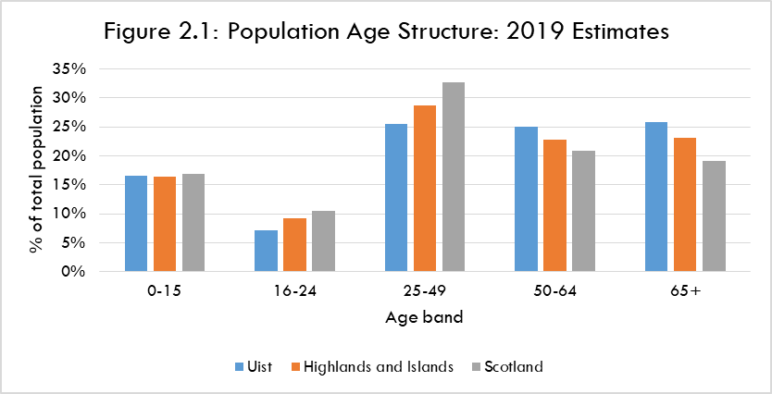

Uist’s population is older than that of the Highlands and Islands and Scotland. In particular it has lower proportions of those aged 16-24 and aged 25-49.

The latter is mostly likely to contain people in work and who are also raising families. Uist has 26% of its population in that age range, clearly lower than both the Highlands and Islands (29%) and Scotland (33%).

In contrast Uist has the highest proportions in the two oldest age bands. More than half of its population is aged 50 years or above, compared to 40% for Scotland.

2.2.7 Estimated Population Change 2011 to 2019

Figure 2.2, over, describes how the age profile of Uist’s population changed in that time.

It is estimated that between 2011 and 2019 Uist’s population fell from 4,862 to 4,630 people. That is a decrease of approaching 5%. It is in contrast to growth in both the Highlands and Islands (0.4%) and Scotland (3.0%) over that period.

Uist has seen a decline in the numbers in each of the age bands up to 64 years. This generally mirrors the trend in the Highlands and Islands and Scotland. However, the extent of decline in Uist is much more marked. For example, a fall of 24% in the number of 16-24 year olds and of 17% in the 25-49 age band.

In contrast Uist had a large increase (23%) in those aged 65 years or more. That is above the level of increase at both the regional and national level.
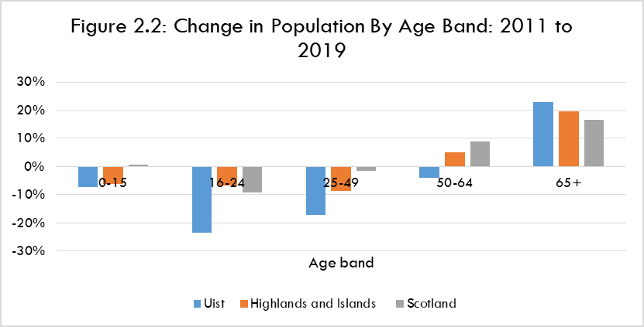

2.2.8 Population: Summary

Uist has a small population-less than 5,000 people. It is estimated to have fallen by around 5% between 2011 and 2019, in contrast to growth at the regional and national levels. Uist also has a relatively old population-and one that is aging at a faster rate than in the Highlands and Islands and Scotland. That includes an estimated large fall in the number of those aged between 16 and 49 years since 2011.

2.3 HARRIS

2.3.1 Employment

In 2019 there was a total of 700 jobs in Harris. This figure does not include the self-employed, and covers only businesses which are registered for VAT and/or PAYE or with Companies House. The data are based on a sample of businesses and are also rounded to maintain confidentiality for individual businesses. Information on self-employment is shown at 2.3.2.

The share of these jobs which is part time (43%) is higher than in the Highlands and Islands (40%) and significantly higher than in Scotland (34%).

Table 2.2, over, describes the structure of employment in Harris in 2019 and provides a comparison with the Highlands and Islands.

The industries in Harris with the largest employment levels were:

  - Accommodation and food service activities: 31%.
  - Human health and social work activities: 18%.
  - Agriculture, forestry and fishing/aquaculture: 8%.
  - Manufacturing: 8%.
  - Education: 8%.

TABLE 2.2: HARRIS EMPLOYMENT STRUCTURE: 2019
 | Share of Total Employment
Industry | Harris | Highlands and Islands
Agriculture, forestry and fishing/aquaculture | 8% | 5%
Mining and quarrying | 0% | 0%
Manufacturing | 8% | 7%
Electricity, gas, steam and air conditioning supply | 1% | 1%
Water supply, sewerage, waste management and remediation activities | 0% | 1%
Construction | 1% | 7%
Wholesale and retail trade; repair of motor vehicles and motor cycles | 7% | 13%
Transport and storage | 5% | 5%
Accommodation and food service activities | 31% | 12%
Information and communication | 0% | 2%
Financial and insurance activities | 0% | 1%
Real estate activities | 4% | 1%
Professional, scientific and technical activities | 0% | 5%
Administrative and support service activities | 4% | 4%
Public administration and defence; compulsory social security | 5% | 6%
Education | 8% | 8%
Human health and social work activities | 18% | 17%
Arts, entertainment and recreation | 2% | 3%
Other service activities | 2% | 1%
TOTAL | 100% | 100%

Thus, two industries account for almost 50% of jobs in Harris. That is much higher than the corresponding figure for the Highlands and Islands (30%).

Accommodation and food service activities, Human health and social work activities and Manufacturing are particularly important sources of full-time jobs. CnES is a major non-tourism employer.

This means Harris has a high degree of dependence on the tourism sector in particular. Tourism activity will also support jobs in industries such as retail and manufacturing.

Harris Distillery is a major all year round employer and is looking to further increase its employment levels. It is also a significant attraction with c70,000 visitors per year. Its role could further increase as it is expected to become part of an Outer Hebrides whisky trail with potential openings of new distilleries in Uist and Barra within the next five years.

In addition there are plans for the upgrade of existing and new visitor centres in Lewis, Harris and North Uist, a number of which will form a complementary visitor trail.

It was reported that for most of 2021 the Harris tourism market was back to pre-pandemic levels. That was accompanied by high accommodation occupancy rates (70-80%) in October and November. It was reported that some existing accommodation providers are looking to increase their bedspace numbers.

The data also indicate the relative importance of employment levels in the following sub-sectors:

- Accommodation.
- Fishing and aquaculture.
- Manufacture of beverages.
- Residential care activities.

The data at Table 2.2 shaded in yellow highlight industries with a share of total employment that is at least two percentage points greater than the corresponding share of Highlands and Islands employment In particular, Accommodation and food service activities’ share of employment in Harris is 2½ times that in the Highlands and Islands.

The other over-represented sectors are Agriculture, forestry and fishing/aquaculture and Real estate activities.

In contrast, a number of industries (shaded in blue) are underrepresented, These are Construction, Wholesale and retail trade; repair of motor vehicles and motor cycles, and Professional, scientific and technical activities.

2.3.2 Self-Employment

The 2011 Census shows that one quarter (25%) of those working were self-employed rather than employees. These individuals were most likely to be working in:

- Agriculture, energy and water.
- Construction.
- Wholesale and retail trade; repair of motor vehicles and motorcycles.

Thus, these industries will be more significant than the employment figures at Table 2.2 suggest.

2.3.3 Wage Levels

Data on wages are only available at the Outer Hebrides level. In 2019, the average (median) gross wage for a full time job was £26,772. That is over £3,000 (11%) less than the figure for Scotland (£30,000).

Given its employment structure-and particularly the importance of tourism-it is expected that wages in Harris will be lower than the Outer Hebrides average. This in a context where a minimum acceptable standard of living in the Outer Hebrides requires between 20% and 42% more household spending than in urban parts of the UK.

2.3.4 Fragility

All parts of Harris are classified by HIE as Fragile Areas. These are generally characterised by declining population, under-representation of young people within the population, lack of economic opportunities, below average income levels, problems with transport and other issues reflecting their geographical location.

2.3.5 Economy: Summary

- Three industries are responsible for more than half of total employment in Harris.
- Tourism is a major employer.
- Specialisations include Accommodation, Fishing and aquaculture, Manufacture of beverages and Residential care activities.
- Wages in full time jobs in Harris appear to be more than 10% below the Scottish average, and are likely to be lower than the Outer Hebrides average. That is in a context of a relatively high cost of living.
- All parts of Harris are in HIE designated Fragile Areas.

2.3.6 Population Levels

The estimated 2019 population in Harris was 1,827. Figure 2.3 describes its age structure and compares this to the Highlands and Islands and Scotland.

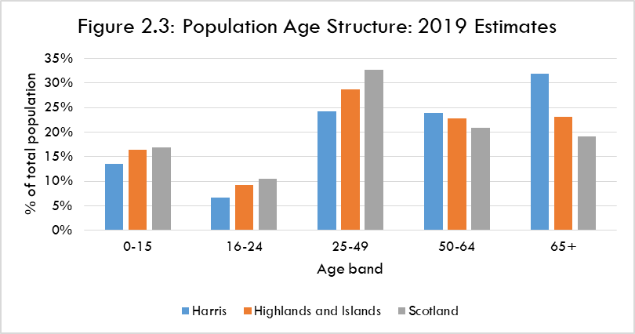

Harris’s population is older than that of the Highlands and Islands and Scotland. In particular it has lower proportions of those aged 25-49. That age group is mostly likely to contain people in work and who are also raising families. Harris has 24% of its population in that age range, clearly lower than both the Highlands and Islands (29%) and Scotland (33%).

In contrast Harris has the highest proportions in the two oldest age bands. More than half (56%) of its population is aged 50 years or above, compared to 46% in the Highlands and Islands and 40% in Scotland.

Some consultees related this to a large number of second homes in Harris. This leads to a loss of younger island residents, in the context of a shortage of affordable housing. Consultees see this as a major issue affecting the island’s future sustainability.

2.3.7 Estimated Population Change 2011 to 2019

Figure 2.4, over, describes how the age profile of Harris’s population changed between 2011 and 2019.

It is estimated that between 2011 and 2019 Harris’s population fell from 1,895 to 1,827 people. That is a decrease of 3.6%. It is in contrast to growth in both the Highlands and Islands (0.4%) and Scotland (3.0%) over that period.

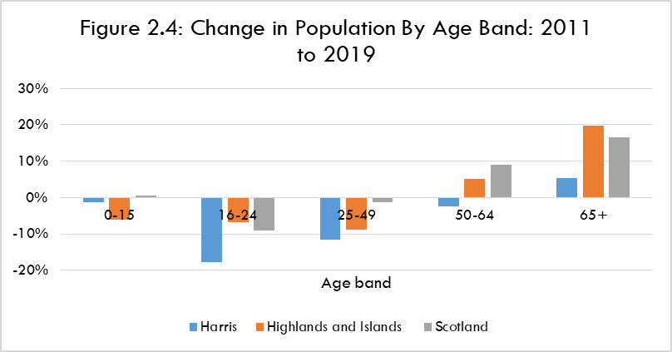

Harris has seen a decline in the numbers in each of the age bands up to 64 years. This generally mirrors the trend in the Highlands and Islands and Scotland. However, the extent of decline in Harris is much more marked. For example, a fall of 18% in the number of 16-24 year olds and of 12% in the 25-49 age band.

2.3.8 Population: Summary

Harris has a small population-less than 2,000 people. It is estimated to have fallen by over 3% between 2011 and 2019, in contrast to growth at the regional and national levels.

Harris also has a relatively old population which is aging at a faster rate than in the Highlands and Islands and Scotland. That includes estimated large decreases in the numbers aged between 16 and 49 years of age.

2.4 LEWIS

2.4.1 Employment

In 2019 there was a total of 8,000 employee jobs in Lewis. This figure does not include the self-employed, and covers only businesses which are registered for VAT and/or PAYE or with Companies House. The data are based on a sample of businesses and are also rounded to maintain confidentiality for individual businesses. Information on self-employment is shown at 2.4.2.

The share of jobs in Lewis which are part time (38%) is slightly below that in the Highlands and Islands (40%). However it is above the level in Scotland (34%).

Table 2.3, over, shows the structure of employment in Lewis in 2019 and compares this to the Highlands and Islands.

TABLE 2.3: LEWIS EMPLOYMENT STRUCTURE: 2019
 | Share of Total Employment
Industry | Lewis | Highlands and Islands
Agriculture, forestry and fishing/aquaculture | 2% | 5%
Mining and quarrying | 0% | 0%
Manufacturing | 7% | 7%
Electricity, gas, steam and air conditioning supply | 0% | 1%
Water supply, sewerage, waste management and remediation activities | 0% | 1%
Construction | 7% | 7%
Wholesale and retail trade; repair of motor vehicles and motor cycles | 13% | 13%
Transport and storage | 4% | 5%
Accommodation and food service activities | 7% | 12%
Information and communication | 2% | 2%
Financial and insurance activities | 1% | 1%
Real estate activities | 2% | 1%
Professional, scientific and technical activities | 3% | 5%
Administrative and support service activities | 4% | 4%
Public administration and defence; compulsory social security | 16% | 6%
Education | 10% | 8%
Human health and social work activities | 20% | 17%
Arts, entertainment and recreation | 2% | 3%
Other service activities | 1% | 1%
TOTAL | 100% | 100%

The industries in Lewis with the largest employment levels were:

- Human health and social work activities: 20%.
- Public administration and defence; compulsory social security: 16%.
- Wholesale and retail trade; repair of motor vehicles and motor cycles: 13%.
- Education: 10%.

Human health and social work activities, and Public administration and defence; compulsory social security are particularly important sources of full-time jobs. In part this reflects that the islands’ capital (Stornoway) is in Lewis.

The four largest industries account for almost 60% of jobs. This means a high degree of dependence on employment in a small number of industries-and the public sector in particular. That is more so than in the Highlands and Islands where the corresponding figure is 47%.

The data also indicate the relative importance of employment levels in certain sub-sectors:

- Manufacture of food products.
- Specialised construction activities.
- Construction of buildings.
- Manufacture of textiles-notably Harris Tweed.

The figures in Table 2.3 shaded in yellow highlight industries with a share of total employment at least two percentage points greater than the corresponding share of Highlands and Islands employment.
For example, Public administration and defence; compulsory social security accounts for 16% of employment in Lewis compared to 6% in the Highlands and Islands.

The data show that the two industries with the highest employment levels are over-represented compared to the Highlands and Islands economy.

In contrast, a number of industries (shaded in blue) are underrepresented. They are Agriculture, forestry and fishing/aquaculture, Accommodation and food service activities (often used as a proxy measure of the tourism sector) and Professional, scientific and technical activities.

Some consultees see the local economy having been relatively resilient during the pandemic. That was attributed to the high level of public sector employment with less reliance on tourism than elsewhere in the Outer Hebrides. Stornoway is the islands capital, by far its largest settlement and the centre for services and goods for the rest of the islands.

There are prospects for employment creation from contracts at the Arnish fabrication yard. This could create opportunities for weekly commuters from the Southern Isles if affordable accommodation is available during the week. That is in addition to major investments through the Islands Growth Deal and in the deep water port at Stornoway (c£50 million).

2.4.2 Wage Levels

Data on wages are only available at the Outer Hebrides level. In 2019, the average (median) gross wage for a full time job was £26,772. That is over £3,000 (11%) less than the figure for Scotland (£30,000).

We expect that, overall, wages in Lewis will be higher than the Outer Hebrides average. This reflects the presence of a significant amount of public sector employment and some sectors with above average wage levels (e.g. media).

However, this is in a context where a minimum acceptable standard of living in the Outer Hebrides requires between 20% and 42% more household spending than in urban parts of the UK.

2.4.3 Self-Employment

The 2011 Census shows that 14% of those working were self-employed rather than employees. These individuals were most likely to be working in:

- Construction.
- Wholesale and retail trade; repair of motor vehicles and motor cycles.
- Manufacturing.

This reinforces the significance of Wholesale and retail trade; repair of motor vehicles for employment in Lewis. It also highlights that Construction and Manufacturing are more significant than the employment figures at Table 2.3 imply.

2.4.4 Fragility

Some 40% of data zones in Lewis fall within HIE-designated Fragile Areas. These are generally characterised by declining population, under-representation of young people within the population, lack of economic opportunities, below average income levels, problems with transport and other issues reflecting their geographical location.

2.4.5 Economy: Summary

- There is a concentration of employment in a small number of industries-notably in the public sector and care.
- Specialisations include Manufacture of food products, parts of the construction sector and Manufacture of textiles. Tourism is a much smaller part of the economy than elsewhere in the Outer Hebrides.
- Wage levels in Lewis are likely to be higher than the Outer Hebrides average. However, that is in a context of a relatively high cost of living.
- 40% of data zones in Lewis are in HIE-designated Fragile Areas.

2.4.6 Population Levels

The estimated 2019 population in Lewis was 18,982. That represents more than 70% of the total Outer Hebrides population.

Figure 2.5 describes its age structure.

Lewis’s share of those aged up to 15 years is quite similar to both the Highlands and Islands and Scotland. However, it has a lower proportion in each of the age bands between 16 and 64 years of age. That is particularly the case for those aged 16-49 who are the most likely to be in work and also raising families.

Further, Lewis has a higher proportion (25%) of those aged 65 years+ than in the Highlands and Islands (23%) and Scotland (19%).

2.4.7 Estimated Population Change 2011 to 2019

Figure 2.6, over, describes how the age profile of Lewis’s population changed between 2011 and 2019.

Lewis’s 2019 population level is around 3.5% lower than in 2011 when the estimated figure was 19,653. That is in contrast to population growth in both the Highlands and Islands (0.4%) and Scotland (3.0%) in the same period.

It was reported that housing expansion in Stornoway reflects increasing number of jobs based in the town, some of which have led to people moving in from rural Lewis.

Lewis has seen a decline in the numbers aged 0-15, 16-24 and 25-49. In each case the size of the decline was greater than in either the Highlands and Islands or Scotland.

2.4.8 Population: Summary

With around 19,000 residents Lewis accounts for more than 70% of the Outer Hebrides’ population. Its numbers are estimated to have fallen by around 3.5% between 2011 and 2019, in contrast to growth at the regional and national levels.

It has a relatively old population, reflected in the decline in most age groups under 65 years old between 2011 and 2019.

3 FERRY TIMETABLES

Summary

- The Sound of Harris service is limited to the hours of daylight. This constrains the length of operating day-and particularly so in the winter.
- The timetable is also restricted by the tides. On many days of the year there are potential alterations to sailing times due to tidal conditions.
- The crossing time is 1 hour.
- For most of the summer timetable either four or five return sailings per day are provided, Monday-Saturday. A lower frequency (three per day) operates on Sundays.
- Monday-Saturday first sailings are ex Berneray 0700 and ex Leverburgh 0815, last sailings are ex Berneray 1720 and ex Leverburgh 1815.
- The gap (“headway”) between departures varies between 2½ hours and 5 hours.
- The winter timetable has a lot fewer sailings and a very limited length of operation.
- For most of the winter there are two return sailings per day, with the service starting at 0815 and ending at 1540.
- Thoughout the winter timetable two return sailings are offered on a Sunday, with a sailing day of just over 7 hours for most of the time.
- In general, Sound of Harris sailings do not connect to those on the Sound of Barra without requiring quite long waits.

3.1 SUMMER 2021

The timetable shown overleaf operated from 26th March to 17th October 2021.

3.1.1 Daylight Hours and Tidal Restrictions

The service is limited to the hours of daylight (defined as one hour before sunrise and one hour after sunset for the route’s primary vessel-MV Loch Portain). This constrains the length of operating day-and particularly so in the winter.

The timetable is also restricted by the tides. On up to 63 out of the 206 days of the summer timetable, there were potential alterations to sailing times due to tidal conditions.

These add a level of complexity to arranging trips at short notice as there is always a need to check the timetable. They can also make the timetable difficult for some users to understand.

3.1.2 Operation and Terminal Locations

The service operates using a single vessel. It commences the timetable at Berneray and returns there on the last sailing. The crossing time is one hour.

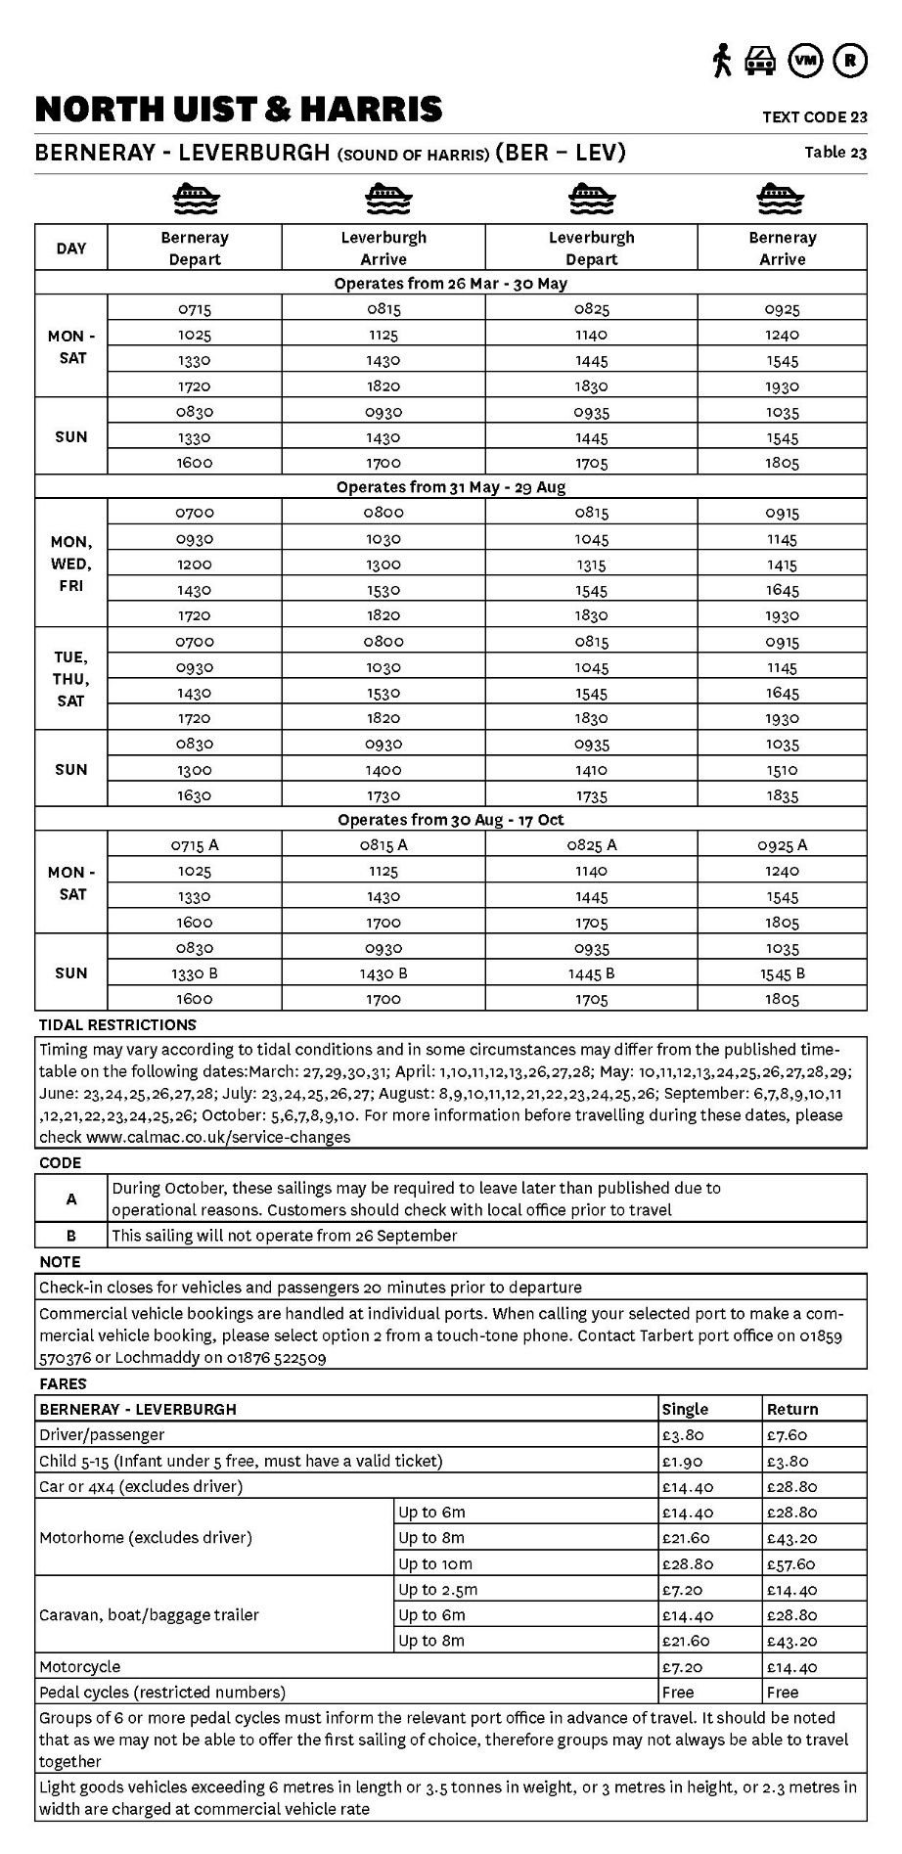

The terminal at Berneray is 33 miles from Balivanich which is the largest settlement in Uist. It is also 59 miles from the terminal for the Sound of Barra ferry service. That has an estimated drive time of between 1¼ and 1¾ hours depending on familiarity with the road. The terminal at Leverburgh is a 56 miles by road from Stornoway.

3.1.3 Variation in Summer Timetables

For most of the summer timetable (late May to late August) either four (Tue, Thu, Sat) or five (Mon, Wed, Fri) return sailings per day are provided, Monday-Saturday. The five sailings per day operations sere introduced in 2021. Four return sailings per day operate in the other months.

A lower frequency (three per day) operates on Sundays for the vast majority of the summer timetable.

The length of sailing day varies across the summer timetable as follows:

 | Monday-Saturday  (hours-minutes) | Time of First and Last Sailings
 | Monday-Saturday  (hours-minutes) | Ex Berneray |  | Ex Leverburgh
March 26-May 30 | 12-15 | 0715 | 1720 | 0825 | 1830
May 31-August 29 | 12-30 | 0700 | 1720 | 0815 | 1830
August 30-October 17 | 10-50 | 0715 | 1600 | 0825 | 1705

 | Sunday  (hours-minutes) | Time of First and Last Sailings
 | Sunday  (hours-minutes) | Ex Berneray |  | Ex Leverburgh
March 26-May 30;  August 30-October 17 | 9-35 | 0830 | 1600 | 0935 | 1705
May 31-August 29 | 10-05 | 0830 | 1630 | 0935 | 1735

The maximum time available in Harris/Lewis is 12½ hours and around 8 hours in Uist. Monday to Saturday the gaps between sailings vary as follows:

- Ex Berneray: from 2 hours and 30 minutes to 5 hours. The average (median) is 2 hours and 30 minutes.
- Ex Leverburgh: from 2 hours and 30 minutes to 5 hours. The average (median) is 2 hours and 45 minutes.

In general, Sound of Harris sailings do not connect to those on the Sound of Barra without requiring quite long waits.

3.2 WINTER 2021-22

The winter timetable shown overleaf operated between 18th October 2021 and 24th March 2022.

For more than two thirds of the timetable, the service operates at a frequency of two return sailings per day. For most of that time there is a short sailing day of around 7½ hours-between 0815 and 1540. This reflects the daylight hour restrictions on the service. The timetable offers users around 6 hours in Harris/Lewis and around 4 hours in Uist.

The service increases to three return sailings per day, Monday-Saturday, from early February onwards. The sailing day is initially slightly more than 8 hours per day, increasing to over 10 hours from early March.
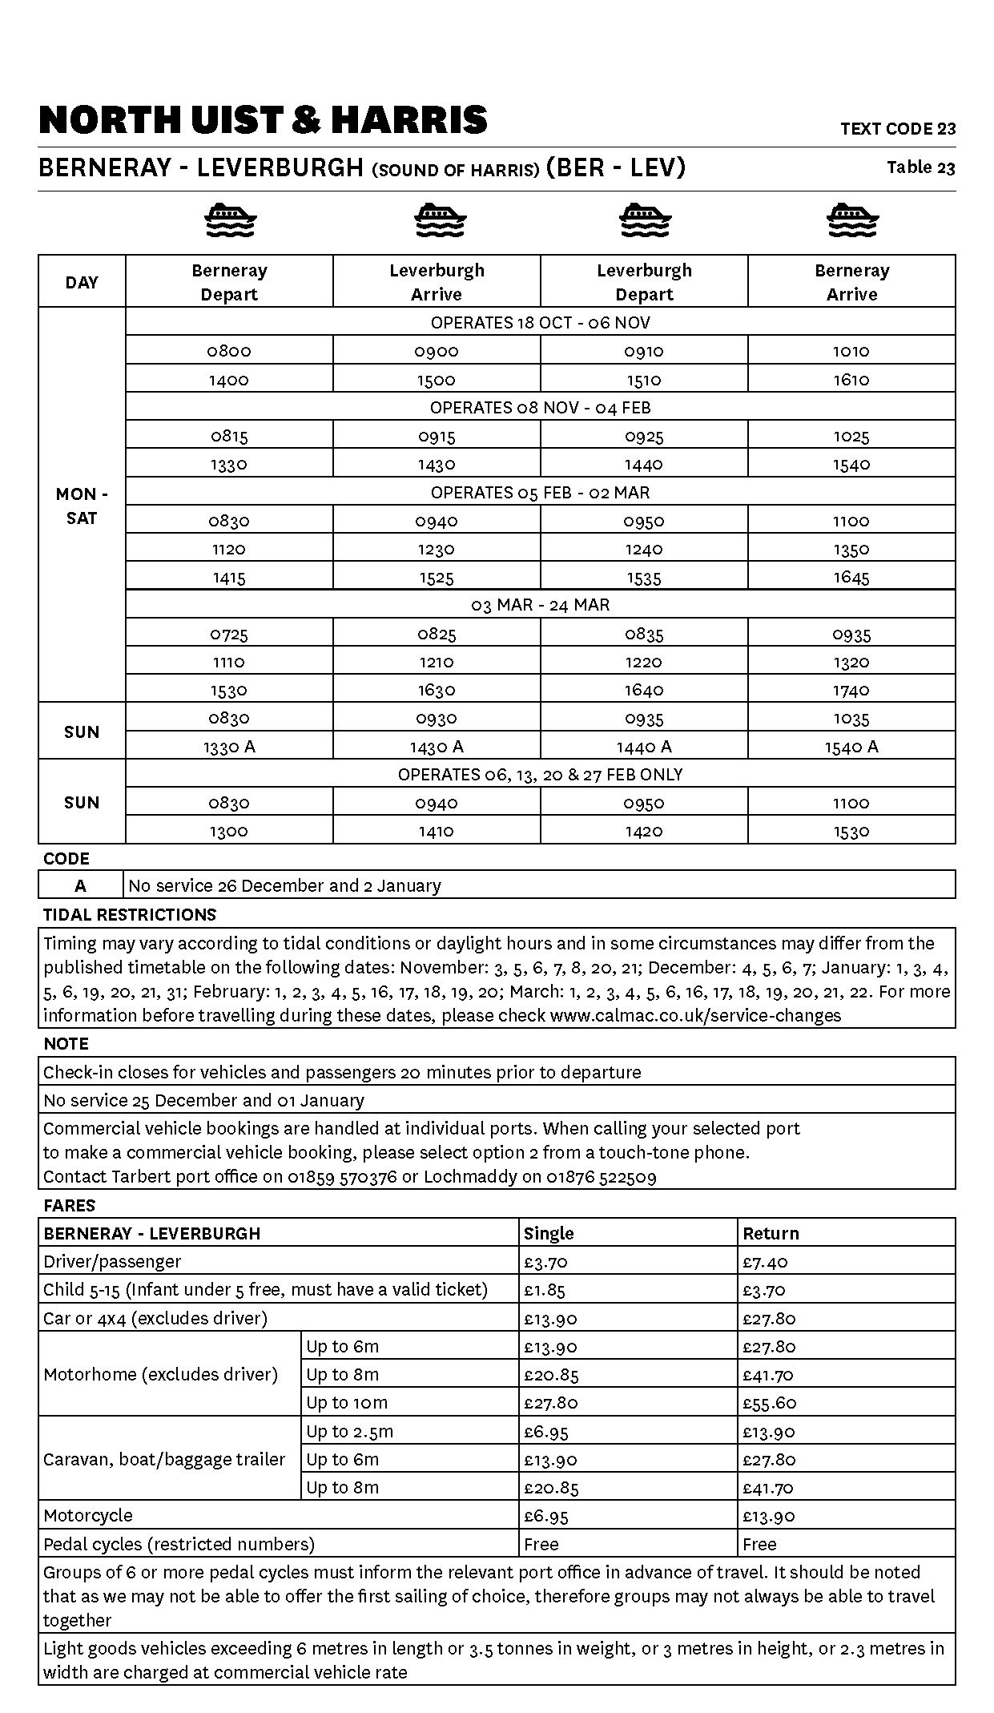
The gap between sailings varies between around three hours and around four hours. Thoughout the winter timetable two return sailings are offered on a Sunday, with a sailing day of just over 7 hours for most of the time.

On up to 43 out of the 158 days of the winter timetable, there were potential alterations to sailing times due to tidal conditions.

In general, Sound of Harris sailings do not connect to those on the Sound of Barra without involving quite long waits.

4 FERRY TRAFFIC ANALYSIS

Summary

- In 2019 the ferry service carried around 76,000 passengers, 32,000 cars, 1,300 CVs and 170 coaches.
- Between 2017 and 2019 both passenger and car carryings grew strongly-by around 10%, while CVs increased by 9%. In summer 2021 on the days when a fifth sailing operated these were well utilised by cars.
- Passenger and car traffic is heavily concentrated in the main summer months. 85% of annual passengers and almost 80% of annual cars travel during the summer timetable.
- In 2019 the peaks in CV carryings occurred outside the peaks in passenger and car demand.
- Summer passenger and car carryings on sailings from Uist are higher than on the sailings from Harris. This appears to reflect visitors arriving in Barra and then using the service to travel onwards to other islands in the Outer Hebrides.
- Passengers and cars are spread broadly evenly across most of the days of the week. However, demand is spread less evenly across the ex Berneray sailings than across those ex Leverburgh. Sailings with the highest number of CVs tend to be at times when car demand is lower.
- Traffic imbalances result in capacity constraints-particularly for the most popular sailings.
- Residents use the service for a variety of trip types, including VFR and health
appointments.
- Business travel is a significant part of non-visitor demand.
- The service is used to connect with other transport services in the Outer Hebrides (particularly the Sound of Barra ferry).
- A high percentage of households and businesses always book a vehicle space on the ferry in advance-at all times of the year. Most households book at quite short notice-i.e. up to two weeks in advance. However, businesses book earlier than this-especially in the midsummer months. Visitors tend to book much further ahead although some look to book quite late.
- If a desired sailing is fully booked more than half of residents and businesses either have to travel on another day or do not travel at all.
- Estimated vehicle capacity utilisation shows very few sailings at 100% or more utilisation (1% of all sailings) or 90%+utilisation (5%). These are much fewer than would be expected given 1) the number of sailings becoming fully booked in advance 2) resident, business and consultees’ views of available capacity on the service. That is especially in June, July and August-when capacity is viewed as very inadequate.
- Survey respondents’ views on the main reasons for/effects of inadequate capacity include: high and increasing levels of tourist traffic, sailings fully booked well in advance, inability to travel at short notice or optimum times, some visitors unable to get bookings.
- Most households and more than half of businesses consider the current summer sailing times to be adequate or very adequate.
- More than half of the households rate the winter sailing times as somewhat inadequate. More than half of businesses rate them as totally or very inadequate.
- Main reasons for/effects of this among households and businesses include: operating day is too short, not enough sailings, cannot make a day trip.
4.1 INTRODUCTION

This Chapter uses a range of sources to analyse traffic on the Sound of Harris ferry service. For carryings, we have used data for 2019. That was the last full year before the Covid pandemic which resulted in markedly lower carryings and a different balance between local resident and visitor traffic.

4.2 ANNUAL CARRYINGS

Table 4.1 shows carryings for each year between 2017 and 2021.

TABLE 4.1: ANNUAL CARRYINGS 2017-2021
Year | Passengers | Cars | Coaches | Commercial Vehicles
2017 | 68,415 | 29,695 | 155 | 1,229
2018 | 69,603 | 30,380 | 150 | 1,297
2019 | 75,508 | 32,367 | 167 | 1,335
2020 | 28,326 | 15,257 | 13 | 1,227
2021 | 56,650 | 26,690 | 91 | 1,509

In the last full year (2019) before the Covid pandemic there were over 75,000 passengers and 32,000 cars. In addition were more than 1,300 Commercial Vehicles (CVs), while coach carryings were slight (167).

Traffic levels grew strongly between 2017 and 2019, as follows:

- Passengers: +10%.
- Cars: +9%.
- Coaches: +8%.
- CVs: +9%.

In 2019, the average length of CV on the route was 11.5m. That is similar to the average length across all CalMac routes (11.9m) in that year.

Unlike passenger and car demand CV traffic increased between 2019 and 2021. Some consultees attributed this to a relatively high level of CnES-related traffic-both the Comhairle’s own vehicles and those of contractors.

4.3 MONTHLY PROFILE

Figure 4.1, over, shows significant peaking of passenger traffic in the summer months.

Passenger numbers range from under 2,000 in each of January, February and March to approaching 13,000 in July. The main four summer months of May-August alone account for over 60% of annual carryings.

Passenger demand is heavily concentrated in the main summer months.

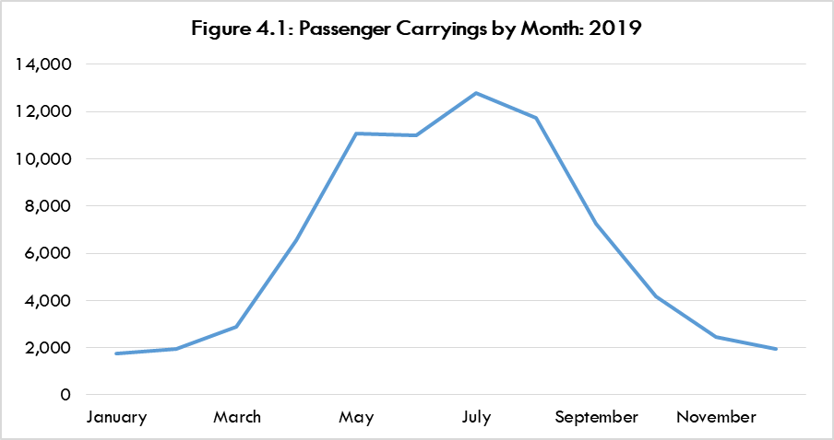
Figure 4.2 also shows significant peaking of car traffic in the main summer months, although to a lesser extent than passengers.

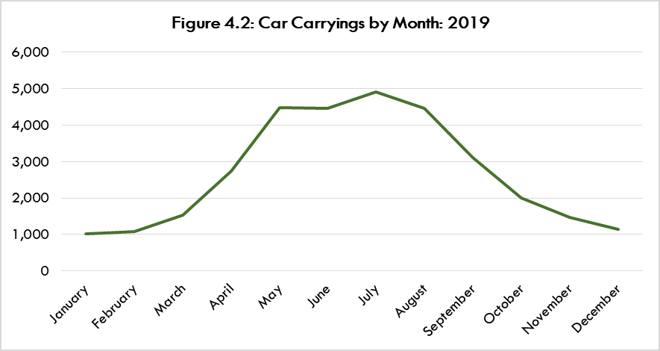
Car numbers range from around 1,000 in each of January, February and December to almost 5,000 in July. The main four summer months of May-August alone account for more than half (57%) of annual carryings.

Car demand is heavily concentrated in the main summer months.

Figure 4.3, over, shows that the monthly profile of CVs differs from that of passengers and cars.

The numbers ranged between less than 100 in the first three months of the year and 170 in September. The highest volumes were in September, October and November. Thus, they do not coincide with the peak months for cars.

In 2019 the vast majority of coaches (136 out of 167) used the service between May and September. None were carried in January or December.

Between 2017 and 2019 the highest absolute levels of passenger and car growth were mostly outside the peak summer months-i.e. in May, July and April.

4.4 TRAFFIC PROFILE

4.4.1 Carryings By Season and Sailing

Table 4.2 shows that carryings during the summer timetable account for the vast majority of annual traffic.

TABLE 4.2: TRAFFIC VOLUMES BY SEASON: 2019
Year | Passengers | Cars | Coaches | Commercial Vehicles
Summer | 63,958 | 25,726 | 163 | 789
Winter | 11,550 | 6,641 | 4 | 546
Total | 75,508 | 32,367 | 167 | 1,335

This includes 85% of annual passengers and almost 80% of annual cars, along with almost all coaches. A lower share (around 60%) of CVs are carried in the summer timetable. The summer accounts for the vast majority of passenger, car and coach traffic.

There is also an imbalance of passenger and car traffic by direction of travel during the summer timetable, as shown at Table 4.3, over.

Around 6,000 more passengers and 1,600 more cars travel on the Berneray to Leverburgh leg than do so from Leverburgh to Berneray. This appears to be a result of more visitors arriving in the Outer Hebrides in Barra or Uist then using the Sound of Harris ferry to travel onwards than do so in the opposite direction.

TABLE 4.3: PASSENGER AND CAR TRAFFIC BY SAILING LEG: SUMMER TIMETABLE
2019
Leg | Passengers | Cars
Berneray-Leverburgh | 34,960 | 13,670
Leverburgh-Berneray | 28,998 | 12,056

Table 4.4 shows summer passenger and car carryings by day of the week. The sailings with the highest volumes are highlighted in orange.

TABLE 4.4: PASSENGER AND CAR TRAFFIC BY DAY OF THE WEEK: SUMMER
TIMETABLE 2019
 | Passengers |  | Cars
 | Ex Berneray | Ex Leverburgh | Ex Berneray | Ex Leverburgh
Monday | 4,485 | 3,668 | 1,874 | 1,734
Tuesday | 5,258 | 4,233 | 2,045 | 1,817
Wednesday | 5,552 | 4,777 | 2,158 | 1,901
Thursday | 5,137 | 4,349 | 2,107 | 1,902
Friday | 5,249 | 4,507 | 2,087 | 1,832
Saturday | 5,653 | 4,934 | 2,049 | 1,812
Sunday | 3,626 | 2,530 | 1,350 | 1,058
Total | 34,960 | 28,998 | 13,670 | 12,056

For passengers Wednesday and Saturday are the busiest days. For cars the busiest days are Wednesday, Thursday and Friday-although carryings are very similar to those on Tuesday and Saturday.

Monday is relatively quiet, while Sunday has the lowest carryings.

Monday and Wednesday are the busiest days during the winter timetable.

Table 4.5 shows Monday-Saturday carryings by timetabled sailing during the summer timetable. Again. the sailings with the highest volumes are highlighted in orange.

TABLE 4.5: CARRYINGS BY SAILING: SUMMER TIMETABLE 2019:
MONDAY-SATURDAY
Ex Berneray |  |  |  |  | Ex Leverburgh
Sailing | Pax | Cars | Coaches | CVs | Sailing | Pax | Cars | Coaches | CVs
07:15 | 5,126 | 2,265 | 6 | 219 | 08:25 | 5,657 | 2,948 | 6 | 106
10:25 | 8,612 | 2,971 | 32 | 47 | 11:40 | 7,542 | 2,881 | 22 | 41
13:30 | 9,071 | 3,698 | 16 | 45 | 14:40/14:45 | 6,891 | 2,609 | 28 | 167
16:00/  17:20 | 8,288 | 3,304 | 22 | 49 | 17:05/18:30 | 6,204 | 2,498 | 11 | 75

Ex Berneray the busiest sailing is the 1330 for passengers and cars and the 0715 for CVs.

Ex Leverburgh the 1140 is the busiest for passengers, while that sailing and the 0825 are virtually equally busy for cars. The highest number of CVs are on the third sailing of the day.

Demand is spread less evenly across the ex Berneray sailings than across those ex Leverburgh.

An analysis of summer 2021 traffic showed that on the days when a fifth sailing operated these were well utilised by cars.

Table 4.6 shows carryings on the first and last sailings of the day in the winter.

TABLE 4.6: MONDAY TO SATURDAY CARRYINGS BY SAILING: WINTER TIMETABLE
2019
Ex Berneray |  |  |  |  | Ex Leverburgh
Sailing | Passengers | Cars | Coaches | CVs | Sailing | Passengers | Cars | Coaches | CVs
First | 2,310 | 1,240 | 0 | 181 | First | 2,450 | 1,624 | 1 | 98
Last | 2,339 | 1,476 | 0 | 51 | Last | 2,528 | 1,275 | 0 | 130

There is a slight bias towards ex Leverburgh movements for passengers and cars. The CV movements are almost identical in each direction.

4.4.2 User Profile

Trip Purpose

The household survey showed, in order of number of responses, the most frequently mentioned trip purposes as:

- Visiting friends or relatives (VFR).
- Business travel.
- Health appointment.
- Holiday.
- Shopping.
- Leisure or entertainment.

The most common (i.e. most frequent) trip purposes were:

- VFR.
- Business travel.
- Health appointment.

The vast majority (94%) of household respondents normally travel accompany a vehicle on the ferry.

Data provided by CalMac for bookings made in 2019 show that within the Outer Hebrides, most were made from the Stornoway postcode area (42%). A further 20% were from Lewis outside Stornoway. This figure may reflect public sector travel bookings made by organisations’ Stornoway HQs. It may also reflect Lewis-based travellers wanting to guarantee a space on the Sound of Harris service given the road distance and time involved in travelling to and from the ferry terminal at Leverburgh.

The remainder were resident in:

- North Uist: 16%.
- Benbecula: 10%.
- South Uist: 7%.
- Harris/Scalpay: 3%.
- Barra: 2%.

In 2019 NHS patient travel on the service was around 770 single passenger trips and around 600 single car trips (including escorts whose travel costs are met by NHS).

In the business survey the most commonly mentioned uses were Customers use it to visit our premises and own staff business travel.

Our consultations identified a wide range of business usage of the ferry service. These include:

- A range of service providers. They include construction and related trades as well as contractors undertaking work for CnES.
- Waste moved to Stornoway by CnES vehicles. There were approaching 500 single movements in 2021.
- Foodstuffs-e.g. bakery, meat products.
- Shellfish-including live movements.
- Fish mortalities.
- NHS related loads-e.g. laundry.
- Fuel tankers.
- Scottish Water.
- Aquaculture-related traffic.

CnES staff and elected members are significant users of the ferry service, with a number of the Comhairle’s services in Harris delivered from Uist. In 2019, around 800 single trips were made.

Connecting Trips

Some of the trips made on the service connect with other transport services in the Outer Hebrides (particularly the Sound of Barra ferry).

Some connecting trips can be planned well in advance. Others are made at short notice if weather or vessel breakdown means people look to travel to the mainland on one of the other island’s ferry services.

Trip Frequency

From the household survey, most of the sample use the service less than weekly. Together, around 75% use it either to 3 times a month or at least four times a year. Some 3% use it weekly or more.

From the business survey, business use is mostly at least four times per year followed by once a week and 1 to 3 times per month.

A number of businesses do not use the ferry but still benefit from it. For example, visitor accommodation providers whose guests use the service.
Breakdown of User Types

The following are best estimates from data analysis, the online surveys and our consultations.

Across the whole year:

- 51% of car traffic is visitors and 49% Outer Hebrides residents.
- 64% of car-accompanying passengers are visitors, 36% are Outer Hebrides residents.

This reflects our estimates of car occupancy as:

- Visitors: 2.4 people per car.
- Residents: 1.6 people per car.

The latter figure for residents appears to reflect the significant business element of residents’ use of the service. Business trips could account for around 40% of all residents’ trips on the service.

Finally, we estimate that 25% of visitor trips on the service are one way, with the remaining visitor trips being a return trip.

4.5 VEHICLE BOOKINGS

4.5.1 Primary Research Findings

Making A Booking

The vast majority (83%) of household respondents always make a booking to use the service in June, July and August. The figures for April, May, September and October and the winter timetable are also high. They are 82% and 75%, respectively.

The extent of booking is just as high for businesses. More than 85% of the businesses always make a booking to use the service, irrespective of the time year.

There is a high level of booking rather than turn up and go.

How Far In Advance Bookings Are Made

Most households book at relatively short notice-i.e. up to two weeks in advance:

- 48% in June, July and August (with 23% booking less than one week before).
- 69% in April, May, September and October (33%).
- 86% during the winter timetable (48%).

Businesses were more likely to book earlier. That is especially in June, July and August when almost half (47%) book no later than five weeks before the day of sailing.

Availability of Vehicle Spaces on Desired Sailings

Households were asked how often they are able to get a vehicle space on the sailings they want to use. More than half (54%) stated Most of the time. A further 38% stated Less than half the time, while some 4% said Always.

Around half (48%) of the businesses said they are able to get a vehicle space on the sailings they want to use Less than half the time. A similar level (43%) stated Most of the time. The remaining few were split evenly between Always and Never.

Households were then asked what usually happens if the Sound of Harris sailing they want to use is fully booked. The responses were as follows:

  - I travel to the ferry terminal to try and catch the sailing I want to use in case a space is actually available: 18%.
  - I travel on the same day but at a different time: 12%.
  - I travel on another day: 33%.
  - I don't make the trip at all: 37%.

Businesses were more likely than householders to make or try to make the trip on the same day that they had planned to travel. The responses included:

  - Staff travel to the ferry terminal to try and catch the sailing they want to use in case a space is actually available: 24%; and
  - Staff travel on the same day but at a different time: 19%.

The business survey also showed:

- Staff travel on another day: 19% of responses.
- Staff don't make the trip at all: 38%.

If a desired sailing is fully booked more than half of households and businesses either have to travel on another day or do not travel at all.

4.5.2 CalMac Booking Data

CalMac provided booking data for the 2019 sailings. These identified the number of days in advance when a sailing was first shown as being fully booked for vehicles. (Thereafter the sailing may have had space available again due to cancellations-and even after that have become fully booked again at a later date).

Table 4.7, over, shows the number of sailings that were fully booked at some stage and their share of the total sailings in each month. They account for one in four sailings across the year.

The highest number of sailings fully booked at some point were in May and August. They account for the more than half of these sailings across the year. The number of booked sailings in June and July are very much lower despite those months being part of the main tourism season.

TABLE 4.7: SAILINGS THAT WERE FULLY BOOKED AT SOME POINT: 2019
Month | Number of Sailings | Share of Total Monthly Sailings
January | 4 | 4%
February | 33 | 21%
March | 7 | 4%
April | 39 | 17%
May | 130 | 54%
June | 53 | 23%
July | 47 | 20%
August | 179 | 75%
September | 12 | 6%
October | 24 | 15%
November | 21 | 18%
December | 6 | 5%
Full Year | 555 | 25%

The numbers of fully booked sailings in February reflect the deployment of the MV Loch Bhrusda on the route in that month. It is a smaller vessel than the route’s main one (MV Loch Portain).

Table 4.8, over, shows the build-up of sailings becoming fully booked for the first time in the months of May and August.

The pattern in the two months differs markedly. In May, the earliest a sailing becomes fully booked is 28 days before the day of departure. (This is even later in the other months of the year apart from August). More than 80% of the sailings become fully booked for the first time less than two weeks in advance-and the vast majority only do so within the final seven days before the sailing.

In August, the sailings start becoming fully booked more than 11 weeks in advance. Around one quarter (50) of fully booked sailings become so around six weeks before the date of departure. Only around one third of the sailings that become fully booked do so within the final 14 days before departure.

Across the year as a whole the sailings most likely to become fully booked are the second and third sailings of the day ex Berneray and the first and second sailings of the day ex Leverburgh.

The sailings that became fully booked for the first time at least four weeks in advance are very largely the first sailing of the day ex Leverburgh and the second sailing ex Berneray.

TABLE 4.8: BUILD-UP OF FULLY BOOKED FOR THE FIRST TIME SAILINGS
May |  | August
Number of Days Before  Sailing | Number of Sailings Becoming Fully Booked for the First Time (Cumulative) | Number of Days Before Sailing | Number of Sailings Becoming Fully Booked for the First Time (Cumulative)
28 | 1 | 71-81 | 11
27 | 2 | 61-70 | 21
25 | 3 | 51-60 | 31
24 | 4 | 40-50 | 50
23 | 5 | 39 | 52
22 | 6 | 38 | 54
21 | 7 | 37 | 56
20 | 8 | 36 | 58
19 | 9 | 35 | 60
18 | 10 | 34 | 63
17 | 12 | 33 | 66
16 | 14 | 32 | 69
15 | 16 | 31 | 72
14 | 17 | 30 | 75
13 | 18 | 29 | 78
12 | 20 | 28 | 81
11 | 23 | 27 | 84
10 | 27 | 26 | 88
9 | 33 | 25 | 91
8 | 39 | 24 | 94
7 | 46 | 23 | 96
6 | 54 | 22 | 98
5 | 61 | 21 | 100
4 | 72 | 20 | 103
3 | 84 | 19 | 106
2 | 99 | 18 | 109
1 | 115 | 17 | 112
0 | 130 | 16 | 114
 |  | 15 | 117
 |  | 14 | 120
 |  | 13 | 124
 |  | 12 | 128
 |  | 11 | 131
 |  | 10 | 134
 |  | 9 | 136
 |  | 8 | 139
 |  | 7 | 142
 |  | 6 | 144
 |  | 5 | 148
 |  | 4 | 152
 |  | 3 | 155
 |  | 2 | 162
 |  | 1 | 170
 |  | 0 | 179
A number of consultees referred to vessels being fully booked well before the day of sailing. Also, that capacity constraints have increased over time and it has become increasingly difficult to get bookings. The visitor season was reported as extending over time, moving further into March and October.

Some attributed fully booked sailings to people making multiple bookings on the same day to leave their travel options open. Others said that some people do not cancel a booking that they no longer need. Thus, spaces are actually available on a fully booked ferry if you turn up at the terminal on spec.

Visitors are not seen as likely to travel to the terminal on the chance of a space becoming available on what is a fully booked sailing. The point was made that local residents and businesses may need to travel at short notice while visitors can book well in advance because their holiday dates are set.

Yet, it was reported that this is not always the case. For example, some visitors arrive at Uig ferry terminal looking to travel inter-island on the Sound of Harris service but cannot be accommodated either one or both ways.

Consultees also referred to increasing numbers of visitors using the ferry service to travel to Harris having entered in the Outer Hebrides in Barra. There is seen as further potential for entry and exit from different Outer Hebrides ports through using the Sound of Harris service. This would have the beneficial effect of spreading visitor traffic across the Outer Hebrides.

4.6 VEHICLE CAPACITY UTILISATION

4.6.1 Approach

The two vessels used on the service are the MV Portain and MV Loch Bhrusda (relief/overhaul vessel). CalMac advised that the former has a car (Passenger Car Unit) capacity of 34, while the MV Loch Bhrusda has a capacity of 16.

CalMac provided information that allowed the conversion of Commercial Vehicles and Coaches carried to Passenger Car Unit (PCU) equivalents. These vehicles were added to the number of cars carried to give a total PCU equivalent carryings on each sailing.

That figure was then divided by the vessel’s PCU capacity to produce a % deckspace utlisation figure. This gives a measure of how full each sailing was. The greater number of full or nearly full sailings then the greater the apparent capacity pressures.

4.6.2 Factors That Can Cause Actual Capacity Utilisation To Be Understated

The estimates of PCU equivalents are simply that. They do not take into account factors than can lead to an underestimation of capacity utilisation.

1

The 2019 traffic data for “cars” include larger vehicles such as motorhomes, trailers and caravans. These will be longer than the average car. These may also be wider-e.g. some motorhomes-and straddle lanes on the deck, reducing available space. The mix of types of vehicles classed as “cars” will vary from sailing to sailing.
This will result in an understatement of capacity utilisation to the extent that motorhomes, etc. are being carried.

2

The conversion of CVs to a PCU equivalent cannot fully take into account the greater width of some of these vehicles, again understating the actual vessel lane metres being occupied.

3

Growth in the average size of cars over the years may mean that actual car capacity of the vessels is less than when they first came into service.

Further, the weight limits of the two vessels on the route can limit the amount of other traffic that can be carried when large (i.e. up to c40 tonne) vehicles are booked on a sailing. Also, the design of the MV Loch Bhrusda means it cannot accommodate vehicles of a certain width or height on busier sailings.

These factors were recognised in the Outer Hebrides STAG Appraisal. It stated that “from an analytical perspective, the utilisation analysis presented in this report and the Route Profiles systematically underestimate capacity utilisation on the Outer Hebrides fleet and thus it simply has to be borne in mind when interpreting the material presented”.

This should be borne in mind in the following analysis.

4.6.3 Capacity Utilisation Analysis

In 2019 2,126 sailings were operated on the route.

Table 4.8 provides a summary analysis of deckspace capacity utilisation.

TABLE 4.8: CAPACITY UTILISATION ESTIMATES: 2019
Sailings Shown At 100% or More Utilisation
 | Split By Vessel |  | Split By Season
Number/  (% of all sailings) | Loch Portain | Loch Bhrusda* | Summer Timetable | Winter Timetable | Most Common Months | Most Common Days | Ex Berneray | Most Common Ex Berneray | Most Common Ex Leverburgh
20 (1%) | 65% | 35% | 85% | 15% | Aug, Jul | Tue, Thu, Mon | 40% | 1330, 0715 | 1140, 1445
Sailings Shown At 90% or More Utilisation
109 (5%) | 78% | 22% | 76% | 24% | Jul, Jun, Feb | Tue, Fri, Mon, Sat | 59% | 1330, 1720 | 1445, 1140
Sailings Shown At 80% or More Utilisation
315 (15%) | 87% | 13% | 79% | 21% | July, Jun, Aug | Wed, Tue, Fri | 59% | 1330, 1720 | 1445, 1140
*Note: MV Loch Bhrusda was the sole vessel on the route for 24 days in February and two days in August

Given the uncertainties around precise measurement, this has been presented using different levels of estimated utilisation. This recognises that on a specific sailing the deckspace could actually be full even if the calculated utilisation figure is less than 100%.

The analysis shows that:

- The number of (potentially) full sailings ranges between 20 and 315 according to the measure used.
- MV Loch Portain accounts for between 65% and 87% of the sailings shown as potentially being at capacity.
- Most (more three quarters) of the sailings are during the summer timetable.
- August, June and July are the months when most of the sailings occur.
- Most of the sailings are ex Berneray-though not to a great extent.
- The most common sailings are the third and fourth sailings from Berneray and the second and third ones from Leverburgh.

4.6.4 Primary Research Findings: Households

Responses

Household respondents were asked to describe available vehicle capacity on the ferry service. Their responses regarding June, July and August are shown at Figure 4.4.

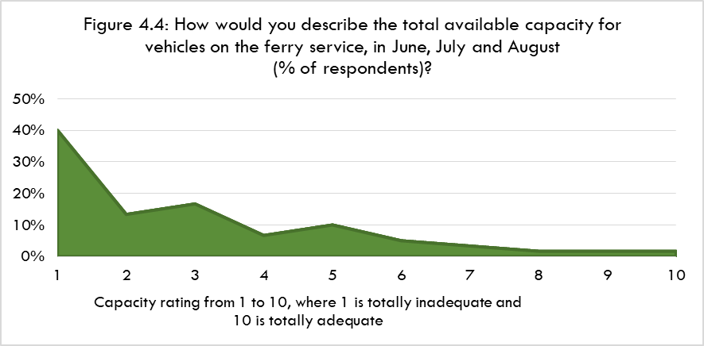
Some 40% gave the capacity a rating of “1” and 70% a rating between “1” and “3”. Less than 15% gave a rating of “6” or above. Thus, the available capacity is generally viewed as very inadequate.

Figure 4.5, over, shows the responses regarding available vehicle capacity during April, May, September and October.

The most common ratings were in the middle of the range. More than half (c60%) gave a rating of either “4”, “5” or “6”. Some 20% gave ratings at/towards the bottom end-i.e. either “1”, “2” or “3”.

Figure 4.6 shows responses regarding available vehicle capacity between November and March.

Approaching half (46%) of respondents gave the capacity a rating of “8” or above and around two thirds a rating of “6” or more. Just 17% rated the capacity at/towards the bottom end of the scale-i.e. “1”, “2” or “3”.

Main Reasons Given For Ratings

The main reasons given for the ratings for vehicle capacity are summarised below. They are accompanied by illustrative quotes from the survey responses.
- Pressure on capacity attributed to increased tourist traffic including a lengthening of the season

Getting a ferry booking can be difficult. Partly due to the demand from tourists and also returning families who may visit relatives during school holiday times

Summer months are extremely busy and often over capacity for every sailing so impossible to get a booking

Visitors are coming to the islands earlier in the year, so very often April and May are challenging in terms of booking too

Campervans especially take up more room and therefore reduce capacity

Full of campervans and tourists. No room for locals in important travel, especially on short notice i.e. for hospital visits

- Sailings filling up quickly, booked up well in advance

I know from lot of friends and family who were waiting for services and goods to come down from Stornoway to Uist but were unable to take on the jobs in Uist due to booked ferries

I avoid using the service because it is overcrowded and subject to too frequent cancellation. We have lost valued members of senior staff due to the sheer impossibility of commuting between Berneray and Harris

I work in Uist and have had to travel the day before my month on/month off and stay in Uist overnight because I have been unable to get on the ferry

Visiting friends have found it hard to get a space on the ferry, unless booking well in advance, for a trip to Harris in the summer months

- Inability to travel at short notice

Difficult to book car onto ferry in the summer months especially if I need to travel at short notice

During the peak summer months I am often in the standby queue and have been left behind due to inability to book far enough ahead and last minute travel changes

In the summer it is very difficult to get the ferry unless you book far in advance, which is not always possible

4.6.5 Primary Research Findings: Businesses

Responses

For the total available capacity for vehicles on the ferry service, in June, July and August, two thirds (67%) of businesses rated this either “1” or “2”. Most others rated it either “4” or “5”. More than 90% rated capacity no more than “4”. Thus, the available capacity is generally viewed as very inadequate.
For April, May, September and October, more than half (54%) of the businesses rated capacity between “1” and “3”. Most others (33% of total responses) gave a rating of between “6” and “8”. Thus, the general view is that the capacity is less than adequate.

For November-March, 46% of businesses rated capacity “6” or above, with 21% rating between “1” and “3”.

Main Reasons Given For Ratings

The main reasons given for businesses’ ratings for vehicle capacity can be summarised as follows. They are accompanied by illustrative quotes from the survey responses.

- Capacity issues due to high visitor demand

Ferry fully booked with tourists in peak months reduces availability substantially

It can be difficult to get a booking on the ferry you need during the summer due to the volume of tourist vehicles

It is often impossible to book onto the preferred crossing

Travel during the tourist season is difficult as sailings often need to be booked weeks if not months in advance in order to guarantee a reservation on the sailings which best suit business travel (early and late sailings).

- Inability to travel at short notice

We often have to meet clients at short notice and the boat is regularly full. The flying option isn't good as we often need to travel outwith Stornoway.

- Some visitors unable to get bookings

Our business has two self-catering cottages and we have had a series of situations where a booking has been cancelled, sometimes many months in advance of the booked dates, because our guests have been unable to book space on a weekend ferry

Guests have been unable to secure weekend bookings to arrive on the day they have paid to start their holiday. More frustrating when booking hopscotch tickets and trying to secure accommodation across all islands. Guests are unable to secure return crossings for day trips

The limited capacity combined with restricted timetable hours severely inhibits guests travelling to our business

- Inability to travel at required/optimum times

Frequently unable to book….business requires some last minute staff or goods movements

Any changes to bookings can result in lost days trying to fit vehicles into free space and this costs downtime
Due to limits on capacity or timing of sailings I often have to travel the day before or cut work short in order to get home

Problems arise if you can’t book on the ferry you need - the alternatives usually curtail the amount of time on Lewis/Harris to an infeasible level for a day trip to be viable

- Winter service

In the winter months the relief vessels are so small that it is a rat race to get on them.

Winter months-not enough ferry runs

4.7 PRIMARY RESEARCH: VIEWS ON THE CURRENT TIMETABLE

4.7.1 Households

Ratings-Summer Timetable

Household survey respondents were asked to rate the arrival and departure times of the existing sailings during the summer timetable. The results are shown at Figure 4.7.

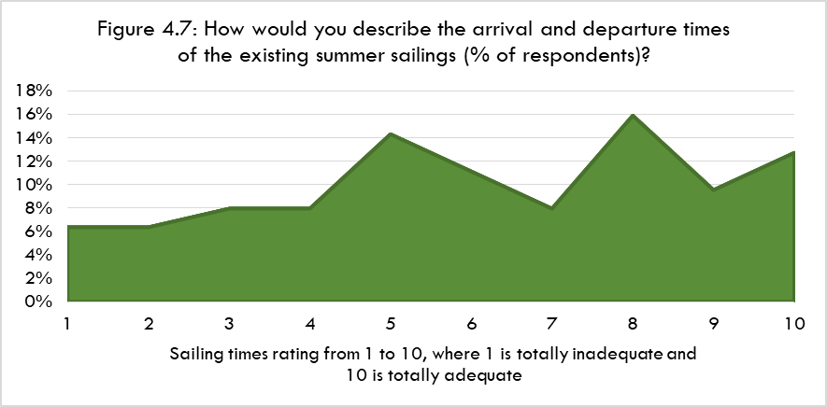
More than half (57%) the respondents rated the sailing times at “6” or above, and c40% at “8” or more. Some 20% gave a rating of between “1” and “3”. Thus, most respondents consider the times to be adequate or very adequate.

Main Reasons Given For Ratings

- Operating day is too short

A later evening sailing from each port in the summer time would be helpful

I always have to have an overnight stay. My needs are a later ferry so I can travel in one day forth and back

If you are travelling to Stornoway for meetings you need to leave quite early to be sure to get last ferry which is not conducive to a full working day

- Not Enough Sailings

Could do with at least five crossings March to October

Not enough sailings to meet the needs of island residents, tourists and business travel

- Those who were positive about the current timetable

If you can get on the first and last ferry it is fine for work as you get most of the day in Stornoway

Times are fine, capacity is the issue

For visiting family I can leave Harris at 8.15/8.30 most days and return around 4-5pm. This gives me enough time for these types of journeys

Ratings-Winter Timetable

Figure 4.8 shows the responses regarding the winter timetable.

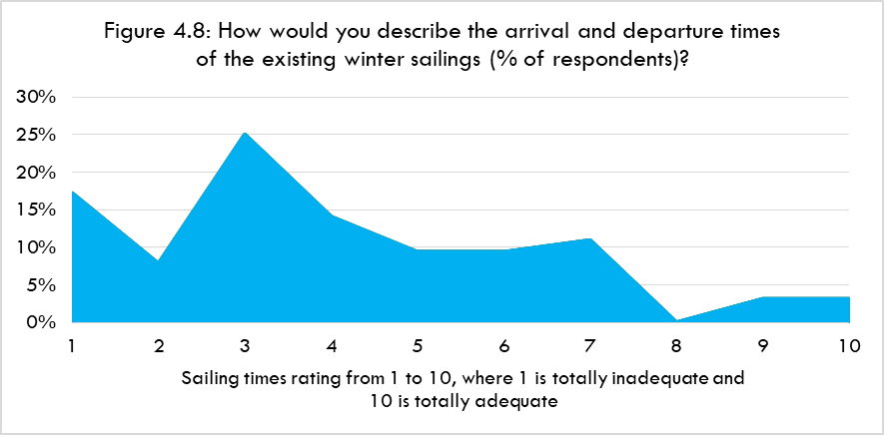
Half the respondents rate the sailing times between “1” and “3”. Most others (33% of all respondents) gave a rating of between “4” and “6”.

Main Reasons Given For Ratings

- Operating day is too short

The winter sailing times don't give me enough time at my destination

Weekdays are ok and I'm aware of the daylight sailing restrictions, however I find weekends lacking in service

Limited sailings, and time taken for journey from Stornoway

Cannot get from Berneray to adequately have time to shop in Stornoway and back in one day

Very poor service...should be three crossings every day including Sundays

Two ferries a day is too few, particularly if there is a risk on one being cancelled for weather or other reasons

Not possible to get to and from Stornoway with meaningful time to conduct business in Stornoway without incurring overnight costs

Importance of Retaining Existing Sailing Times

Household respondents were asked that if changes were made to the current timetable how important is it that the timings of the existing sailings are kept the same.

Around one third considered this “very” (6%) or “quite” (25%) important. However, more considered this either “slightly” (13%) or “not at all” important (35%). A further 21% stated “Don't Know”.

The most commonly mentioned sailings to be retained were the early sailings, followed by the late sailings.

4.7.2 Businesses

Ratings-Summer Timetable

Business survey respondents were asked to rate the arrival and departure times of the existing summer sailings:

- 44% rated them “7” or above.
- 30% rated them between “1” and “3”.
- 26% rated them between “4” and “6”.

Main Reasons Given For Ratings

More sailings could be available at earlier or later times to allow staff to travel and return same day

The latest ferries of the day are still quite early in the evening

It’s not the times, it’s the availability at either end of the working day

Timings are fine - capacity is the major issue

The limited timetable hours mean customers cannot travel between Lewis/Harris and Barra and manage to return on the same day

Ratings-Winter Timetable

In terms of the winter sailing times:

- 52% rated them either “1” or “2”.
- 30% rated them “7” or above.
- 18% rated them either “4” or “5”.

Main Reasons Given For Ratings

Not enough time can be had on Harris, and not enough time to complete work and get back in a day on Lewis

To deliver a day of training needs effectively three days with two days of travel either side

When Loch Bhrusda is on relief for Loch Portain it’s impossible to get a booking as far too small

Too few sailings

Importance of Retaining Existing Sailing Times

Some 33% of the business respondents considered it “not at all” important that existing sailing times are retained. A further 25% considered this to be “quite” important and 17% “very” important. Some 8% stated “slightly” important, while 17% said “Don't Know.

The most commonly mentioned sailings that should be retained were the early and the final sailings of the day.
5 OPTIONS FOR TIMETABLE ENHANCEMENTS

5.1 INTRODUCTION

Two options have been assessed, having been agreed with the client group. They were tested in the online surveys of households and businesses. Both options were identified in the Outer Hebrides STAG Appraisal.

5.2 OPTIONS

5.2.1 Option A

Increase the number of return sailings in the summer timetable

From the current four or five per day, Monday-Saturday, to up to eight sailings with longer hours of operation-within available daylight hours. This would be achieved by using two vessels on the route during the day with additional crew.

It was agreed at the inception meeting for the study that there would be a two vessel service, with no vessel capacities actually specified.

An indicative timetable for the peak months of June, July and August is shown below. This was used in the online surveys of households and businesses.

Vessel 1 |  | Vessel 2
Depart Berneray | 07:15 | Depart Berneray | 08:45
Arrive Leverburgh | 08:15 | Arrive Leverburgh | 09:45
Depart Leverburgh | 08:25 | Depart Leverburgh | 09:50
Arrive Berneray | 09:25 | Arrive Berneray | 10:50
Depart Berneray | 10:25 | Depart Berneray | 11:40
Arrive Leverburgh | 11:25 | Arrive Leverburgh | 12:40
Depart Leverburgh | 11:40 | Depart Leverburgh | 13:00
Arrive Berneray | 12:40 | Arrive Berneray | 14:00
Depart Berneray | 13:30 | Depart Berneray | 15:00
Arrive Leverburgh | 14:30 | Arrive Leverburgh | 16:00
Depart Leverburgh | 14:45 | Depart Leverburgh | 16:40
Arrive Berneray | 15:45 | Arrive Berneray | 17:40
Depart Berneray | 17:20 | Depart Berneray | 18:15
Arrive Leverburgh | 18:20 | Arrive Leverburgh | 19:15
Depart Leverburgh | 18:30 | Depart Leverburgh | 19:20
Arrive Berneray | 19:30 | Arrive Berneray | 20:20

This would increase the number of return sailings from the present 27 to 48, Monday-Saturday, during this period. That would represent an increase of more than 75%.
There would be final departures from Berneray and Leverburgh around one hour later than at present-allowing additional time at both ends of the route.

It is estimated that seven return sailings per day, Monday-Saturday, would operate during the rest of the summer timetable-i.e. outside June, July and August. This would increase the number of return sailings from the present 24 to 42, Monday-Saturday-an increase of 75%. However, the sailing day would be no longer than it presently is.

The timetable is based on both vessels overnighting at Berneray. However, there may be merit in considering whether improvements to Leverburgh harbour would allow one of the vessels to overnight there. That would allow longer sailing days in both directions.

5.2.2 Option B

Increase the number of return sailings in the winter timetable

From the current 2 or 3 per day, Monday-Saturday, to four per day. This would be achieved through using two vessels on the route during the day using additional crew.

An indicative timetable-for the main winter period of November to February-is shown below. This was used in the online surveys of households and businesses.

Vessel 1 |  | Vessel 2
Depart Berneray | 08:15 | Depart Berneray | 09:30
Arrive Leverburgh | 09:15 | Arrive Leverburgh | 10:30
Depart Leverburgh | 09:25 | Depart Leverburgh | 11:30
Arrive Berneray | 10:25 | Arrive Berneray | 12:30
Depart Berneray | 11:30 | Depart Berneray | 13:30
Arrive Leverburgh | 12:30 | Arrive Leverburgh | 14:30
Depart Leverburgh | 13:00 | Depart Leverburgh | 14:40
Arrive Berneray | 14:00 | Arrive Berneray | 15:40

This would double the current number of sailings. However, the length of operating day would remain unchanged due to the restriction of the service to daylight hours.

6 TRAFFIC FORECASTS

Summary
- There is a considerable degree of estimation in the forecasts. That reflects, in particular, the mismatch between the capacity utilisation analysis and our primary research with users and the bookings data.
- Our approach has been to consider the available information in the round rather than mechanistically applying figures from various parts of the research.
- The forecasts are for cars and their accompanying passengers. They include both resident and visitor traffic. CVs and coaches have not been included because they can be expected to have much lower levels of frustrated demand than car traffic.
- Across a full year it is estimated that the traffic uplift from 2019 levels could be:
* Option A Passengers 10%, Cars 11%.
* Option B Passengers 2%, Cars 2%.

6.1 INTRODUCTION

This Chapter sets out our traffic forecast for the two options considered in this study where a set number of additional sailings are provided.

There is a considerable degree of estimation in the forecasts. In particular, this is because as noted at Chapter 4 the capacity utilisation figures for the current service appear to understate the amount of frustrated demand. That is particularly so in light of the greater extent of capacity constraints implied by:

- Our primary research with households, businesses and consultees.
- To a lesser extent, the profile of bookings.

Put simply, the primary research and booking data point to greater capacity constraints than the utilisation figures suggest.

Therefore, we have adopted the approach used in our previous traffic forecasts for CalMac services. That is, the forecasts are based on estimation and professional judgement taking the evidence as a whole rather than attempting to mechanistically apply specific data from the capacity utilisation analysis, household surveys, etc.

6.2 EVIDENCE BASE

The key findings from the route analysis at Chapter 4 were:

- Between 2017 and 2019 both passenger and car carryings grew strongly-by around 10%, while CVs increased by 9%.
- Passenger and car traffic is heavily concentrated in the main summer months. 85% of annual passengers and almost 80% of annual cars travel during the summer timetable.
- Passengers and cars are spread broadly evenly across most of the days of the week. However, demand is spread less evenly across the ex Berneray sailings than across those ex Leverburgh. Sailings with the highest number of CVs tend to be at times when car demand is lower. These various imbalances in carryings result in capacity constraints.
- Business travel is a significant part of non-visitor demand.
- A high percentage of households and businesses always book a vehicle space on the ferry in advance-at all times of the year. Most households book at quite short notice-i.e. up to two weeks in advance. However, businesses book earlier than this-especially in the midsummer months. Visitors tend to book much further ahead although some do look to book quite late.
- If a desired sailing is fully booked more than half of residents and businesses either have to travel on another day or do not travel at all.
- Both households and businesses view the available capacity in June, July and August as very inadequate.
- Businesses are more likely than households to view capacity in the other summer months as less than adequate.
- Most households and businesses rate the capacity in the winter to be adequate or better.
- Most households and more than half of businesses consider the current summer sailing times to be adequate or very adequate, but generally consider the winter times as inadequate.

6.3 APPROACH

The figures shown are the increase in carryings from 2019 levels. They do not include any underlying growth in the year if/when an option would be introduced.

They are for changes in vehicles classified as cars in 2019 and their accompanying passengers.

This reflects, first, the expectation that very many coaches and most CVs will have booked relatively far in advance. Short notice CV trips may not be able to be made on the desired sailing due to it being fully booked. However, our experience is that they are then largely made at other times. Thus, capacity constraints do not result in a significant suppression of CV demand.

Second, the survey evidence indicates that foot passengers are a very small proportion of overall passenger carryings-and will generally not be affected by vehicle capacity constraints.

The forecasts include:

- Car and passenger numbers by time period-i.e. June, July and August, rest of the summer timetable, winter timetable.
- Generated trips and diverted trips.
- Trips by visitors, and those by residents split between business non-business purposes. These are not shown in this Chapter but have been used in the calculation of quantified economic impacts at Chapter 7.

The split of generated traffic between visitors and resident car trips is estimated as 60:40 during the summer timetable, and 80:20 in favour of residents during the winter timetable. However, as noted at Chapter 4, visitor cars have a higher number of passengers than residents. In turn, residents’ cars making a non-business trip have a higher occupancy than those making business trips.

Our experience is that frustrated visitor demand tends to be less apparent than for residents. It is generally a significant part of the traffic increase when west coast ferry services’ frequency is increased.

That is despite visitors generally booking earlier than residents. However, as shown at Chapter 4, businesses provided evidence of frustrated visitor demand under the current timetable.

6.4 FORECASTS: OPTION A

This would increase the number of return sailings in the summer timetable. From the current four or five per day, Monday-Saturday, to up to eight sailings with longer hours of operation-within available daylight hours. Across the summer:

- There would be an increase of 75% in the number of sailings.
- The average time (“headway”) between the sailings be reduced by around 40%-50%.

More than three quarters (77%) of household survey respondents-and over 60% of businesses-stated that they would make more trips on the Sound of Harris ferry service under Option A.

This confirms the potential for generating additional trips. However, it is generally accepted that survey respondents tend to overestimate the number of new trips they will make as a result of an enhanced transport service.

Table 6.1 sets out the forecast of generated traffic for Option A.

TABLE 6.1: OPTION A: GENERATED TRAFFIC
 | Existing (2019) |  | Estimated Generated Traffic |  | Increase
Period | Pax | Cars | Pax | Cars | Pax | Cars
Jun-Jul-Aug | 35,508 | 13,808 | 4,808 | 2,347 | 14% | 17%
Rest of Summer | 28,450 | 11,918 | 2,685 | 1,311 | 9% | 11%
Total | 63,958 | 25,726 | 7,493 | 3,658 | 12% | 14%
*Compared to all current passengers-i.e. including those accompanying CVs and coaches, and foot passengers

6.5 FORECASTS: OPTION B

Option B would increase the number of return sailings in the winter timetable from the current 2 or 3 per day, Monday-Saturday, to four per day.
Thus:

- There would be an increase of around 75% in the number of sailings.
- The average time (“headway”) between the sailings would be reduced by around 45%.

More than half (59%) of household respondents-and around 40% of businesses-stated they would make more trips on the ferry service under Option B.

Table 6.2 shows the forecast of generated traffic for Option B.

TABLE 6.2: OPTION B: GENERATED TRAFFIC
 | Existing (2019) |  | Estimated Generated Traffic |  | Increase
Period | Pax | Cars | Pax | Cars | Pax* | Cars
Winter | 11,550 | 6,641 | 1,375 | 797 | 12% | 12%
*Compared to all current passengers-i.e. including those accompanying CVs and coaches, and foot passengers

6.6 SUMMARY

Table 6.3 combines the estimates for the two options.

TABLE 6.3 ANNUAL TOTAL GENERATED TRAFFIC: OPTIONS COMBINED
 | Estimated Generated Traffic |  | Increase (Annual)
Option | Pax | Cars | Pax* | Cars
A | 7,494 | 3,658 | 10% | 11%
B | 1,375 | 797 | 2% | 3%
Total | 8,868 | 4,455 | 12% | 14%
*Compared to all current passengers-i.e. including those accompanying CVs and coaches, and foot passengers

The household survey asked if Option A was introduced when the additional sailings should operate. The vast majority (more than 85%) said during the whole summer timetable rather than in June, July and August only. The business survey showed a very similar result.

7 THE CASE FOR TIMETABLE ENHANCEMENTS

Summary
- The strategic case for the enhancements is based around:
* ferry service provision supporting the Outer Hebrides as a single entity in in administrative, public services, economic and social terms.
* the distances and quality of roads between its main settlements.
* the need to raise productivity among businesses, third sector organisations and the public sector.
* the relatively high cost of living.
* meeting household business and visitor travel needs-sufficient capacity, greater day trip opportunities, ability to travel at short notice, and access to mainland and inter-island transport services.
* increased ferry capacity, frequency and better timings making the Outer Hebrides a more attractive location and supporting efforts towards a more balanced demographic.
- Each option has been assessed through a mix of qualitative and quantitative measures, recognising that not all impacts can be measured quantitatively.
- The quantitative measures relate to tourism impacts, business productivity, and cost savings to businesses and households.
- Together the impacts of the two options have been quantified at around £630,000 of output, £300,000 of GVA and £30,000 of household benefit (i.e. cost savings). Option A accounts for the vast majority of these impacts.

7.1 INTRODUCTION

This Chapter sets out the case for timetable enhancements on the Sound of Harris service. It covers:

- The strategic case for the enhancements.
- An assessment of the two options-both qualitative, and quantified where possible. This draws on a range of information including the household and business surveys.
- A summary of the total quantified impacts for the two options.

7.2 STRATEGIC CASE

The Outer Hebrides is a series of islands separated by water-notably between Barra and Uist, and between Lewis/Harris and the Southern Isles. The Outer Hebrides is a single entity for:

- Key economic activities-notably the supply of goods and services from Stornoway to businesses and consumers in the rest of the islands.
- Public administration, with many organisations having staff distributed across the islands.
- Health services provided by NHS Western Isles. Uist residents travel to appointments in Stornoway.

The Sound of Harris service is a barrier to the integration of the islands. That is because the ferry service adds time to the journey.
That is both time spent on the crossing and because the ferry operates to a fixed timetable (unlike a tunnel or a causeway).

This is in a context of the road lengths between main settlements in Uist and Lewis/Harris, with journey times elongated due to the road quality.

The Outer Hebrides economy faces the challenge of low productivity, reflected in its relatively low wages. For some areas and businesses this is partly due to internal ferry services. These add time to journeys including when there are gaps in the timetable and a lack sailings in the early morning and later evening. This can involve increased costs and time-e.g. having to make unwanted overnight stays. That is in a context of the relatively high cost of living in the Outer Hebrides.

At times the sailings have insufficient capacity to meet vehicle demand. This means that some trips are delayed, shortened or not made at all.

Ferry sailing times and capacity constraints also reduce the ability to make day trips. They also constrain short notice travel-e.g. business appointments, personal/family emergencies.

All these factors affect the various types of trips that are made on the Sound of Harris service. These include:

- For residents, health travel in particular, plus other trip types such as VFR and participating in inter-island sports competitions and other events.
- A significant amount of business travel by the public, private and third sectors.
- Tourism, an important and growing part of the economy.

Increased ferry capacity, sailing frequency and better timings can support each of the above elements.

In so doing, this will make the islands a more attractive place to live, work, visit and invest. It will help attract/retain the key group of working age people, including those with families.

7.3 OPTION ASSESSMENT

7.3.1 Scope

Each option assessment includes a mix of qualitative and quantitative analysis. It should be recognised that only some impacts can be quantified. That is because of a lack of information or absence of values that can be used.

Accordingly, we have focussed on impacts that can be measured and which relate most closely to the intended outcomes of the options. Thus, the figures presented are partial ones. They do not encompass all the potential economic impacts of an option.

7.3.2 Quantitative Measures Used

The following impacts have been assessed at the level of the Outer Hebrides economy:

- Tourism-impacts of increased visitor numbers and activity-output and Gross Value Added (GVA).
- Conversion of business waiting time into productive time-output and GVA.
- Reduction in business overnight stay costs-GVA.
- Reduction in household overnight stay costs-financial value of reduction (“household benefit”).

7.4 APPROACH TO VALUATION OF IMPACTS

7.4.1 Tourism

The traffic forecasts produced estimates of generated visitor trips on the Sound of Harris service for the two options.

These were converted into absolute visitor numbers. That was by applying the estimated split of visitor trips on the service that are one way (25%) with the remaining visitor trips (75%) being a return trip (as noted at Chapter 4).

Based on our knowledge of the Outer Hebrides visitor market we estimated the amount of additional tourism activity the generated visitor trips might produce. The factors used are set out at Table 7.1.

TABLE 7.1: TOURISM IMPACTS: ADDITIONALITY FACTORS FOR GENERATED TRIPS
Ferry Use Type/Additionality | Deadweight/  Displacement | An Additional Day Spent In the Outer Hebrides | Wholly Additional Trip to the Outer Hebrides
One Way | 20% | 30% | 50%
Day Return | 45% | 35% | 20%

It is assumed that 20% of those making through trips on the ferry do not spend any more time and money in the Outer Hebrides as a result of now being able to travel on the Sound of Harris service. For example, they may have spent a holiday in another area of the Outer Hebrides-e.g. Barra.

A further 30% of visitors stay an additional day in the Outer Hebrides as a result of now making a trip on the ferry service. Finally, the remainder (50%) would not have made a trip to the Outer Hebrides if they had not been able to use the Sound of Harris ferry service so their spend in the islands is wholly additional.

The same process was applied to visitors who would now make a day trip on the Sound of Harris service.

Visitor expenditures were based on data from the 2017 Outer Hebrides Visitor Survey, expressed in 2022 prices. The expenditures per head are estimated as:

- An additional day spent in the Outer Hebrides: £57.
- Wholly additional trip to the Outer Hebrides: £349.

The expenditure total of all visitors was converted into output by, first, deducting the VAT included in the spend. Output was then converted into GVA by applying the ratio between the two measures from the 2019 Annual Business Survey data for the Outer Hebrides.

Note that output and GVA are two different measures of economic activity. Therefore, they should not be added together.

Finally, indirect and induced impacts were included in both output and GVA. That was by applying multipliers based on our experience in undertaking tourism impact studies in the Outer Hebrides. The multipliers used were:

- Output: 1.24.
- GVA: 1.27.

7.4.2 Conversion of Business Waiting Time Into Productive Time and Increased Output

The inclusion of additional sailings will reduce the waiting time between sailings y an average of 1.5 hours under Option A and around 2 hours under Option B. Some businesses are expected to switch to the earlier sailing so they can return to their business earlier-or, for example, make additional customer visits on their return leg.

The time has been valued at £15 per hour. That reflects average wages in the Outer Hebrides and information provided by business consultees for our research.

Based on our consultations and the business survey we estimate that 75% of businesses who divert to the new sailings will use the time saved productively and thus increase their business output.

In addition to the impacts of diverted business trips we also included those of generated ones. As a proxy for the latter we took half of the value of a diverted trip-as per the “rule of half” in transport appraisal.

The total impact was calculated by, first, multiplying the total hours that are now productive by the £15 per hour wage rate. That was converted into output and GVA using 2019 Annual Business Survey data for the Outer Hebrides.

Some of this additional output is likely to be displaced from other Outer Hebrides businesses. Therefore, the impacts were reduced by 30%. That figure is based on a combination of:

- Business survey responses.
- Our own knowledge of the Outer Hebrides economy.
- The fact that some of the benefits will accrue to public sector organisations that do not have competitors in the islands.

Finally, indirect and induced impacts were included by applying the following multipliers:

- Output: 1.20.
- GVA: 1.33.

7.4.3 Reduction in Business Overnight Stay Costs

From our consultations the average cost for a business person to stay overnight in accommodation is estimated as £70 (net of VAT). Later sailings than at present means this cost can be avoided. That is because some business travellers would no longer need to stay overnight away from home after finishing business. However, this would very likely apply only in one direction of a return trip and this is reflected in the calculation.

It is estimated that 75% of the people would otherwise have had to pay for overnight accommodation to make the trip in the absence of the later sailings under Option A.

Again, in addition to the impacts of diverted business trips we also included those of generated ones. As a proxy for the value of the latter we took half of the value of a diverted trip-as per the “rule of half” in transport appraisal.

The avoidance of some overnight stays reduces a business’s “bottom line” operating cost which in turn increases its GVA. However, as it is a cost saving rather than an increase in output no multipliers are applied to the amount saved.

7.4.4 Reduction in Household Overnight Stay Costs

This calculation uses the same approach as for business overnight stay costs (as described at 7.4.3). As the trips are not business-related then the impact is simply treated as a saving to the household.

7.5 OPTION A: SUMMARY ASSESSMENT

7.5.1 Households

Strategic

  - Greater ability to undertake trips at short notice and day trips, including health appointments.
  - Extra deckspace capacity to support VFR trips.

Main Expected Purposes of Generated Trips

VFR, Shopping, Leisure/entertainment.

Identified Wider Benefits

  - Supporting VFR trips.
  - Better timed trips for business/education and health travel, including avoiding overnight stays.

Potential Negative Impacts

Around one in five respondents see potential negative impacts from the increase in the number of sailings. These mostly related to increased pressure on visitor infrastructure from increased tourism-e.g. roads, visitor accommodation.

7.5.2 Business/Economy

Strategic

- Supporting tourism growth and dispersal of activity.
- Improved business productivity by reducing sailing headways.
- Increased capacity during the working day to meet vehicle demand.
- Allow more day trips and business trips at short notice.

Main Expected Purposes of Generated Trips

- Undertaking more business/trade, including with new customers.
- Moving goods, equipment and vehicles.
- Work-related meetings.

Business Impacts

The vast majority of businesses expect positive impacts.

More than half expect the changes in their business performance to be “significant”.

Main business effects expected to be improved access to/for customers and increased staff productivity by removing dead time waiting for sailings. Increased collaboration with other Outer Hebrides businesses/organisations was also mentioned.

Impacts are expected to be mostly increased sales (reported by most businesses) and also reduced costs and increased employment.

Only one of the 24 businesses expected any negative impacts from the increased number of sailings.

7.5.3 Quantified Economic Impacts

Table 7.2 shows the economic impacts that have quantified for Option A.

TABLE 7.2: OPTION A: QUANTIFIED IMPACTS (£000)
Impact | Output | GVA | Household Benefit
Tourism from generated trips: One Way: 1,301, Day Trips: 1,952 | 425 | 188 | 0
Productive Time Leading To Increased Business Output: from 687 generated and  1,444 diverted trips | 116 | 55 | 0
Saving on overnight costs-business: generated trips: from 687 generated and  1,444 diverted trips | 0 | 13 | 0
Saving on overnight costs-household: generated trips: from 1,602 generated trips and 4,083 diverted trips | 0 | 0 | 33
Total | 541 | 256 | 33

7.6 OPTION B: SUMMARY ASSESSMENT

7.6.1 Households

Strategic

- Opportunities for better timed trips.
- Additional capacity through an increased number of sailings.

Main Expected Purposes of Generated Trips

VFR, shopping, Leisure/entertainment.

Identified Wider Benefits

- More options for times of travel.
- Additional capacity, in a context of a lengthening tourist season.

However, some mentioned that the Option B would not increase the current length of sailing day.

Potential Negative Impacts

A small number of respondents saw potential negative impacts from the increase in the number of sailings. These mostly related to the additional cost to CalMac of providing the extra sailings. A number of others also noted that Option B would still mean a limited length of sailing day in the winter months.

7.6.2 Business/Economy

Strategic

- Improved business productivity by reducing sailing headways.
- Opportunities for better timed trips.

Main Expected Purposes of Generated Trips

- Visits to new or potential customers and networking.
- Business trips.
- Movement of plant and resources.

Business Impacts

More than half of businesses stated that Option B would result in positive impacts for their business.

More than half expected the changes in their business performance to be either “significant” or “very significant”.

The main business effects of Option B are expected to be improved access to/for customers and increased staff productivity through reduction in dead time waiting for the next sailing.
The main impacts on business performance were seen as reduced costs, followed by increased sales and increased employment.

None of the businesses saw any potential negative impacts from the increase in the number of sailings.

7.6.3 Quantified Impacts

Table 7.3 shows the economic impacts that have been quantified for Option B.

TABLE 7.3: OPTION B: QUANTIFIED IMPACTS (£000)
Impact | Output | GVA
Tourism from generated trips: One Way: 94, Day Trips: 142 | 31 | 14
Productive Time Leading To Increased Business Output: from 299 generated and  563 diverted trips | 61 | 29
Total | 92 | 43

7.7 QUANTIFIED IMPACTS: COMBINATION OF OPTIONS

Table 7.4 brings together the impacts that have been quantified for the two individual options.

TABLE 7.4: QUANTIFIED IMPACTS OF THE TWO OPTIONS (£000)
Option | Output | GVA | Household Benefit
A | 541 | 256 | 33
B | 92 | 43 | 0
Total | 633 | 299 | 33

It shows a total of around £630,000 of output, £300,000 of GVA and £30,000 of household benefit (i.e. cost savings). Option A accounts for the vast majority of the impacts.

We reiterate that these results reflect only the impacts that can be quantified. They do not include other significant benefits-e.g. increased sales by non-tourism businesses.

8 CONCLUSIONS

The case for the timetable enhancements is evident in, first, the traffic forecasts indicating potential for significant increase in demand for use of the Sound of Harris service. In addition, some existing trips could now be made at more suitable times, saving both time and costs.

Second, the strategic case is strong. The options considered help to address the main issues for improving the economy and quality of life for residents. That is by more fully meeting household, business and visitor travel needs. That would be though providing sufficient capacity, greater day trip opportunities, ability to travel at short notice, and access to a number of mainland and inter-island transport services.

Third, we have quantified a range of impacts in monetary terms. The results reflect not only potential generated demand on the ferry. They also reflect the assumptions that underpin the calculations. For example, how far the generated visitor trips on the Sound of Harris service would lead to new spend in the Outer Hebrides rather than simply distributing existing expenditures more widely across the islands.

It is recognised that some of the business benefits of enhanced timetables cannot be quantified. In particular, the business survey and our consultations highlighted the significance of improved timetables in providing better access to customers (potentially leading to new sales); and also more opportunities to collaborate with other Outer Hebrides businesses’-which would help to increase productivity.

An issue raised by consultees and in our surveys was greater integration of the timings of the two Sounds services. However, each route has its own dynamic requiring sailings at certain times. Co-ordinating timings on the two routes could have significant negative impacts on some households and businesses. However, an increased number of sailings-and ones at new times of the day-will still offer greater opportunities for more efficient journeys between the Southern Isles and Lewis/Harris.

A Minimum Income Standard For Remote Rural Scotland: A Policy Update (Centre for Research in Social Policy, Loughborough University October 2016)

