What is the Fort William Integrated Transport Plan (ITP) and what will it do?
The ITP is a strategic study aimed at improving transport infrastructure and connectivity in and around Fort William. It aims to address long-standing issues such as trunk road resilience, journey time reliability, and accessibility.
The Fort William ITP will appraise 'multi-modal' (e.g., car, bus, train, cycling, and walking) transport solutions within Fort William’s urban boundary (see Map). It will provide a clear action plan and programme for delivery of whichever options are identified during the study as the preferred way forward.
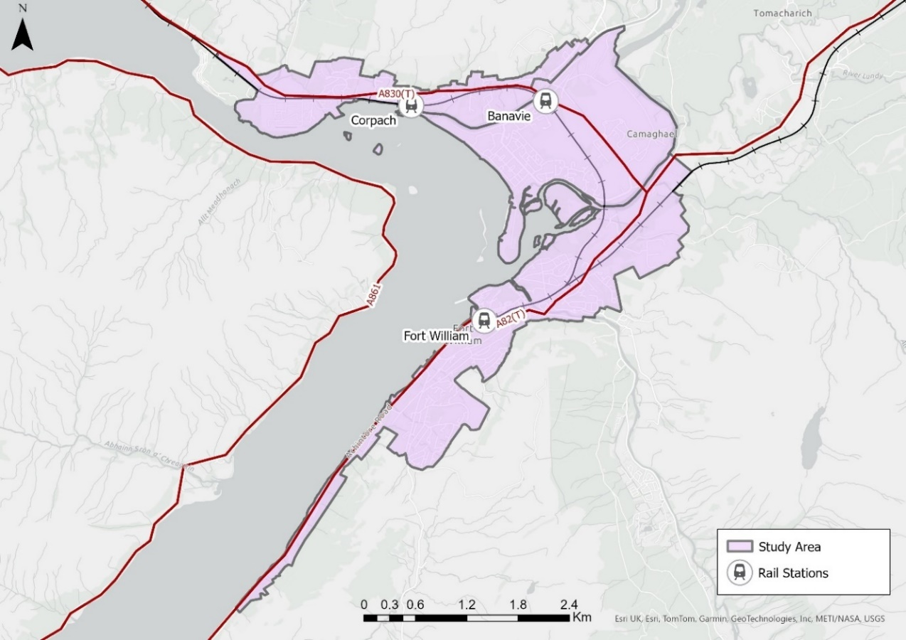

Why is this Integrated Transport Plan needed?
There are a number of longstanding challenges impacting the strategic transport network in and around Fort William. The Scottish Strategic Transport Projects Review 2 included the following recommendation which this study will seek to address using the Scottish Transport Appraisal Guidance (STAG), a recognised approach to determining the transport related problems and opportunities within an area.
Recommendation 32: Trunk road and motorway renewal for reliability, resilience and safety, specifically recommends continued and increased investment in the trunk road and motorway network over and above current maintenance levels to keep the network reliable and resilient for road users. Potential measures would include, but are not limited to, carriageway and structure schemes, strengthening of major bridges, removal of accessibility barriers and development of integrated transport plans for Fort William and the A90 Kingsway through Dundee.
Who is leading and funding the study?
The study is being led by HITRANS (www.hitrans.org.uk), in partnership with Transport Scotland, Highland Council, and Highlands and Islands Enterprise. Transport consultants AECOM/Stantec have been appointed to undertake the commission. Funding has been provided by HITRANS, Transport Scotland and the Highland Council.

What stage is the work currently at?
As of Autumn-2025, the project is in the early stages of:
- Reviewing previous transport studies
- Collecting new data
- Developing an engagement strategy
- Initial public and stakeholder consultation to support validation of the study objectives that will be used to assess the different transport options and what these options are.

How can the public get involved or provide feedback?
Public consultation events will be held and these are likely to be in the first half of 2026. Updates and opportunities to participate will be shared on the Highland Council and HITRANS websites.
Key engagement activities will include:
- An online survey, which will be supported by background information about the project and the options under consideration. This will be promoted via social media and within public venues (e.g. libraries and council buildings).
- A maildrop to a selection of local residents.
- Attendance at the Lochaber Annual Community Partnership Event on the 12th November 2025.
- Two informal drop-in sessions in Fort William open to all, to view designs and speak directly with the project team. One session will be held to allow the public and stakeholders to view and comment on the proposals and one session will be held to report back on the appraisal outcomes.
A dedicated email address has been set up for the study, which will allow stakeholders and members of the public to provide feedback directly to the project team - the email address is FortWilliamITP@aecom.com.

What kind of options will be considered?
Options across all types of transport (excluding air) will be considered during the study, along with the ability of these options to address transport related problems affecting the town and surrounding areas. Options will include consideration of improvements for walking, wheeling and cycling, public transport (bus and rail), freight and road improvements.
How will options be assessed?
Options will be assessed using the Scottish Transport Appraisal Guidance (STAG) which is a recognised approach to determine the transport related problems and opportunities within an area, the objectives of any options considered and the performance of options against the objectives and the standard criteria of Environment, Climate Change, Health, Safety & Wellbeing, Economy, Equality & Accessibility, along with deliverability criteria. STAG includes consideration of cost vs. benefit. More information can be found at: https://www.transport.gov.scot/media/50895/scottish-transport-appraisal-guidance-managers-guide.pdf

When will the Integrated Transport Plan be complete?
A final Integrated Transport Plan is scheduled to be complete by the end of 2026.

What is the timescale for implementation of measures recommended as part of the Fort William Integrated Transport Plan?
The study will identify a prioritised action plan with estimated timescales for implementing different options. The ITP is a long-term strategy and the timescale for implementation will depend on the outcomes of the study, funding availability, and prioritisation of projects. A timetable for the next stages of delivery will be developed as part of the study.

How much will it cost to implement interventions emerging from the Fort William Integrated Transport Plan and where will the funding come from?
Cost and deliverability are elements of the appraisal. The study will identify a prioritised action plan with estimated costs for implementing different options. The study will outline the business case supporting the identified options, which is the first stage in securing funding for those options.

How will the Integrated Transport Plan interact with other initiatives ongoing within Fort William?
The Client Delivery Group overseeing the consultants delivering the ITP is a partnership. Alongside the various engagement and consultation activities being undertaken as part of the ITP, this partnership will makes sure that relevant information and co-ordination with other organisations, projects and initiatives in the area e.g., the new Belford Hospital takes place.

How will this affect local businesses and residents?
The ITP aims to improve accessibility and reduce travel disruption, which should benefit both residents and businesses. Stakeholder and community input will be key to shaping outcomes.

I noticed some traffic surveys being undertaken in Fort William in August – is this linked to the Fort William Integrated Transport Plan?
Surveys were undertaken throughout August 2025 (additional surveys will take place in November 2025) to help inform our understanding of how traffic flows around the town at different times of day and year. This information will inform the modelling work that will in turn inform the appraisal of different options as part of the study.

